Grandpa’s Boat

Bob Luciano, Sr.

Foreword:

This is a story about my family. Specifically, it involves me, my wife, Lorraine (Lori), my daughter, Susan, and my two sons, Bob, Jr. and Larry. Most importantly all of the important events revolve around my father, Anthony (Tony) Luciano, and a boat that he originally purchased.

I am writing this for the benefit of my grandchildren and those of future, as yet unborn, members of my family. It is important that they know the incidents and facts related in this story, and other similar stories, in order that they may begin to gain some insight into the real characters and personalities of us, their ancestors, and the actual lives we led. Hopefully, this story will be only one of many such stories that, God willing, I intend to write

The Story of Grandpa’s Boat:

Despite all of the scientific reasoning that tells us otherwise, sometimes it appears that certain inanimate objects actually possess the ability to affect events in real life. Often this ability manifests itself in a negative way. As unscientific as it sounds, some objects are jinxed! No matter what you do, every time you rub shoulders with that object, something bad happens!

Grandpa’s boat was such an object. Having experienced all of the negative trials and tribulations that that boat caused my family, there is no doubt in my mind. Absolutely, the boat was jinxed! My wife, Lori, is even more emphatic. She says that the title of this story should be: “The Boat from Hell!”

The story of the boat and the unfortunate incidences that it caused closely intertwines with the history of my family in the years when my three children (Sue, Bob, and Larry) were in their pre-teen and teen years. Hence, to fully understand the significance of the boat’s worst moments it is also necessary to spell out how these incidences influenced the lives of my immediate family, in addition to my father’s life, at the time of each occurrence.

In the beginning Dad had good luck with his boat and he enjoyed using it tremendously. However, things sure did not end up that way. To understand this better it is first necessary to know some basic things about my father.

My Dad (Grandpa):

My dad was from the “old school”. He married my mother in 1930, right at the start of the great depression. He was always a hard worker but early in the marriage, as had many others at that time, through no fault of his own, he lost his job. He never did succeed in getting another steady job for many years. Things were rough all over. It had nothing to do with his willingness, indeed, his burning anxiety, to work. There were just too few jobs to be had. With only a vocational school education to his credit, he was low on the totem pole when it came to being selected by prospective employers. There was normally an overwhelming list of people who wanted a job – any job – and too many of them had better educational qualifications than dad did.

With a growing family of three kids, he and mom had a rough time in the first 10 years of their marriage just to put a roof over our heads and food on the table, no less, to be able to afford any kinds of luxuries in life. Just about when things started to get better and he finally got the good job that he had been looking for, World War II came along. The good job was with Bell Telephone Laboratories who were well known at the time for providing permanent positions with numerous benefits. However, World War 2 changed things, drastically.

Dad was a strong patriot and he enlisted in the Seabees even though at age 34, and with 3 kids, he was ineligible for the draft. He saw a lot of action in the Pacific during the invasions of places like Okinawa and other islands in the Pacific. When he got home after the war in 1945 he had a lot of catching up to do with his growing family, a lot of necessary home improvements, and of course, his job.

It took a while but he succeeded in all of these areas. Over the years we kids grew to adulthood and all of us turned out “all right”. After multiple “do-it-yourself” renovations, so did the house. In his job he rose to become the Director of Security at the Bell Laboratories location where he worked. He ended up taking early retirement, at the age of 60.

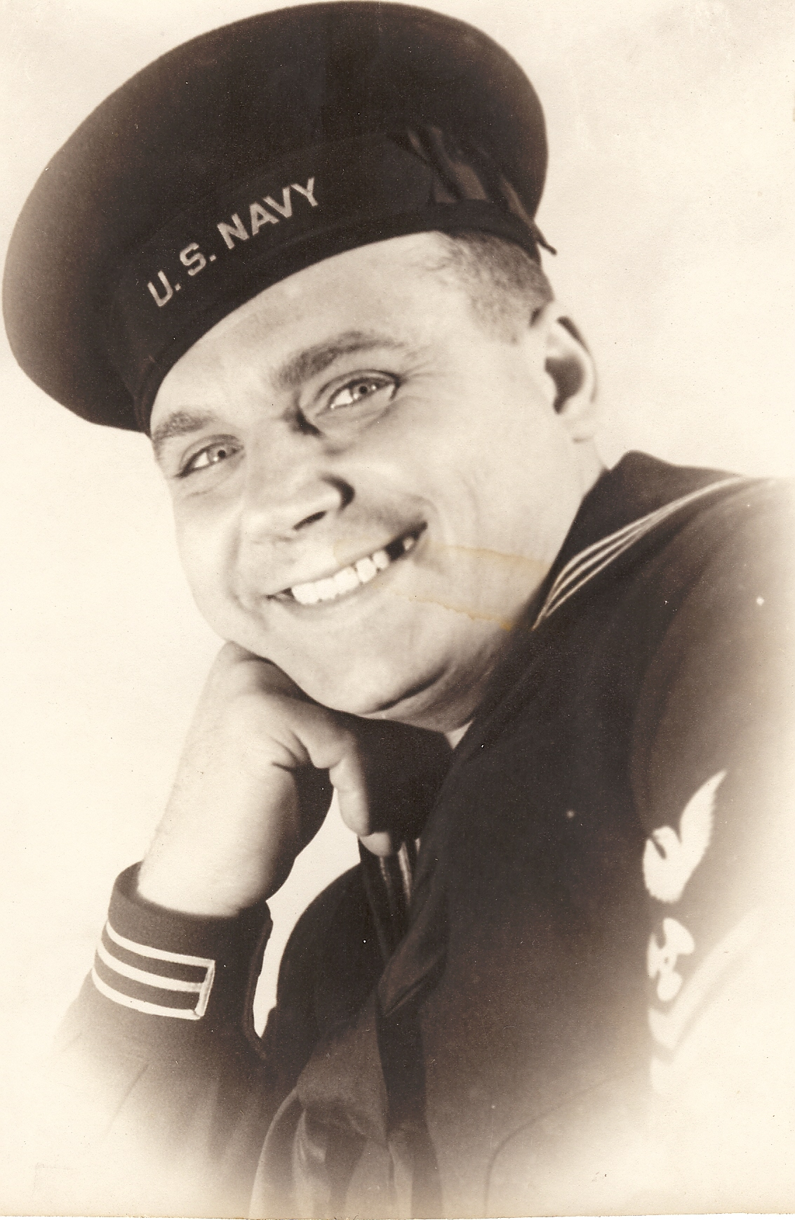 Grandpa (Anthony Luciano), 1943, Age 35

The Boat:

Now, here is where the story really begins. Dad was finally at a point in life where he had some disposable income and, just as importantly, he had the good health and the time to do something with it. This is when we learned that one of his lifelong ambitions was to own his own boat. Characteristic of him he had always subordinated this desire to the needs of his family. He did this to the point that we had never heard him speak about wanting a boat, no less, seen him in one, even a rowboat, except for, perhaps, his time in the Navy.

In retrospect I got to understand that one of the reasons that he joined the Navy Seabees, in addition to his patriotism, was this desire to be around boats. As it turned out he became a Chief Petty Officer and as part of his responsibilities he was trained in Piloting and small boat handling. So it was, that shortly after his retirement, he bought the boat of his dreams.

The boat was really good-looking! It was a sleek, 18 feet long, open cockpit “runabout” that was made by the Winner Boat Company of North Carolina and it was adequately powered by a built-in, Mercury 60 horsepower outboard/inboard engine. The controls for steering and the motor were mounted “mid ship” at the driver’s seat that was equipped with a full width plexi-glass windshield. The hull was made of shiny white and blue fiberglass with bright chrome trim and inside it had blue vinyl upholstered seats. Dad had it specially outfitted with a blue canvas convertible top that was made to fold down, completely out of the way when it wasn’t needed. The interior freeboard of the open cockpit was about thigh-high for an adult, making the boat as practical for fishing as it was for just plain joy riding at high speeds or for water skiing.

Needless to say the boat was dad’s pride and joy! On its back transom he painted its name, “Ros-Ton”, after my mother and him: Rose and Tony. To everybody else in the family, though, this name did not resonate. We all called it, simply, “Grandpa’s Boat”, the name that stuck with it throughout the time that it was owned within our family.

The first two years that he owned and operated the boat it met all of his expectations, and more. He trailered the boat and used it entirely in the fresh waters of Lake Hopatcong, a large lake not far from our home in New Jersey. He had bought the boat from a dealer local to that lake and he usually accessed the lake from dockage owned by the dealer.

My father had a great sense of humor coupled with a gift of being very funny, particularly by utilizing funny physical actions and songs, when he chose to be. However, his normal demeanor was one of unquestioned authority and, normally, he presented a stern, if somewhat benevolent demeanor. In other words, in our Italian heritage family – he was the boss! When he spoke, we all listened. In particular, the grandchildren adored him but, at the same time, his commands always elicited unquestioned obedience and they held him in great respect bordering on awe; especially, in their younger years.

Dad took the small boat-handling course that the Navy had given him very seriously. We all learned this very early. The first ride that I had in the boat with him at the wheel was with my wife, Lori, and our three children. The children were between the ages of 9 to 12 years old. As soon as we all got into the boat he inspected all of us with a critical eye. Then he told each of us where to sit. He shifted us around several times until he was, at last, satisfied that the boat was properly “in trim”. He told us that we could move around whenever the boat was stopped but when it was “underway” we must all stay in our assigned seats at all times. He was very strict about this and woe be it onto the child (or adult) who dared to move about in the boat when it was “underway” under Grandpa’s “command”. This was particularly true in the frequently choppy waters off the Jersey shore.

However, I’m getting ahead of the story. Grandpa used the boat in the fresh waters of Lake Hopatcong for approximately the first two years that he owned it with good success. I was very busy with my business at the time but I did manage to sneak in a few boat rides around the Lake with him that turned out to be some of the better moments I ever had with him in our adult relationship. He sure did love that boat! And he delighted in “teaching” me the proper way in which it should be handled, the proper adherence to the marine laws, and, in particular, how to handle it in rougher waters by manipulating it through the prevailing waves at the correct speeds and angles, etc. We talked about his war experiences and many other things. It was all good stuff and I have good memories from those times.

Another one of the marriage-long dreams that was shared by both dad and mom was to own a vacation cottage at the Jersey shore. This they were finally able to afford from both a time and a money standpoint soon after dad’s retirement. They bought a small vacation home in the Mystic Islands subdivision near Tuckerton, NJ. The house was located on a manmade canal that accessed directly into nearby Barnegat Bay and, subsequently, into the Atlantic Ocean if one wanted to go that far. Of course dad brought the boat there and permanently docked it in the water at the dock in front of the cottage.

During their first summer there he used the boat a lot and he found a companion, fellow retiree resident to accompany him many times on his forays into Barnegat Bay and, sometimes, when the seas were calm, out into the nearby areas of the Atlantic Ocean. Sometimes they fished but mostly they just enjoyed riding and exploring the nearby marine areas with the boat. He called me several times and invited me and my family down but I was very busy with my business at the time and didn’t make it down there until early in the fall.

I brought my family and, of course, Grandpa soon had us all in the boat. Everyone except my mom, that is. Although she was happy for dad and his success at finally having the boat, she never took to boating. She was extremely susceptible to motion sickness. To my knowledge, she never took a ride in the boat. Happily, however, she stayed home and cooked while we were out and, upon our return; there would be one of her typically delicious and munificent Italian meals welcoming us.

He was anxious to show us the nearby areas and shorelines of the Atlantic Ocean. To get there we had to transit through Barnegat Bay and at the entrance to the ocean we had to negotiate through a breakwater protected inlet. There was a severe chop in the water that day, particularly in the inlet. In addition, there were severe counter currents. The overall situation made for a serious challenge to the small boat that we were in; especially, considering that it’s somewhat flattened hull design was meant for the calmer waters of fresh water lakes.

Dad, of course, had gone through his usual ritual of assigning everyone their proper position in the boat to attain proper trim. Again, we were not allowed to move from these positions while the boat was underway. Things went pretty well and the ride was enjoyable until we entered the inlet. Because of the roughness and changeable turbulence of the waters, Dad was unable to find a course through the channel that suited his perception of being on a safe course. We made several starts but each time after we were only part way through, he reversed the boats progress back to the entrance area for a new assault on a different tack. The seas were rough and some of the kids were beginning to turn green. In addition, some were getting very wet from the spray but each time one of them tried to move to a drier new position Grandpa would yell at them to stay where they were because they would ruin the trim of the boat. It was hard for them to understand why we were continually going back and forth in the same spot and continually getting wet but, except for some abbreviated complaining, they were all good troopers and put up with the situation rather well.

Eventually Grandpa reversed our course and gave up trying to get out into the ocean. Instead we ended up taking a long boat ride around the calmer waters of Barnegat Bay that turned out to be quite enjoyable. Afterwards we pulled into the canal dock in front of Grandpa’s place and, subsequently, had a good dinner that Grandma had cooked while we were out in the boat. It ended up being a really good day and when we were leaving Grandpa and I promised each other that we would get together “soon” to do some serious fishing from the boat. Little did I know at that time that it was a promise that never would be kept. The ride that we had together with the family that day was to be the last time that Grandpa and I would ever be together again in that boat.

The Bad Luck Begins:

It turned out that I had a very busy business schedule that summer and some time passed before we had contact with Grandpa again. This time it wasn’t good news! We got a telephone call telling us that Grandpa was in the Intensive Care Unit at St Claire’s Hospital in Denville, NJ. He had suffered a massive heart attack and, while his condition was stable he was listed in serious condition. Naturally, we dropped everything and rushed there as a family.

The way the attack happened had everything to do with the boat. My father and my nephew, Tony (my sister Arlene’s eldest son), who was about 14 at the time, had been out fishing alone in the bay when the motor suddenly overheated, stalled, and seized up. There was no way that Dad could get the motor restarted and, hence, without power there was no way to steer the boat. They eventually drifted into shore and the boat grounded itself in a remote marshy area along the shoreline.

This was a time before cell phones and they had no radio, or other means to call for help. They came up with what they thought was a good plan. There was a boatyard not too far away, probably no more than a half mile, or so, on the other side of the marsh, although it was out of sight. The marsh appeared to be firm enough to walk across. At that time Dad had been showing some signs of physical ailments and he certainly was not in good enough shape to make the trip so it was decided that he would stay with the boat. Tony was a strong young fellow in excellent physical shape. However, after he left, Grandpa started to have second thoughts and guilt feelings about sending him. When, after an hour, or so, Tony did not show up with, or without help, he was beside himself with worry that something bad might have happened to Tony.

He actually got out of the boat to try and follow Tony. However, the boat had drifted after Tony left and it came to rest in some extremely soft and wet sand. When Dad got out of the boat he immediately started to sink in the sand – like quicksand! As Grandpa described it, it was a hard struggle and it took a great deal of strenuous effort to just to get back into the boat. He was exhausted and convinced that he had sent Tony into a very bad situation. Grandpa was in a situation where he could not do anything to help “save” his Grandson and he worked himself into a state of guilt and anguish over it.

Eventually, Tony did show up, unharmed and in a boat with help from the boatyard. His trip through the marsh had been safe and uneventful, but it had taken longer than they had thought plus it took some time for the boatyard to set up the rescue operation. With Grandpa and Tony as passengers, the boat was towed to the boatyard without further incident. It was left there for repairs. However, the damage had been done. The excessive emotional stress caused by this incident turned out to be the trigger for Grandpa’s heart attack, which occurred directly after he returned home that evening.

I Inherit the Boat:

When I eventually got into the ICU to see Dad he was groggy but cognizant. Apparently he had been thinking a lot about things and the first words out of his mouth when he saw me went something like this, “Bob, I don’t want that boat any more. I’m through with it and I want you to have it. I’m giving it to you! Use it and enjoy it with your family.” I really didn’t want the boat, since, as a family we already had made other plans in that direction so I immediately protested but Dad was firm.

You don’t argue long with someone who might be at death’s door so I didn’t protest much and I gave in and thanked him for the present. In that way, even though Dad did recover and lived for years after that incident, the boat became mine. Anyway, when I accepted the boat as a present, I thought in my own mind that it was a gift that would be temporary. It was made under stress and, as soon as the incident was over and time passed, Dad would reconsider and he would be happy to have his prize possession, his boat, back again. As it turned out, how wrong I was.

For several years before these happenings, my family and I had been making a yearly vacation trip to the Florida Keys where we camped on the beach at Bahia Honda Key State Park for two weeks. As part of that yearly trip we always stopped in Key Largo for a day at John Penneycamp State Park which, at that time, contained the best underwater reef in the United States. We would rent a small, open, outboard powered, flat bottomed boat there and spend a day alone, as a family, snorkeling at the reef. Both the coral and the fish life were spectacular and, as a family, we became addicted to it.

So much so that, on the way home that very year of Grandpa’s heart attack, we had previously stopped in Orlando to look at similar boats that would be good for snorkeling and shallow water fishing. We actually picked out a boat that we wanted and I made tentative plans with the dealer to pick one up on our annual trip down the next year. We had shaken hands on the deal and it was all set. However, there was no way that I wanted two boats so one of the first actions I took after agreeing to take over Grandpa’s boat was to call and cancel the Florida boat. This action was not exactly popular with members of my family but, reluctantly, we all agreed that it was the right thing to do.

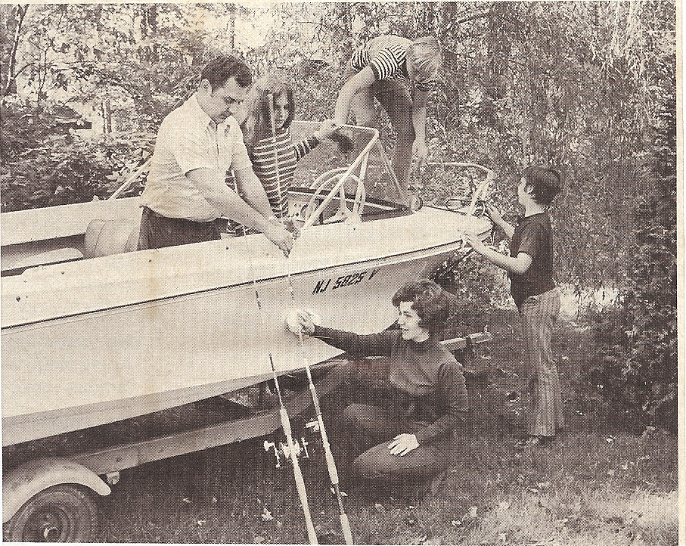

Grandpa’s Boat, 1970 +/-, Bob Sr., Sue, Lori, Bob Jr., Larry

A Near Collision:

Shortly after Grandpa’s heart attack we, as a family, went down to the boat yard on the bay where Grandpa had left the boat. I had previously called and they said the boat was ready. I was informed that they had flushed out the cooling system and then had run the motor in a tank for fifteen continuous minutes and that it operated fine. Our plan was to have some fun using the boat in Barnegat Bay before putting it on the trailer and bringing it home.

We had a good boat ride for a short time; say about half an hour, when we spotted a small overturned boat in the water ahead of us with people swimming in the water around it and waving for our attention. Obviously, they were in trouble. I headed straight for them and, as I got closer, slowed the motor to idle speed. There were four people, an adult woman and three small children, in life jackets, floating in the water next to the overturned boat.

We were closing in on them so I toggled the lever to put the prop into reverse, intending to stop short of them and then use the hand paddles to maneuver the boat in for close pick-ups. It was a good plan except that it didn’t quite work out that way. I kept toggling the reverse lever but the motor unit refused to go into reverse! The boat kept going straight ahead. It was in an idle condition so I had no means of steerage and we were closing on the woman and children straight ahead in the water.

When we first approached the woman was smiling, obviously at the thought of being rescued. However, as we started closing in straight at her, say within 10 – 15 feet, the look on her face changed to horror. All of this time I had been frantically toggling the reverse lever to no avail! Seemingly at the last possible moment, the motor finally kicked into reverse! I was able to stop and reverse the forward motion of the boat just short of hitting anyone in the group. It had been a scary incident but no physical harm had been done.

It turned out that the woman had been giving her three young grandchildren a ride in her boat, a small 14 foot pram equipped with a small outboard motor, when a large rogue wave hit and overturned the boat, depositing them all in the water. Fortunately, they were all wearing life jackets and they had only been in the water for about 5 – 10 minutes when we found them.

Using the hand paddles to get to them, we fished them out of the water one at a time and then, with the help of my boys, Bob and Larry, we managed to upright their boat and tie it onto ours with a tow rope. Except for being somewhat shaken, she, and all of her family, were in good physical shape. The day was warm and sunny so they soon dried off and stopped shivering. Following the woman’s directions we took them all to shore. Their home was on a canal with a private dock, similar to Grandpa’s except that the house was grander and it was in a more exclusive area.

Our troubles were still not quite over. As I approached the dock I slowed the boat’s forward speed and then, just at the right moment, I put the boat into reverse to stop it precisely at the dock – at least I tried to put it into reverse. Again, it would not go into reverse no matter how many times I hit the controls! We hit the dock with a pretty good thud. No damage was done but it was a little nerve wracking: especially, after the near miss in the water.

It seemed that the woman could not get out of the boat quick enough with her family. After all, she had gone through some crazy experiences in a small amount of time. I am sure she was relieved that all had survived in good health but she had seen enough of this crazy boat. She thanked us profusely but then, quickly disappeared into the house with her brood. That’s the last we had contact with her.

Our troubles with the boat were still not quite over for that day. Shortly we re-entered the bay and, at cruising speed, resumed our boat ride. After a very short time, the temperature gauge started to register hot. I immediately stopped and, with the motor controls in neutral, kept gunning the engine in an attempt to dislodge anything in the cooling system that might be clogging it. My efforts were successful and the gauge readings returned to normal. We decided that we had had enough for one day so we headed in for the dock. When we got there, we put the boat on the trailer and headed home.

In retrospect, that day’s occurrences coupled with Grandpa’s bad experience were clear signs that the jinx associated with the boat had firmly taken hold.

The Initial Repairs:

It was apparent that the boat was in desperate need of repairs. I elected not to have these done in the boat yard near Dad’s summer cottage because of its long distance from our home in Warren, NJ. Instead I took it to a boat dealer in Watchung, NJ, who was much closer to home. Despite being inland, the dealer was well equipped to make these repairs since his facilities included an immersion tank large enough to handle sustained test running of the engine. When I took the boat there the dealer said that he would be happy to work on it but that he couldn’t get to it right away because he was extremely busy with prior work. I told him to get to it when he could. Another unfortunate choice – it was a full six weeks before he called me and told me he was finally working on it. By that time the kids were back in school and the summer boating season was basically over.

I went to the boat yard and the dealer had the rear cover of the motor removed. Sure enough there was a link attachment in the gear shifting linkage chain that was severely corroded and had broken completely in two. The entire linkage chain, itself, showed severe corrosion at the joints. Apparently the linkage chain had been frozen stiff and the repetitive toggling that I had done had proven sufficient enough to loosen it. However, the stress finally proved too much for the one link that failed and it broke in two. It was extremely lucky that it held together for that one last time that enabled us to avoid the collision with the woman and her family in the water.

The dealer agreed to replace the linkage chain with new parts and to thoroughly flush the cooling system of the motor and, finally, to subsequently test run the motor in the immersion tank for at least one continuous half an hour to assure that it was completely clean. About a week later he called me and told me that everything had been done and that it had passed with flying colors. I picked up the boat and stored it for the winter under an open, roofed area attached to the rear of our barn.

The Thousand Islands Experience:

When the kids were young we had a small travel trailer that we utilized for family camping. With this rig we had, as a family, enjoyed many happy family camping experiences up and down the U. S. east coast.

Whenever these excursions were to places convenient to local open water, we also took along a small, open, 12 ft. long, aluminum “car-top” boat with an accompanying, small 6 horse power outboard motor. Hence, the kids were accustomed to camping, boating, and fishing and they thoroughly enjoyed; indeed, eagerly looked forward to such excursions.

That winter, being that we now had a larger boat that had been “completely reconditioned”; we arrived at a plan to make a family camping trip that we had wanted to do for some time. We had previously camped in the Thousand Islands region between New York state and Canada. It is a beautiful area within the St. Lawrence Seaway containing many scenic small islands that are only accessible by boat. However, the distances between many of the more interesting islands are large – sometimes several miles. With only our small “car-topper” boat we had heretofore been forced to camp on land near to the water’s edge and we only had access to islands that were nearby.

Now, with this larger boat, we would be able to take all of the gear necessary to actually camp on an island remote from shore and, better yet, be able to explore still remoter islands and land areas that heretofore had been basically inaccessible to us. The boat was even large enough to include our family dog, a chocolate Labrador Retriever named Bruno.

The place we chose as our destination was Grindstone Island. The island is located not too far off shore from the Freedom Bridge that separates New York from Canada. On the island is a state park that contains tent camping facilities plus a boat docking area with slips that will accommodate a boat of our size. In addition, they allow pets and, at least at that time, we were able to reserve our campsite and boat slip ahead of arriving there; hence, we were assured of a spot. It was ideal for our purposes.

The entrance to the Park is just past the Freedom Bridge. At the entrance is a concession with a store, boat rentals for small boats, and, most importantly, an access ramp into the water to unload the boat. There was also a parking area to leave the family station wagon and boat trailer while we camped on the island. We floated the boat, loaded it with our gear and the dog, parked the wagon and trailer, and took off in the boat to the island.

We quickly set up camp on the island in our prearranged site. It was all we could have hoped for, near enough to a drinking water source, the showers, and the toilets to be handy but not too close to get the smells. We set up our tents and there was still enough daylight left for a boat ride. We took a nice ride in the boat and watched the sunset from the water. The boat performed flawlessly.

The next two days were great. We rode the boat throughout those two days, swimming, fishing, picnicking, and some long distance sightseeing around the many islands. Our dog, Bruno, proved to be the hit of the camp. The other kids in the camp really had fun with him, playing fetch, making him perform his begging tricks, and just running around with him, in general. He loved it when they would throw a stick into the water from the dock. He would take off with a running leap into the water with both his fore and hind legs extended straight out, and land with a tremendous splashing belly flop some 5 - 10 feet out from the dock in his enthusiastic pursuit of the stick. He would do this over and over until we were tired of throwing.

Perhaps the most fun times were when we tried to fish from the boat when he was in it. Every time we would cast out a lure Bruno would jump over the railing into the water to try to retrieve the lure. Of course we couldn’t let him get it and we had some fun keeping it away from him. Trying to get him back into the boat was more fun. We had to lift him, soaking wet, over the railing from the water (He weighed about 90 lbs.). As soon as we got him into the boat he would shake himself furiously, getting us all wet. He then would look at us appealingly, panting with his tongue hanging out, anxious to do it all over again.

During these few days there was no trouble from the operation of the boat; in fact, it was a pleasure to operate it. We shared some really good family time during those few days. At the time, I remember thinking that our troubles with the boat might be over and that owning it might be a good thing after all. However, such thoughts quickly proved to be premature. In the end, those few, quite perfect days in the islands proved to be the only time that we used that boat wherein we did not immediately end up with some type of trouble with it.

On the third evening of our stay I was standing on the dock watching the sunset when an impressive looking, obviously expensive, 40 feet long, motor yacht pulled in parallel to the dock preparatory to tying up to it for the night. The person on the bridge steering the yacht was a very attractive blonde haired woman. I watched her moving it into position to allow her crew to tie it up. She was really good in the maneuvering procedures and the whole docking process turned out to be smooth and efficient. When she came ashore I complimented her on her boat handling and we exchanged some pleasantries before she proceeded back onto the yacht.

The next morning we were in need of some supplies at our camp and I was prepared to make a trip back to the concession store to get them. It appeared that everyone was either too busy or having too good a time with the camp activities to accompany me. I got into our boat alone and was just clear of the slip when the blonde woman flagged me. She inquired if I was going into the store and when I informed her that I was she asked if she could accompany me. She said that her boat was a little too big to be convenient for such a short errand. I readily agreed and she got into the boat.

It was about a 3 mile trip across the channel to the store and, if everything went as planned we would be there and back within an hour or two with our business completed. However, things did not go as planned. We got about half way across the channel, about 1 ½ miles from land in any direction, when the motor overheated and the engine stopped. It was completely seized up and it would not even turn over! There was nothing that I could do. We were completely adrift in mid channel and, with no power from the motor; we had no means of steerage.

I tried to flag down a passing boat but, at that early morning time in this recreational area traffic was light. No boats were close enough to respond to my flagging. She asked me if I had a radio and shook her head in disbelief when I told her I didn’t. After about 5 – 10 minutes of an awkward silence between us she looked at me red faced and informed me that she had to go to the bathroom - really bad! I didn’t know what else to do so I told her I would turn my back and that she would have to sit on rail and go over the side. That’s what we did and I heard, but didn’t see, her peeing over the side. She wasn’t exactly a good sport about it. She didn’t say anything but her actions sure let me know she was kind of disgusted with the whole process and, most likely, with me and my boat too.

Finally, I was able to flag down a passing boat and its owner readily agreed to tow us to the concession. My plan was to rent one of the small open boats at the store and return with it to the island, leaving my boat there to be worked on and, hopefully, fixed.

While we were being towed I started working a bit on the motor. There was a plastic hose connection in the cooling system. When I removed it there was a large piece of rusty metal lodged in it with other pieces of smaller rust surrounding it. The tubing was completely clogged so that no water could pass through it. I cleaned it out and reassembled it but at that point I knew – there would be no way of saving this motor. Grandpa had run it continually in salt water and the constant presence of the salt within the cast iron cooling manifold had severely corroded its internal surfaces – surfaces that were completely inaccessible for cleaning purposes. Because of this severe corrosion, such flaking would continue to happen and the motor could continue to overheat, unexpectedly, any time it was operated. It was plain. The boat would need a new motor if we wanted to continue using it.

We got to the concession but, again, my plans were foiled. All boats were currently rented and there would not be another one available for two more days. I could live with that since we had planned on that many days for the vacation anyway. The immediate problem was how to get back to my family on the island with the supplies and, also, my somewhat unhappy passenger. The owner told me not to worry. The Ranger made the rounds in his boat between the islands (there were several islands which also contained state parks) every day and he was due in to the store for his daily visit within the hour. He said it was not unusual for him to take passengers in need of a ride for one reason or another.

So it was that we, the blond woman and I, with our supplies, boarded the ranger boat for a return trip to the island. We settled in and had to sit on the side rails as there were no seats. That wasn’t so bad but there was one fact that we didn’t know about that soon became evident after we boarded. The boat was a garbage collecting boat and it was only midway between its rounds when it picked us up. It had half a load of garbage on it and it smelled bad! There was no way to get away from the smell while we were on that boat and the boat did not move through the water very fast. Needless to say, it was neither a pleasant nor a swift trip back. The woman didn’t say anything on the way back except to wrinkle her nose more than once.

When we got back the blond woman got off that boat as quickly as she could. She didn’t say thank you, or goodbye, or say anything, for that matter. She went directly to her yacht without looking back and the yacht, with her on it, was gone within the hour. Somehow, I don’t think I made a good impression with that woman.

That damned boat had done it again! It teased us with a good time for a while but, in the end, it had only been setting us up for another near disaster. I didn’t fully realize it at the time but this process of initial success followed by near disaster would continue as long as I owned that boat.

As soon as I got back to the campsite there was another serious problem developing. My daughter, Sue, was doubled over with severe pains in her groin area. We couldn’t tell for sure but it had the symptoms of a possible appendicitis attack. It was plain that she needed medical attention – and quickly. We did not have a boat to take her.

Fortunately I had met and befriended a fellow camper who did. He was interesting – a widowed, retired Coast Guard officer, he owned an older “Woodie”, 16 foot runabout boat. It was a classic boat and he kept it in immaculate shape. He was on the island with the boat by himself, renting one of the cabins that the State Park offered in addition to the tent sites at the campground. He told me that he was there recapturing some of the good memories of the times he and his wife had had together there. I don’t remember his given name but we, at the camp, nicknamed him “Captain” and that’s who I remember him as.

I went to his cabin and he readily agreed to take me and Sue to shore. We left immediately. He was a master at handling his boat. He told me he was well used to rescuing and helping people in boating oriented situations. It was/is a large part of what the Coast Guard does. We got to shore where my station wagon was parked and, after obtaining directions, rapidly got Sue to the hospital which, fortunately, was nearby.

Thankfully, the diagnosis at the hospital was that it was not appendicitis but, rather, it turned out to be a urinary tract infection. They medicated her and gave me a prescription for follow-up medication. They told me that, as a precautionary measure, they wanted to keep her overnight for observation. We left her in the hospital and arranged to pick her up the next day. I was somewhat reluctant to do this as I could see that she was apprehensive about staying there alone. However, there was no other good choice. She put on a brave face when I left and I was proud of her.

The captain and I returned to camp. Between the bad situation with Grandpa’s boat and the fright we had with Sue the vacation was clearly over. The next morning we broke camp and packed our gear into Captain’s boat early. It was a tight, overflowing fit but we managed to get everyone and everything, including the dog, into the boat. The Captain took us to shore where we thanked and said goodbye to him. We picked up the station wagon and the boat and left.

We proceeded to the hospital and picked up Sue who, thankfully, had been diagnosed to have no further complications. Finally, we headed for I-81 South and home. Once home I parked the trailered boat in its spot under the overhang at the rear of the barn where it was destined to remain until I figured out what to do next with it.

Grandpa Coronary Bypass:

This next sequence of events dealing with Grandpa’s coronary bypass operation is, perhaps, not strictly necessary to the telling of the story of his boat as related herein; however, the telling of the events leading up to and following the operation will give some better insight into the history of my family and the manner in which it faced a severe family crisis.

Also, the reading of it will give some insight into the reasoning that caused me to make the fateful decisions that I did concerning the eventual refurbishing of the boat. For these purposes it is necessary to backtrack a bit to the time just after Grandpa’s release from the hospital following his initial heart attack.

He was referred to St Barnabas hospital in Livingston, NJ, where they had a newly formed Cardiac Surgery Unit. They admitted Dad and performed a series of tests on him – the most important being an invasive Angiogram wherein they actually locate and view any blockages in the coronary arteries of the heart. My older brother, Al, and I accompanied Mom and Dad into the chief surgeon’s office when it came time to hear the results of the testing.

The Doctor showed us the X-rays. The news wasn’t good! Dad had three seriously blocked arteries, one of which was very severely blocked (over 90 %)! We were informed that another, possibly life ending, heart attack was imminent and it could occur at any time.

Their recommendation was for an immediate “coronary by-pass operation” wherein Dad’s chest would be surgically opened and the affected arteries on his living heart would have sections of veins grafted to them in a manner to provide by-pass blood circulation past the blocked areas. The veins would be surgically “harvested” from Dad’s legs between the ankle and the knee.

The operation was a brand new procedure at that time. It was beginning to be proved to be effective but there was still much reason to be apprehensive. In Dad’s case there was little alternative. Either he tried the operation soon, or else, he would be looking forward to a very foreshortened life. He was only 64 at the time. We all agreed to the operation, Dad, probably being the most enthusiastic about trying it.

As soon as it was decided to proceed with the operation, the tone of the meeting changed. The Doctor informed us that it would cost $75,000.00 (a major sum at the time) and he questioned us closely on how we were going to pay for it. I looked at Al and we both told the Doctor not too worry that it would be paid for. The Dr. replied that some money would be required up front and some mechanism would be required to assure final payment. Dad had good health insurance but we were not certain at the time whether it would cover everything. Between Al, my sister, Arlene, and me all of any bill would be paid but the Dr. did not know that and he was clearly skeptical. The troubling part to us was that that the ability to pay was so important to him. We left the office telling the Dr. that we would get back to him with our final decision. He admonished us not to wait too long. One thing we did was to take a copy of the X-ray and medical reports with us when we left.

After leaving the office Al and I had conversation about the mercenary approach exhibited by the Doctor. Dad was oblivious to these concerns. He just wanted to get the job done and get on with his life. Al and I agreed that we should get a second opinion. Al volunteered his secretary’s service to locate sources for a second opinion. I was somewhat relieved by his volunteering to do this, since, Lori and I had just taken the kids out of school for our annual two week trip to the Florida Keys. Everything was packed, including our camping trailer and my family was prepared to go as soon as I returned from the hospital. Al and I agreed between us that I should call in within the next two days on my way to Florida to plan our next steps. I was prepared to fly home to help implement any plan should it become necessary. So we left for Florida that day.

I called from the road a couple of days later. Al was amazing. In that short interval he had ascertained that the best man in the world for that second opinion was Dr. Denton Cooley. Cooley had actually invented the operation and he, and his team of surgeons were successfully performing it on a regular basis in their hospital complex in Houston, Texas. Al had already sent the X-rays and medical information to him by Special Delivery (That was the best you could do in those days before Fed-Ex). He was expecting a call from Cooley’s office as soon as they arrived and had a chance to examine them. There was nothing else to do but wait so we agreed on another call within the next few days.

It was more like three days later that I made that call. I had been very busy getting my family installed in the campground in the meantime. Shortly after I talked to him, Al had received the call from Cooley. He and his team had reviewed the information that Al had sent. It was their unanimous opinion that Dad was in an emergency state and that he should be sent to Texas as soon as possible for the operation. Acting completely on his own, Al had already made plane reservations for himself, Mom and Dad and they were flying to Houston that very day. He gave me the hotel address where they would be staying. There was no way that Al could call me. I would have to call him to monitor the progress.

I did call again within the next few days. Things had moved quickly. Dad was already under the knife, still in the operating room. I immediately called for plane reservations to get to Houston myself. I would have to fly out of Miami leaving my family in the campground. It was a 4 -5 hour trip from where I was at. The best I could do was to get to Houston two days later, which I did. By the time I got there it was all over. Dad had survived the operation and was on the mend. Al had already left on some pressing business matter. The best I could do was to stay with Mom for a few days and keep her spirits up.

The operation was not without problems. As I understood it, Dad’s heart had stopped while he was on the operating table after only two grafts were successfully installed. They successfully revived him but the third graft was aborted and never was installed. Fortunately, this was the least necessary graft that would have fixed the least serious blockage.

Because of these complications the doctors were keeping Dad in the hospital for observation for at least two weeks. They were nice to my mother. They put a cot in Dad’s room and she was allowed to sleep there with him for the entire time that Dad remained in the hospital, at no extra charge. It was under these conditions when I arrived. I checked into a hotel and stayed a couple of days.

Dad lived for fourteen more years after the operation. So, in spite of the missing graft, the operation had to be deemed a success. Things also worked out well from a cost standpoint. The final bill was around $35,000.00 and Dad’s insurance covered everything. I’ll always be grateful to my brother Al. He sparkplugged and implemented the whole thing and, principally because of his efforts, Dad received the best care available in the world at that time.

While visiting Dad in his hospital room, he and I had some nice conversations. In one of them he brought up some of his experiences with the boat. He was animated and obviously happy when he reminisced about them, particularly some of his fishing trips in Barnegat Bay with his buddy. It was at this point that I began to think seriously about the boat. I wanted to make my father happy. At the time I thought that one way I might accomplish this would be to fix up the boat and then spring a surprise on Dad by taking him for a ride in it. Of course I didn’t tell him this at the time because I still wasn’t sure in my own mind that that was a course I wanted to take.

Refurbishing the Boat:

After the debacle with the boat in the Thousand Islands, I parked it on its trailer under the overhanging roof attached to the rear of my barn in Tewksbury. There it languished, abandoned, for the next year, or so. My business was really busy and I did not have much time to think or act about anything but the business. Besides, I was pretty disenchanted by the bad luck that I had experienced with Grandpa’s gift up to that point. It took a while for me to work up any degree of enthusiasm for continuing on with it.

However, I still wanted a boat. During the next winter the big annual Boat Show came to New York. I went over with Lori and the boys. At that point I was still wrestling with the competing ideas of either refurbishing Grandpa’s boat or abandoning it and starting all over with a brand new one.

The initial, good family experience with Grandpa’s boat in the Thousand Islands had given us a taste for a boat of that size and general design. We found several boats at the show that fit that bill that we really liked but, after adding up all of the costs of outfitting any of them the way we wanted, they all came in with price tags in excess of $12,000.00. I did not want to spend that much.

As an alternative, we scoured the show to find a way to refurbish Grandpa’s boat with a new engine. Mercury, the equipment supplier for the original motor on the boat no longer made a line of inboard/outboard motors. I was sold on that type of motor for the boat. When it was running right, that type of motor had handled extremely well in Grandpa’s hull.

In that whole show, we could find only one motor manufacturer who made an inboard/outboard motor that I felt might work in that hull. The motor was made by Volvo. It was cooled by a closed, recirculating fresh water cooling system that would eliminate the cooling problems associated with the present engine. Dimensionally, while it was bigger than the original engine, by my calculations, along with the dealer’s, it would fit. It was a100 horsepower engine as opposed to the 60 horsepower of the original motor but, again, we ascertained that the hull could handle the extra power. I was a little troubled by the extra weight of the engine but it was only in the order of 10 pounds, or so. The best thing about it though was that the dealer would install it and guarantee its correct operating characteristics for the sum of $6,000.00 – less than ½ of any of the alternatives we had found, so far. .

I went home and thought about it. It wasn’t just the price differential that was swaying me. I still strongly felt that it was the right thing to do for my father. I still wanted to surprise him. Two days later I called the dealer and made the deal. If I removed the present motor and brought the boat to his yard at the Jersey shore, he would install the motor, including all necessary controls, and ensure that it worked, with good handling characteristics, for the $6,000.00 price he quoted. This price also included the revision of the boat’s transom which would have to be revised to fit the new motor.

It wasn’t quite the boat that I had been wanting but at that savings it would be close enough if it operated correctly. And the final thing that caused me to choose to refurbish it was the thought that it would make Dad happy. I was looking forward to taking him for a ride in it after it was fixed.

A young engineer who worked for me at the time volunteered to remove the original motor from the boat. He said he wanted to take it home and work on it. I agreed and he did remove it and took it away. I never heard any more about that jinxed motor, nor did I want to.

I trailered the boat to the boatyard at the shore and left it there. I stopped on the way and made arrangements for a new canvas top and new upholstered seats to be installed at a place near the boatyard... These would cost an additional $1,500.00. I felt pretty good about the whole arrangement. Since the hull was in really good shape, I would have a basically brand new boat for a total of only $7,500.00 – a savings of at least $5,000.00.

Like everything else about that boat things didn’t work out quite as easily as expected. It seems that there was a delay at the dealer’s. Some of the parts they needed were on back order from Sweden. When they finally arrived there were scheduling conflicts with other work at the dealer’s. The net of it was that the whole summer had passed by, into middle fall, before the boat was declared ready for me to test.

I went to the dealer with my sons. Sure enough the boat was in a gantry sling, poised to put into the water when we arrived. It looked great. If one didn’t know the original, there would be no way to ascertain that the motor was not part of the original boat. The dealer had cleaned the hull up and done a truly masterful job of fitting the motor into the transom. The controls were professionally mounted within the boat. It really looked like a new rig.

We lowered the boat into the water and, while it was still contained on the sling I got into the boat with the dealer. He showed me how to start it and operate the trim and gear controls. He got out, the boys got in, and they removed the sling. With me at the controls we immediately took off from the dock. I was anxious to see how she performed.

She didn’t disappoint. We ran around the bay at top speed. Her nose rose sharply with the first burst of acceleration, then, rapidly settled down into a virtually level horizontal plane. The speedometer was bouncing between 35 and 40 miles per hour – a good 5 to 10 miles per hour faster than with the previous motor. She was a bit skittish in a tight turn but that was to be expected with the new, narrow plane contact surface combined with the higher forward speeds. At ¾ speeds she handled perfectly, even in the tight turns. I was well pleased.

We stopped the boat at idle in the middle of the bay to look her over more closely. We were in the middle of this inspection process when Larry shouted, “She’s filling up with water!” Sure enough, the lowest rear surface of the inside deck was rapidly filling with water. I reached down into the water in back of the transom where the drainage plug was located. There was no drainage plug. Someone had removed it and not replaced it. We were in open water, about ½ mile from the dock, and rapidly starting to sink!

There was only one viable option. If a boat, such as ours, is run fast enough through the water, a Venturi effect is caused past the open rear drain hole that creates a vacuum. By continuously running fast enough, this vacuum action will actually drain the water from the boat and keep it drained as long as the boat maintains enough forward velocity. I immediately put the throttle into full forward and headed for the dock. Sure enough, the water immediately began to drain from the deck and when we got to the dock there was no sign of any water in the boat.

We soon had the plug in place and the dealer was red faced. It was his people who had not replaced the plug. However, we took the boat for another short spin and she performed flawlessly. There was only one negative. Because of the heavier motor, the boat had a slight upward tilt from the horizontal as it sat at rest in the water. I didn’t like it but it wasn’t too bad, or too noticeable, and it didn’t seem to make any difference in the performance. I accepted the boat and wrote the final check out to the dealer.

We trailered the boat to the canvas maker and left it there for installation of the new top and newly upholstered seats. Again, the canvas maker took longer than expected. He didn’t finish the refurbishing until midwinter. It was a long drive for me and I was busy. I didn’t get back down the shore to pick it up until springtime. They had done a good job. The new canvas and upholstery were great.

Unfortunately, because of the delays, we had missed an entire boating season but, on the plus side, we now had virtually a brand new boat, a new boating season was upon us, and I was optimistically looking forward to a good boating season with the boat. However; I should have been forewarned. The episode with the drainage plug should have told me that the jinx with that boat was still with us.

The Jinx Continues:

I was looking forward that spring to surprising Grandpa by taking him for a ride in the refurbished boat. Before I did that, however, I wanted to make sure everything was OK with it. I gathered my family one sunny spring day and we put the boat into Lake Hopatcong at Lee’s Cove. With its new canvas, motor, and upholstery, she really looked good in the water. The motor had not been run since late in the fall of the previous year and I had some trouble starting it. It eventually kicked over and we left the dock at a slow, “no wake” speed which was required until we were out into open water.

When we got into open water I opened the throttle but the motor responded poorly. It started to” miss” at ¾ throttle and I couldn’t get it to smooth out. I felt that it just had to be run in a bit because of its long layover in the winter so we headed out into the center of the lake at a reduced speed and a sputtering motor. When we got out into the center, probably a mile, or so, from the dock the motor died. No matter what I did I could not get it restarted.

We sat adrift for a while and a passing boat, roughly the size of ours, stopped and asked if we needed help. It resulted in us being towed back to the Lee’s Cove dock by that boat. It was still early and I didn’t want to give up on the motor. The symptoms pointed to trouble with the carburetor. One of the features of that Volvo motor was that it did not have a separate choke control, the choke being automatically integrated with the throttle control. I took the motor cover off and, as good as I could, I manually simulated a choking action. It took a while but, either through my actions, or just by naturally clearing itself through repeated trials, the motor finally kicked in.

We took her out again, this time with much better results. The motor responded flawlessly at all speeds, from idle to full throttle. We had a long, good boat ride. When I was a young, single man I had owned an outboard runabout boat jointly with my good friend, Al Rosenbohm. We docked and used that boat in Lake Hopatcong, so I was very familiar with the lake. It was fun showing the family its different points of interest. I was starting to feel good again about Grandpa’s boat but, as always, something happened to ruin that day’s boating experience. The jinx wouldn’t go away. It was still alive and causing trouble!

We approached a point wherein the lake narrows to a point where a small bridge crosses it and, then, it widens out again on the other side. In effect this point is a bottleneck to the flow of boat traffic passing under the bridge. There is a strictly enforced, “no wake” speed limit in effect at the approach to the bridge. It is also a point where the Marine Police frequently hang out to check the passing traffic of boats.

I slowed the boat speed correctly as we approached that bridge. However, as we were getting closer into the inlet, a marine police boat appeared with flashing lights and we hove to as it approached us and came alongside. They had correctly ascertained from the license decal displayed on the bow of our boat that it was the previous year’s decal. The net of it was that I got a summons, payable in court, for improper registration. It was true. I had neglected to renew the license for that year.

The boating was over for that day. They instructed me to take the boat out of the water until I complied with the law. The jinx had won again!

Grandpa Says No:

I paid the fine and attained an up to date registration for the boat. Based on the final, good performance of the boat at the lake on the day that I received the summons I thought it was finally the right time to invite Grandpa for a ride with us on the boat. Way back, while Grandpa still owned the boat we had talked about a trip that he wanted to take with it.

That trip was to put the boat into the Hudson River and, then, to take a trip around New York City’s Manhattan Island, traversing the Hudson River, the East River, the Harlem River, and, finally, back into the Hudson. It was, at the time he told me about it, kind of a dream trip for him. For one reason, or another, he had never made this trip during the time he owned the boat. I thought it would make him really happy to finally make the trip.

So it was that I approached him and invited him to make the trip. When I made the offer he didn’t hesitate one minute to give me his answer. It was a resounding, “No!” He said, “I told you I was through with that boat and I meant it. You take your family and enjoy the ride but I’m through with that boat!” There was no way that I could get him to change his mind. I was kind of crushed. The main reason that I had elected to fix up his boat instead of buying a boat that I really wanted was that I thought that I could surprise and please him by fixing it up for him. However, it didn’t work out that way.

The boat had won again. It seemed that no matter what I did with it, whatever positive steps I took, I always seemed to come up with a negative result.

The New York Trip:

While I was extremely disappointed by Grandpa’s reaction, I elected to make the Manhattan traverse with my family, anyway. So it was that one bright sunny morning we trailered the boat to Liberty State Park on the New Jersey side of New York Harbor. We put the boat in the water from the trailer ramp there. It started up immediately and, at idle speed, we proceeded into the harbor.

I put the throttle at full and the motor responded well. When I brought it back to ¾ speed, the motor stalled out. It restarted immediately and ran well at idle speed and, also, at full throttle. However, at any speed in between the motor would immediately stall out. It was really perplexing. Based on our experience, and eventual success, with the motor being cranky at the lake a few weeks before, I wasn’t too concerned. I figured that, with continuous running the motor would eventually clear itself and we would be able to make the run efficiently.

So we continued on with the motor at full throttle and were making somewhere in the vicinity of 35 - 40 miles per hour. Our first goal was to circle the nearby Statue of Liberty, which we did at full speed. The ride was OK, if somewhat thrilling at that speed but, since that waters were relatively calm around Liberty Island where the Statue resides, it turned out to be a good ride. We, also, took a similar ride around nearby Ellis Island where, at the time, we thought Grandpa had entered the country from his original birthplace in Italy with similar results.

When we finished circling the two islands I tried to make the motor respond better: however, at any speed other than idle or full speed, the motor still conked out. I decided to attempt the full circumnavigation of Manhattan Island anyway. I was still convinced that the motor would eventually clear itself and start to respond normally.
I put the boat on a course to enter the East River at the point where it enters the Harbor, just below the tip of Manhattan Island. As we got just below the point, the waters got extremely rough. At that point the waters flowing from both the Hudson and the East Rivers conjoin and since both had strong currents that day, the net effect was to create a good sized area of about two feet high standing waves.

This area would have been a challenge for our boat at any speed but, at full throttle it made for an extremely bumpy and somewhat scary ride. At that speed the waves really hammered the bottom of the boat producing a continual, rough banging and bottoming. It was really hard on our butts and, to say the least, it wasn’t pleasant. Once we had made it through that section, the die was cast. There was no way that I was going to turn around to go back to the dock if I had to re-traverse those waves. Hence, we entered the East River at full throttle to begin the actual traverse of Manhattan.

The ride up the East River was exciting, to say the least. There was a lot of slow moving barge traffic that day and we had to continually dodge in and out between them traveling at full speed. However, the river is relatively wide and we were able, even at the high speed, to dodge and weave through the traffic with relative ease. There were no near misses. And the views of New York City from that perspective were special, even though they were fleeting due to our high speed.

When we got into the Harlem River, things changed – for the worse. The Harlem is a much narrower river and that day, for some reason, there were a lot of logs and large pieces of drifting wood coming down in the river’s current. They were hard to spot in time due to our low point of view combined with our excessive speed. I tried slowing down but the motor kept stalling out, except at idle speed. At the idle speed we were not able to make any progress and we were actually moving backwards with the current. There was no choice except to continue on at full throttle. We finally made it unscathed but we had a number of near misses wherein I had to make some quick, high speed, tight turn maneuvers, at seemingly the last instant, in order to miss large pieces of drifting wood that would surely have caused bad damage to the boat. We finally made it through unscathed to the Hudson River but, to say the least, I wouldn’t want to take that ride again. Lori, in particular was very upset. So was I but I didn’t want to let on because of the kids... It had been one downright scary ride!

The character of the ride changed again when we entered the Hudson, this time for the better. The Hudson is very wide compared to the other rivers we had traversed that day and, being that we were now going downstream, it was possible to proceed at idle speed and still make forward progress. This part of the traverse turned out to be really pleasant. River traffic was light that day and the views were really special. Because of our slow speed and the light traffic, we had plenty of time to savor them, all in the sunniest part of the day.

On the left side was New York City with its parks along Riverside Drive, the boat docks and skyline of skyscraper buildings further down, and, as a special treat, the New York Yacht Club which I managed to steer in very close to. On the right side were the Palisades of New Jersey and my memories of Palisades Amusement Park when I was a boy. Further down, were the docks and Terminals around Hoboken and Jersey City. We went past the Colgate Palmolive plant where I had formerly worked as a young engineer. Finally, we were back to Liberty State Park where we were to take the boat out.

Despite all the troubles and near misses that we had experienced that day, the last part of our journey had been positive. I was starting to feel somewhat better about the boat. I should have known better. The boat still had some mischief up its sleeve for us.

We had to approach the dock at idle speed which was OK. As I got very close, all of a sudden the prop hit bottom with enough force to stall the motor. I hadn’t realized. The tide had gone out since we started and waters that were deep enough for navigation when we left were now too low for proper clearance.

We managed to dock all right and get the boat on the trailer but the propeller was ruined. A new one would be needed. It eventually cost $125.00 for the new prop.

That boat had done it again. The jinx was still in full force!

One Last Try:

It took me a while to get over this latest fiasco but a few weeks later I was ready to try again. I had ascertained that the motor was still under warranty. I didn’t feel like towing the boat all of the way back to the shore to the original dealer for repairs so I located a Volvo dealer in Lake Hopatcong. The new dealer turned out to be the San Bar Boatyard. This was the very boatyard where Al Rosenbohm and I had docked the boat that we had jointly owned, “Snake Eyes”. Howie Morrow, the original owner had retired but the yard was now run by his son, Howie, Jr.

When I took the boat there it was still springtime. They were to replace the carburetor, tune up the motor, under warranty, and replace the prop, which was not under warranty. As it turned out, they had none of the proper parts in stock and had to order them. What I didn’t know at the time is that they had to order then from Sweden. I called continually during the summer to hurry them but it wasn’t until late fall that the work was finally done.

When I arrived to pick up the boat it was so late in the season that the water level in the lake had been lowered. Something they did each year to let homeowners around the lake to make repairs to their docks and retaining walls. Before we took the boat out for a test run, Howie Jr. cautioned us to stay away from the shores of the lake because of the lowered waters.

We took the boat out for an extended ride and, I must say, it had never run better. I put through its extended paces and it ran and handled great. I was well pleased. We headed back to San Bar. When we got within the confines of their docks, heading for the takeout spot, all of a sudden, the propeller hit something solid and the motor stalled out. We had destroyed another prop! Howie, said he had warned us, which he had, but not specifically about a rock in his own boatyard. He wouldn’t give in and I had to pay for a second prop. After I left with the boat and a new prop I never saw Howie again, nor did I want to.

That boat had done it again! The jinx was still in effect.

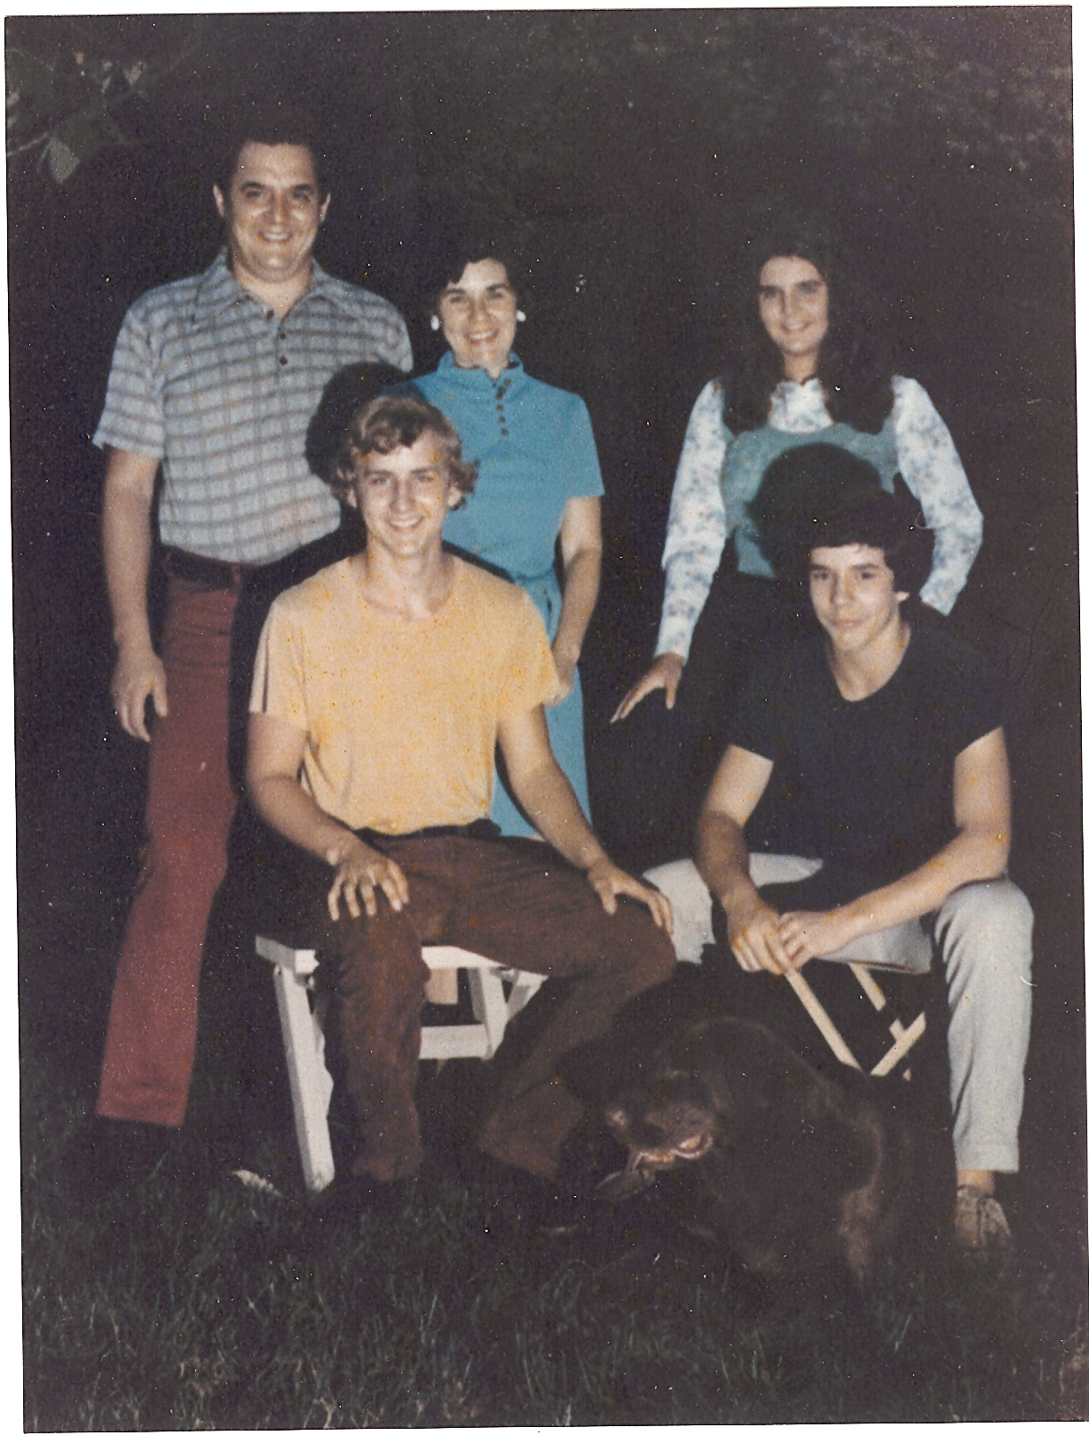 Teen Age Years, with Bruno, 1974 +/-

The Trailer Speaks Up:

I took the boat home and put it back into storage where it sat for some time. The next person to use it was my son, Larry. By this time he was old enough to drive. He called me one day while I was away on an extended business trip and wanted to know if he could use the boat with some of his buddies. I readily agreed. I had kept up the annual registration and I was happy that someone would use it.

The next I heard about it was after I got home from the trip. The boat was gone from the back of the barn. I called Larry and asked how he made out. He said, “Good and, not so good”. Apparently the boat had run fine and he and his buddies had had a good time using it, with no untoward incidences.

However, after they had loaded the boat on the trailer and were leaving the park, the left wheel fell off the trailer! When they examined it they found it to be excessively corroded around the axle bore – so much so that it was beyond repair. They had to leave the boat and trailer, on blocks, at the park. Larry had ordered a new wheel but it had not come in yet.

The wheel came in and, eventually, Larry and I went to the park and put the new wheel on the trailer. We were both busy so we did not put the boat in the water but returned home with it immediately. I did not know it at the time but neither Larry nor I, nor anyone else in my family, were destined ever to ride in that boat again. With that last episode of the wheel, the jinx had bitten us for the last time.

However, that was neither the end of the story, nor of the jinx.

The Bishop:

I brought the boat home and parked it in its place behind the barn where it sat, unused, for several years. By this time the kids had grown and were either away at school or pursuing their own “growing up” agendas. Without them around to share it I had lost interest in the boat. As it sat there the bright blue colors of its “new” canvas and upholstery began to fade. It no longer looked like a newly refurbished boat.

As it turned out, my business was growing and I needed to expand the barn by closing in the area where the boat was stored and expanding the machine shop. I had to do something with the boat. I instructed my then secretary, Mary, to place an ad in the paper. She had a better idea.

Her husband, Bob, was active in his local Episcopalian church. They were having a fair to raise funds and they needed items for their auction. If I donated the boat to the church, I would be able to claim full book value for the donation, which, at the time was $8,000.00. That would enable me to get a 35% income return, or, about $2,500.00. I would have been hard pressed to sell the boat on the open market for that much. Boats were not selling so good at that time. So that was what I did, donated the boat to the church with all its papers denoting a new motor, etc.

The boat was the star of the auction. It sold for $1,400.00. The woman who bought it said it was a birthday gift to her father who was a retiring Bishop of the church. Mary had told me that much of the story and I thought that I would not ever hear of that boat again.

However, a few months later I got a call from the Bishop. It seemed he needed my signature on some legal document concerning the boat. Moreover, it was requested that I be present at the DMV office when I signed the paper. A few days later I met the Bishop at the DMV office in Morristown, NJ.

The office was very crowded when I got there. I met the Bishop and we had to pick a queue number. Our number was way down the list and it was apparent that the wait would be long. He turned out to be a regular guy. We hit it off well immediately. We sat down and began what turned out to be a long conversation. He was a nice fellow. Naturally, our conversation turned to the boat.

I’m paraphrasing but the conversation went something like this:

He said, “Bob, you know I never did want that boat but my daughter was so happy giving it to me that I couldn’t let on that I didn’t want it. We towed the boat to my place on the lake and put it into the water. It started up rather quickly but as I was taking it out into the lake I couldn’t get it to run much faster than an idle speed. No matter what I did it would not work. You know there’s no choke on that motor. Anyway, I took the boat to a Volvo dealer and he installed a new carburetor in it. After a successful test run at his place we put the boat on the trailer and brought it home. Just as I was turning the corner to my house, the strangest thing happened. A wheel fell off the trailer!”

All I could do was to tell him that when I last ran the motor and the trailer, both were in good shape, which was true. I told him to look in the papers that had accompanied the boat and he would find receipts for both a new carburetor and a new wheel.

Eventually he looked at his watch and said that he had a prior appointment and had to leave. He asked me if I wouldn’t mind signing the paper and, then mailing the resultant document to him. I agreed to do as he asked and he left. When my turn finally came up I signed the paper and, that afternoon, and mailed the document to him.

Right after he left, sitting in that crowded waiting room, I busted out laughing out loud. Everyone in the room was looking at me as if I were crazy but it took a while before I could stop laughing. I wished the Bishop no ill will but I was laughing in relief. That jinx had finally left me and was now someone else’s problem! I never heard from the Bishop again, nor do I want to!

Note: I mentioned Al Rosenbohm a couple of times in this piece. He is not part of our family. However, Al and I during our younger years were best friends and constant companions. In a way, Al’s influence to the central theme of this story is substantial. It was with Al and our joint ownership of a 16 foot outboard runabout motor boat that I first attained a liking (perhaps a need) to own and operate my own boat.

Al and I used to work together as draftsmen in Bell Laboratories in Whippany, NJ. As I said we were constant buddies and had been palling around double dating, playing softball in the lunchtime league, bowling, and, most nights, just carousing around in general. We had done this for a couple of years before acquiring the boat. I was about 19 and he was about 24 when he broached the subject of buying one together.

I remember it clearly. We were sitting at our drafting boards one day during our break when he said to me, “Lucky, let’s buy a boat!” (They used to call me by a nickname, “Lucky”, in those days). We saw an ad on the company billboard for a used boat by a fellow Bell Labs employee who lived in Brooklyn, NY. To make a long story short, we went to Brooklyn and bought the boat complete with a trailer to haul it with.

The boat was a 16 foot long, wooden, lap-strake construction hull. Its basic design was identified as a “runabout” and with its integral oak forward decking and its stained and lacquered wooden interior it would be considered as a “classic woodie” today. These were the days before fiberglass hulls had taken over the small boat industry. It was powered by a 25 horsepower Johnson Outboard motor (big for that time) which was steered and shifted from internal cabled controls located at the driver’s seat, mid ship in the boat. It was sleek looking with a modified “V” displacement hull as manufactured by the Old Town Canoe Company. For its time, it was about as good a boat as anything else available in its class.

As soon as we attained the boat we went right to work to put it into excellent shape. We scraped down the entire boat by hand to bare wood and re-lacquered and re-painted it to an “as new” condition. We installed a plexi-glass windshield of our own design. A good friend and fellow Bell Labs draftsman named Otto Wrentsh, who was good at art, painted an original logo on the front of both sides of the hull. The name of the boat, which we had christened “Snake Eyes”, was contained in the logo, along with two dice showing one dot each (“Snake Eyes”). The logo itself showed the name with a snake intertwined between the letters. Overall, the boat was a thing of beauty and Al and I were quite proud of it.

We put the boat in at Lake Hopatcong at the San Bar Boatyard in Mt. Arlington where we continued to dock for many years.. For a couple of seasons as young, single guys, we had a great time with it. We fished and did a great deal of towed aquaplaning with it. Of course we had many double dates with the boat, with various young ladies and, on occasion, one or the other of us would take it alone for a single date. Perhaps the most fun was for Al and I to pull into the docks of the many night spots that existed at the lake at that time. Sometimes we met new young ladies who wanted a ride. Of course we accommodated them whenever the situation permitted.

Soon after, both Al and I met the women of our dreams - the women that we married. He met Ruth Wirden and I re-met Lorraine Chennette. We all worked at Bell Labs at the time. We courted on that boat, sometimes in pairs and sometimes as single dates. I proposed to Lori on the boat, one night sitting, drifting in the middle of the lake. Al and I became the “best man” for each other at our weddings and, as they say, “the rest is history”. Apparently it was the right thing to do.

As of the date of this writing (2011), Lori and I will be celebrating the 56th year of our marriage and Al and Ruthie, who married about a year and a half later, will be celebrating their 54th. Both marriages are still going strong. Another important thing happened between us. Al and Ruth asked me to become “Godfather” to their first child, Janice. This resulted in a close relationship between Janice and I– a relationship that Lori and I hold dearly, to this day..

As our marriages matured and we took on more responsibilities we had less time, and money, available for the boat. Finally, after one complete year in which we had paid to dock the boat and neither of us had used it at all, we sold it.

However, from my good experiences with Snake Eyes I acquired a lifelong attraction to boats. The time I spent with Grandpa’s boat, albeit misguided, was one manifestation of that attraction.

Again, I thought that I would include this last note for the benefit of my grandchildren and those still unborn members of my family who will come in the future. As I noted before, it is important for them to know some of the things that influenced the lives of my generation – the lives of their ancestors.

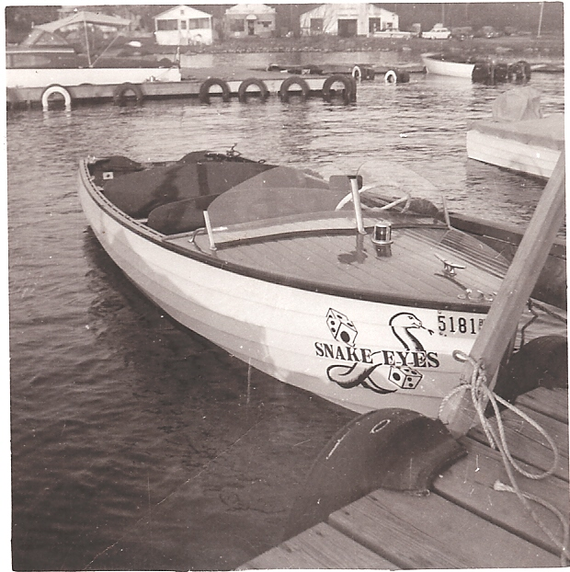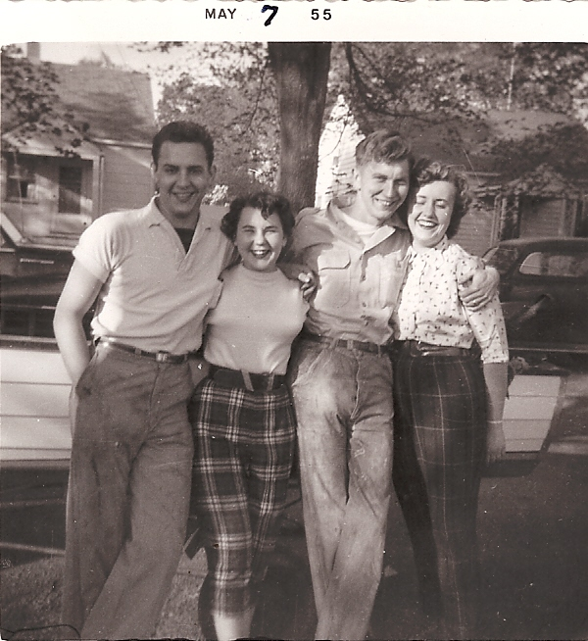

Snake Eyes Bob, Lori, Al, Ruth, 1955

.

