Fishing Adventures on the Rio Negro

Bob Luciano, Sr.

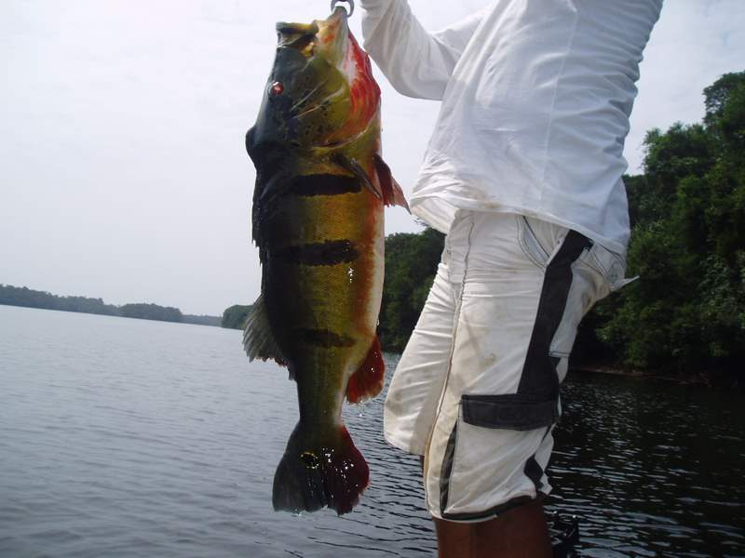 A Prize Winning Peacock!

Some Facts about the Amazon Basin and the Rio Negro Lodge:

The Amazon Basin is one of the last great wilderness areas left on earth. Any realistic description of it must necessarily utilize many superlatives. It is the largest river basin in the world. The Amazon River flows through the Basin. Over a thousand tributaries, in turn, feed the Amazon River. With its tributaries, the Amazon system drains an area of an amazing 2,375,000 square miles – three quarters the size of the continental United States. It carries one fifth of the world’s fresh water out to sea. Its flow into the
Atlantic Ocean is ten times that of the Mississippi River.

The Amazon is, also, the largest river in the world. Its biggest tributary, the Rio Negro River, is the fifth largest. The Rio Negro is classified as a “black water” river. The water is actually a very dark brown in color (very much the color of dark tea). It obtains its colorization from the fine organic sediments suspended in it which release dissolved plant compounds, typically, tannins. The Rio Negro joins the main body of the Amazon River (classified as a “white water” river) in Brazil, just upstream of the area’s largest city, Manaus.

Manaus is approximately 800 hundred miles upriver (as the parrot flies) from the area where the Amazon River estuary joins the Atlantic Ocean. Up the Rio Negro from Manaus it is another 250, miles, or so, to the small river town of Barcelos. Barcelos is the last inhabited outpost into the rainforest jungle for many hundreds of miles in any direction. It is completely surrounded on all sides by thick, untracked and, many times impenetrable, rain forest jungle. From Barcelos it is still another 60 miles upriver to the Rio Negro Lodge.

The Rio Negro Lodge sits on a bluff overlooking the southern shoreline of the river. The lodge, and its immediate environs, is an almost completely self-contained enterprise with regard to its daily food and service needs. It has been carved out of the thick, luxuriant jungle growth that makes up the area. Surrounding the lodge is a compound that contains a small village for its service staff with associated farmed areas for its food needs.

The river waters up and downstream from the lodge are renowned as a haven for world class Peacock Bass fishing. Fishermen come from all over the world to catch this worthy prey. The sole reason for the Rio Negro Lodge’s existence is to provide such fishermen the means by which they can pursue this worthwhile sport. The entire enterprise is exquisitely designed for this purpose.

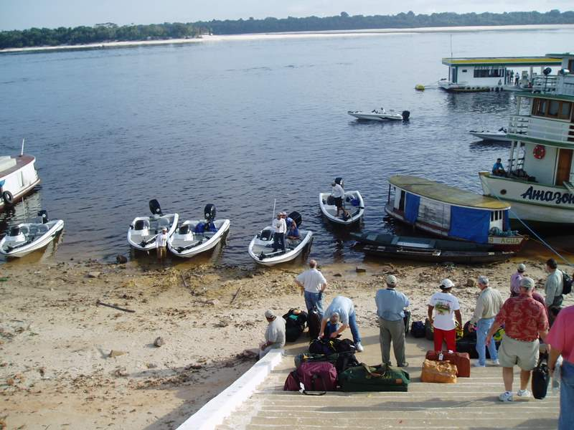Nitro Boarding at Barcelos

The Fishing Adventures:
A Fine Morning on the River: It was early in the morning on the Rio Negro River. This day, the last fishing day of the trip, promises to be fine and clear, but hot. Most days are in February in this equatorial jungle section of Brazil. We have been fishing the area for the past week. The early morning air is very still and, combined with the early morning mists that are still rising from the water; the overall scene has a quiet, smoky quality. We have found the spot of entry into the jungle that we have been looking for - about 45 miles from the lodge. This morning’s trip had begun with the usual, exciting early morning rush in the Nitro boat, this time upriver, at speeds on the water that sometimes reached 45 mph. However, we are no longer in the main river channel and, for the past 15 minutes, or so, we have been going slower, making a winding path around small islands and through narrow channels, penetrating ever deeper into thickening jungle, before we reach this spot. Enrico, my Indian guide for the past week and newly found friend, slowly noses the Nitro bass fishing boat towards a large bare area on the shore line that fronts the dense, green jungle in back of it.
At this time of year the river is low, exposing a continuous strip of sandy/silt, bare ground that rims every shoreline. This bare strip varies in width, from narrow to very wide, sometimes as much as 100’s of yards. The ground generally tilts upward from the waterline to the green edge of the jungle. In other times of the year, when the river is high, all of this bare ground is covered with water but we are now in the dry season. Enrico runs the boat straight onto this bare shore at a point where the beach is very wide; cuts the motor, and we both jump out and pull it forward another few feet, onto the shore.
This morning I’m sporting a scruffy, week’s growth of beard and I’m dressed like a walking advertisement for the adventure travel clothing industry. I am wearing my “Travelsmith” bush clothes: vented light, composite fabric, long-sleeved shirt and light composite fabric, full- length pants that can be zippered off into shorts. On my head is the new “Amazon Adventures” baseball cap that I had been given at the lodge and, on my sockless feet, is a pair of “New Balance, All Terrain’s”. Sun glasses attached with a neckband and a small fanny pack that holds a two sandwich lunch, an apple, a stainless steel “Leatherman” utility tool, sun screen, bug repellent, and two 12 oz. plastic bottles of water complete my outfit for the day. I carry a small, “Olympus” weather proof, digital camera, along with a spare battery pack, in one of my shirt pockets and a small, pair of “Minolta” binoculars in the other.
Enrico is wearing only a long sleeve T-shirt and a pair of shorts. His feet are bare. I’m envious. For the last 6 days, except for the bare feet, I had been similarly dressed and I had really gotten into the easy negligence of it. However, I do not possess Enrico’s immunity to the environmental excesses that equatorial jungle fishing exposes one to; namely, the severity of the sun exposure and the proliferation of mosquitoes that reside in some of the jungle areas we have been fishing. Over the past week the sun has slowly been toasting my body into a deep tan. It isn’t quite a burn yet, but I don’t want to push my luck. Also, this morning, at my request, we are going much deeper into the jungle than we had since the trip started and mosquitoes are sure to make their presence known. Influenced by such rationalizations, I finally donned the full cover-up bush outfit that I had been studiously ignoring since I arrived but had brought for just such an occasion.
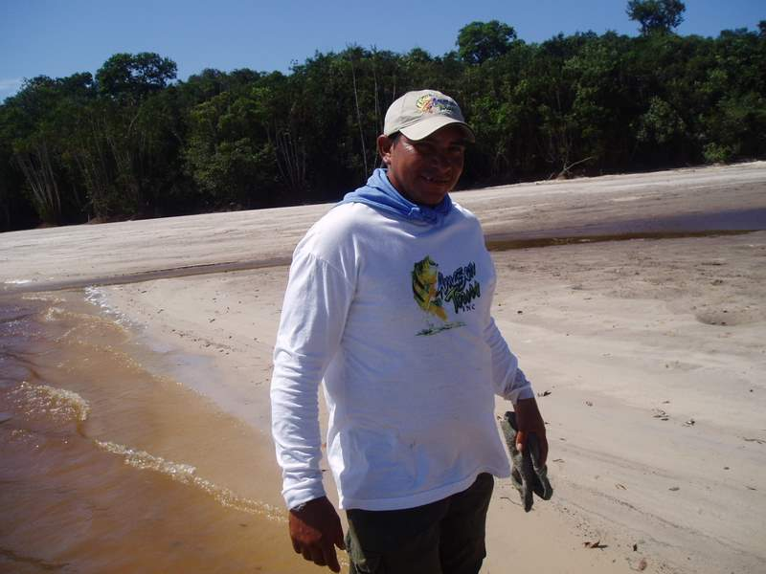Enrico – Ready for a Morning’s Fishing
Enrico jumps back into the boat and ties the lures for the day onto the lines of two fishing rods: my rod, with a 6 inch long, silver spoon type lure and a spare rod, with a 6 inch long, top working, “wood chopper” lure. He puts a spare, golden spoon lure and his clamp-type fish weighing scale into his pockets. He stows the little bit of remaining loose gear that we have into the boat’s built-in cabinets, grabs his machete and jumps out of the boat, handing me the two rods. Without a word and without looking back, he proceeds to walk across the bare, silt soil towards the jungle, which is about 100 yards away. I pick up the two rods and follow him.
We are just about to enter the jungle when we hear two loud, short, coughing roars in the vegetation to the right and shortly ahead of us. Enrico holds up his hand and stops. He then points down to the ground and there, depressed in the sand, is the sharp, fresh impression of a large paw print. He says, “Jaguar”! Apparently the large cat had just passed this way. Perhaps, it had been watching when we beached the boat. Immediately, the hackles go up on the back of my neck, but Enrico just grins. He says the cat is not interested in us. There are many wild pigs in this area and they are the big cat’s main prey, probably the reason why it is in the area. It isn’t interested in us. Small solace! I keep going, following Enrico, but I still keep apprehensively looking around as we enter the jungle. Apparently, Enrico is right though for we never do see or hear any more signs of the Jaguar.
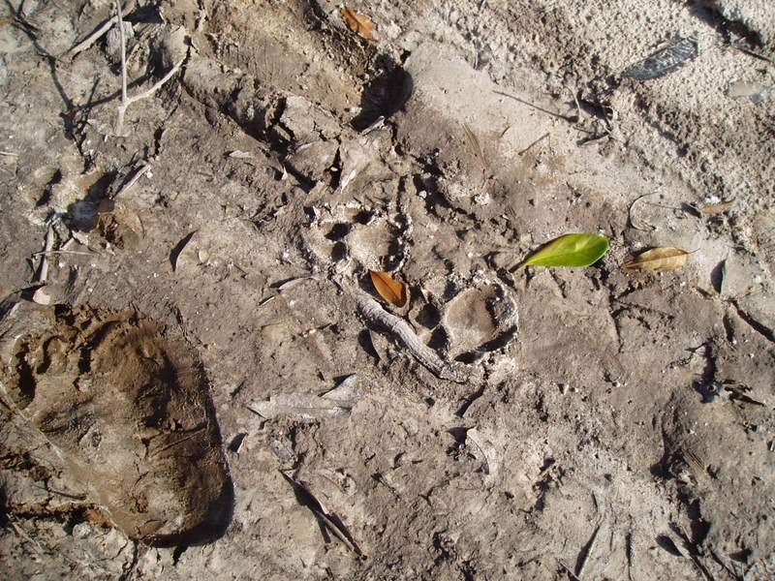 The Jaguar’s Track
The jungle undergrowth is quite thick in spots and there are repeated, intermittent areas where Enrico has to use the machete to hack a trail for us. Everywhere, underfoot, we walk on a thick matting of dead vegetation. Enrico stops again and points to the overhead canopy where the tree branches are waving back and forth. Then, I see them, too. It is a troupe of monkeys moving and swinging rapidly through the tree limbs. They are too far for me to identify by type with my naked eyes and, by the time I get the binoculars from my shirt pocket they are gone. Still, it is thrilling to see the natural wildlife like this, just going about their normal business!
A short while later, he again stops and points overhead. This time I just get a glimpse of a very large bird before it disappears into the tree leaves. However, the glimpse is long enough for me to see a flash of bright red and blue colors. It is a wild Macaw and I see one for the first time in the wild.
We proceed in this manner for, perhaps a quarter of a mile more with Enrico pointing out more of the native fauna as we come across it. We find several large, intricately patterned spider webs with strikingly beautiful, multi-colored, large spiders in residence, some small mole like animals hurrying across the path, and a short glimpse of a small snake. We come upon a trail, which is probably just a game trail because there is no other human habitation for miles, either along the river or in the jungle. This trail, Enrico says, will, eventually, lead us to a small lake, hidden deeply in the jungle. As we are walking, I begin to ruminate about the past week on the river.
Day 1, Getting Started Fishing: To digress a bit, an insight into such jungle lakes and the reasons why I was at this spot, basically alone in the remote jungle, are important for this narrative. Every year, during the wet season, the Rio Negro River rises due to the excessive amounts of rain on and around it. The river floods the adjacent shores, in some areas for miles into the jungle. Fish breed in these flooded areas (Peacock Bass, Piranha, Aruana, and other species native to the river). When the rains stop, the river lowers back to its normal levels and the jungle dries out, returning to its normal, land state. Most of the growing fish return to the river proper with the receding waters. However, some of the receding water is trapped and remains in the lower depressed areas of the land. Thus, these land locked lakes are formed. Inevitably, some of the young fish do not make it back to the river and they become entrapped within the lakes. Eventually, some of these fish grow to truly large sizes.
I had come to the Rio Negro on a pre-arranged trip with my two sons, Bob, jr. (46 years old) and Larry (45 years old) as part of a mixed group of 17 fishermen overall, all intent on catching the giant Peacock Bass that this area is famous for. We have been staying at the Rio Negro Lodge who supplied the week’s lodging and sustenance; the fishing gear and the boats; and, most importantly, the local Indian guides on whom we depend to find the right fishing spots and to provide the local knowledge on how to actually fish for the giant Peacocks.
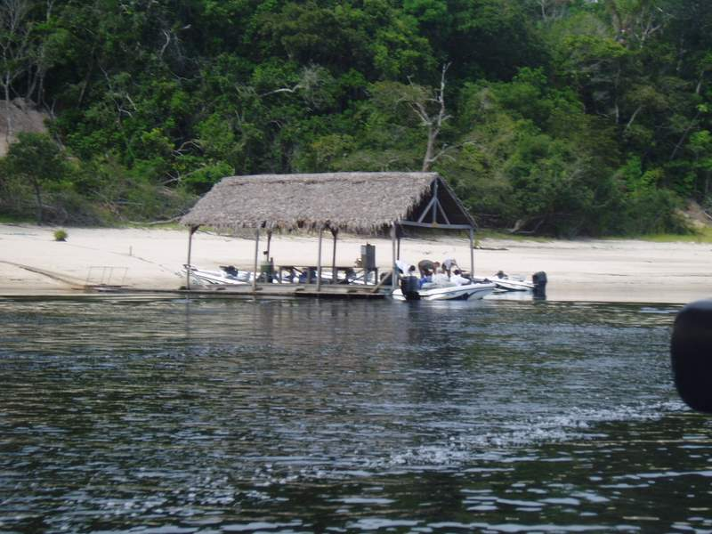The Dock at Rio Negro Lodge
I had teamed up with Enrico on the first day and after some “adjustment time” (for me) on how to use the fishing gear in the correct way to catch the Peacocks, I began to catch a good share of sizable Peacock Bass and many other species of native fish by utilizing his ability to find and take me to the good fishing spots. Enrico and I hit it off well and we found that, despite our severely different backgrounds and differing languages, we were able to communicate well. He spoke Portuguese (and local Indian) and talked to me in sort of a “pidgin” English. I can speak a smattering of Spanish. It proved to be enough.
The drill was for the group to split up into separate parties of two fishermen and a native driver/guide each morning and go out, each party in a separate Nitro bass boat, to fish at spots of each guide’s choosing. The parties left early in the morning and normally each party would fish alone, without seeing any of the others, until returning to the lodge in the late afternoon or early evening
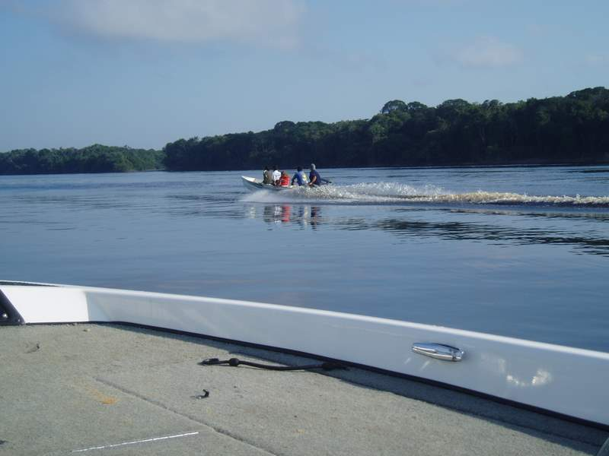Heading Out in the Morning
At the beginning of the trip we each had put money into a pool. There were several ways to win. The highest two total weights of fish each day winning incremental shares of the total, and the biggest fish for the week winning the lion’s share. I had been lucky, early.
The lure in favor, recommended by the guides to catch the largest, trophy sized Peacocks, is the “woodchopper”. This is a top running lure that is retrieved in spurts by rapidly sweeping the rod tip in a manner that makes the lure (about 6 inches long) swim rapidly along the top surface of the water on a staggering path toward the fisherman. In between each sweep of the rod the reel is rewound in a rapid but smooth manner so that the velocity of the lure stays as smooth as possible. There is a rotatable metal “propeller” mounted on the lure that spins rapidly as it interacts with the water it is being pulled through. The faster it is retrieved during each rod sweep, the more furious the “rooster-tail” of water that erupts and it makes a sound like a motor driven “woodchopper”. The theory is that it is this sound combined with the violent turbulence of the water that attracts the Peacock Bass.
Whatever the theory, the lure does work when it is used properly and, to prove it, there have been many world record breaking Peacocks caught with “woodchoppers”; most of them in this same Rio Negro area. The lure is heavy, enabling it to be thrown great distances when casting. A proper technique needs to be acquired to work these lures correctly. In addition, it requires a fair amount of effort to do this repetitive retreiving and by the end of the day it can be very tiring, especially to the forearm.
Surprisingly, the reel that is recommended for this repetitive casting type of fishing is a bait casting, as opposed to a spinning reel, type. I came equipped with a brand new Shimano Type ___ bait casting reel that had been given to me as a present by my son, Larry, just for this trip (My two sons, Larry and Bob are ardent fishermen, they fish more than me, and they both know a lot more about fishing and the gear and techniques required than I do). My problem was that I was accustomed to using a spinning type reel, which entails a much easier operating technique than the bait casting type. It took a while on the first day’s fishing to acquire the right technique.
The result usually attained by incorrect bait casting reel technique is, very often, the creation of a tangled “bird’s nest”. This occurs when the lure hits the water before the reel stops spinning; thus the fishing line has no place to go and it just keeps blooming outward and tangling within the reel cage. The way to stop the reel from over-spinning is to hit (close) the bail at just the right instant as the lure hits the water. It is a technique that takes a bit of practice to master.
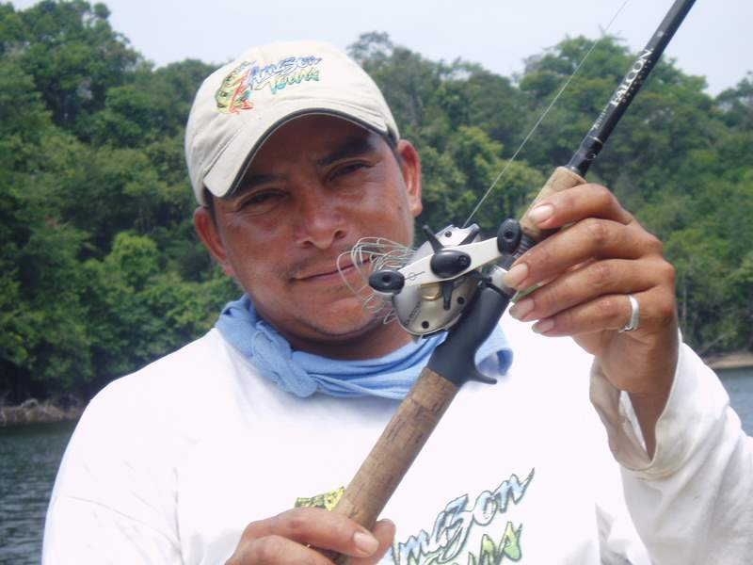My Reel with a Tangled “Bird’s Nest”
During the learning process it is not unusual to experience a high frequency of “bird’s nests” occurrences. “Bird’s nests” are usually very visible, difficult to untangle, and they are, also, usually the cause of much derisive merriment among one’s fishing companions. In the beginning stages of the trip I was able to contribute a good share of these events for the further enjoyment of my fishing companions.
On the first day’s fishing I was teamed with my son, Bob, Jr. Enrico was our guide and Nitro boat operator. It was an abbreviated day because of our late morning arrival at the lodge; hence, we didn’t start fishing until after 1:00 PM. Phil Marsteller, the owner of the lodge and our host, had lectured us that these first, few hours on the river were principally meant as a primer, for familiarization with the area and learning the fishing techniques necessary for the “serious” fishing that would begin the next day.
The typical way of fishing for the Peacocks is to drift fish along the shoreline about 50 to 100ft out, allowing the current to bring the boat and the lures past the chosen spot where, hopefully, the big fish are lurking. During the drifting the proper fishing technique is to repeatedly cast the lure in towards the shore and retrieve as prescribed, presenting the lure as closely as possible to the selected target area (i.e., a pile of brush, a snag, etc.).
Standing up in the back of the boat and using “woodchopper” lures, Bob and I both proceeded to fish in this manner while Enrico piloted the boat. Bob took to it right away, throwing out long, accurate casts and retrieving the lures with strong, rooster-tail and noise producing, rapid sweeps. My approach was somewhat more problematical. My best casts were probably about 85% of the length of Bob’s. The casts were accurate enough but the retrievals were neither as crisp nor were the noises they produced as well defined as his. With all of that, my casts were probably good enough if it weren’t for the “bird’s nests”. In the beginning it seemed like every third or fourth cast produced the dreaded “bird’s nest”. It took time but I managed to untangle most of them by myself and I was slowly getting better at it (possibly one nest out of every 20 to 30 casts). A couple of the nests were really bad and Enrico had to help me clear them. He did it, however, with unaffected good humor and we shared some good laughs and jokes (in Pidgin English) about them. I liked him and we started to bond almost immediately.
In the first hour, or so, the action was really slow, to non-existent, and we moved to new sections of the river several times without any better luck. The only thing that happened during this time period to break the monotony was that Bob’s rod suddenly, and inexplicably, broke into two pieces. Bob had just been casting with it, in the proscribed manner, when it broke. He had done nothing wrong. It was a boat rod and, apparently, it was just worn out.
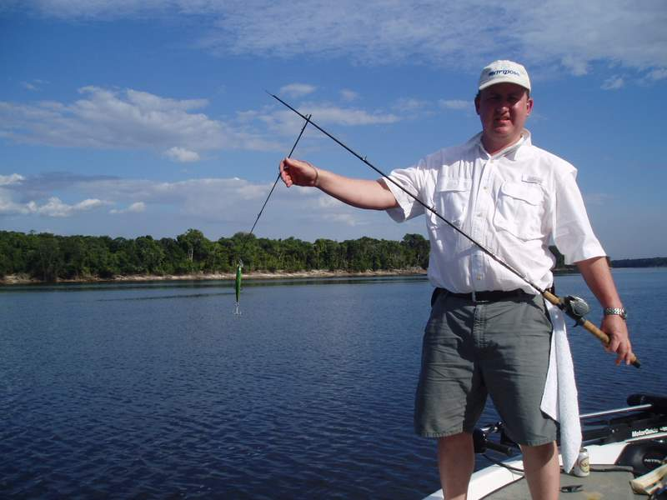Bob’s Broken Rod
I began looking wistfully at the passing jungle and was itching to go ashore to explore it. Also, I got tired of the “woodchopper” lure. It was a lot of work and I was slowly losing faith in its efficacy to get the job done. Finally I asked Enrico if there wasn’t any other type of lure that would work, for instance a shiny, reflective, spoon type. It seemed to me that such a lure might be easy for a fish to spot in the dark brown waters of the Rio Negro. If I had one I would have tried either a large “Daredevil” or any similar type of shiny, silver, spoon type lure.
Enrico gave me a kind of secretive but happy smile, reached under the deck, and produced what proved to be a 6-inch, silver, spoon lure. After I got to know him better I found that he was very partial to this particular lure and he preferred fishing with it, himself, when he fished on his own for “food” fish to feed his family. The lure is very effective in catching the Peacocks although the “woodchopper” still seems to be the more consistent one for the really big Peacocks (over 20 pounds). However, the further attraction of the spoon lure is that it consistently catches a greater variety of fish that are native to these waters, such as the smaller, but succulent Butterfly Bass, Piranha, Cara, Aruana, etc. He changed the lure for me and went back to steering the boat, which he brought somewhat closer to shore. I soon found out why because, while I could still cast the new lure a good distance, it was only about 2/3 as far as I had been able to cast the “woodchopper”.

During this time Bob had kept fishing with the “woodchopper” (attached to a new rod) and I could tell by his demeanor that he thought my actions were not a good idea. After about my 4th or 5th cast he started to tell me that I should have stayed longer with the recommended “woodchopper” and proceeded to lecture me on being impatient, why the new type of lure was not a good idea, that I would miss out on catching fish, etc.
During this lecture I felt a definite tug on my line. The tug became persistent and I set the hook. It was a good battle. There was definitely a big fish on the end of the line! It made a good-sized, sustained run and, for a while, we had a standoff battle, with the fish intermittently stripping off as much line as I was able to gain. Eventually, it tired and I was able to bring it to the boat. Enrico removed it from the water. It had been a good fight that proved to be the forerunner of many in the following week.
It proved to be a big Peacock and I don’t think that I have ever seen a more colorful fish. It looked really big for a fresh water species. The basic color is bright gold, morphing into a dark green color on top and into a brilliant red color on the bottom. Its fins are a bright red and its general shape is that of a very large, large mouthed bass. There are three very pronounced, vertical black stripes on each side as well as two bright yellow ringed, irregular black spots on each side – one on the tail and one on the head. The eyes are large, bright red circles with very pronounced, jet-black pupils in the center. It weighed in at 10.5 pounds! I held it up while Enrico took my picture holding it and then, we released it, as we would all the rest of our catches during the ensuing week.
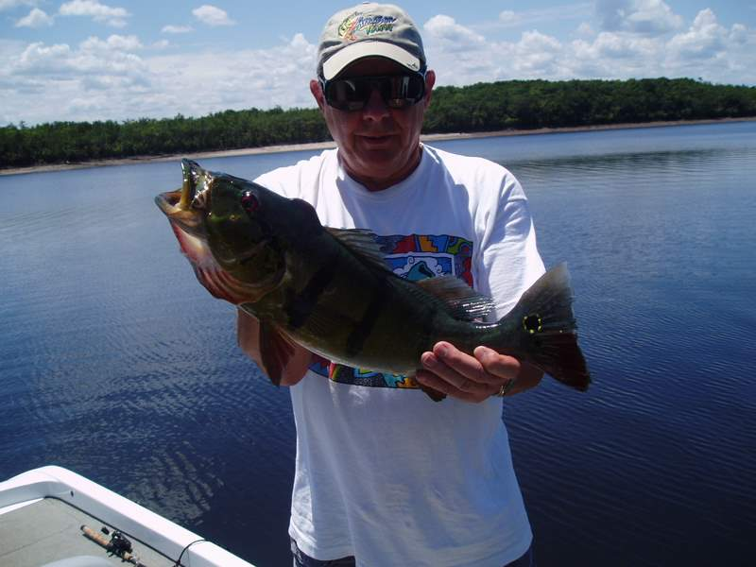 A 10.5 lb Peacock – My First!
We resumed fishing for a while in the same manner but, again, the action was slow – not so much as one bite. Enrico suggested that we move and this time, instead of casting, try trolling in another spot that he knew. We agreed and, when we got there, he changed Bob’s lure to a gold colored spoon similar to the silver lure on mine. We proceeded to slowly troll along the new shoreline, dragging the two lures behind the boat. After about 10 minutes I got another hit, Enrico slowed the boat, and I set the hook. This one felt big, also, but not as big as the first one. A very spirited fight ensued and we had a good tugging match before I landed it. The Peacocks were proving to be really exciting game fish! When we got it to net, it was a good-sized Peacock that weighed in at a very respectable 6.0 pounds. After another photo taking we returned it back into the water.
We trolled for a while longer without much action except that, at one point I felt a slight tugging. I asked Enrico to stop so that I could check my line, which he did. When I pulled the line in there was, indeed, a small fish on the end of the line. It was about 10 inches long, had a long thin shape and it resembled a very large sardine. When we opened its mouth, however, it was like no sardine, or other small fish, that I had ever seen. It had a full set of long, needle shaped teeth that were reminiscent of a vampire. It was kind of scary. I nicknamed it the “vampire fish”. As I was later to find out, the possession of an extremely dangerous set of teeth or other formidable attack armament was a phenomenon typical of this jungle area.
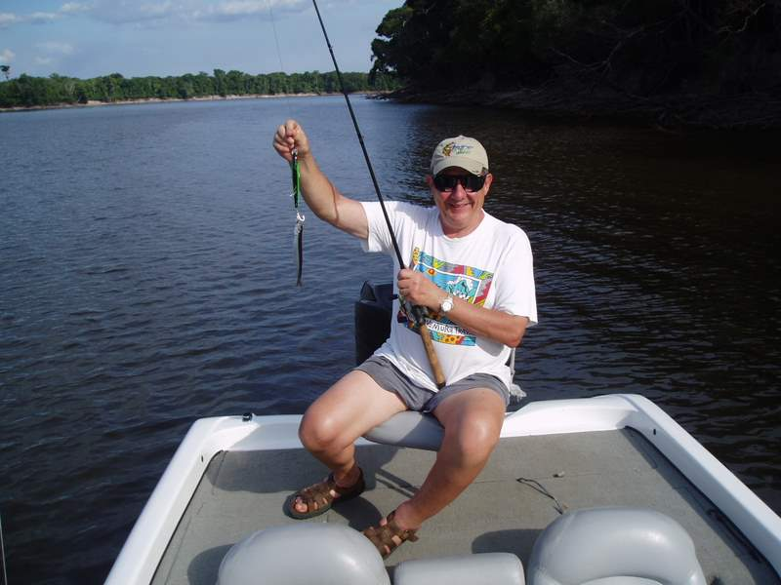 Not a Money Winner!
The jungle is a mean place and there are many species, both plant and animal, that, at first glance, seem to be benign but on closer inspection prove to possess either mean looking teeth or sharp spines that are used for either protective or carnivorous purposes. For instance, when in the jungle it is not wise to grab hold of any plant or tree limb without first inspecting it, as many plants contain protective thorns or spines, some of which might even prove to be poisonous.
By this time the shadows were growing long and it was time to return to the lodge. That evening at cocktails everyone in our group of 17 fishermen signed a sheet denoting their catch of Peacocks (and their collective weights) for the day. At 16½ lbs., I discover that I was tied for the day’s lead and that I had won $125.00. I kind of smugly noted to my sons that it was not too bad a day’s work for an old man who was using the “wrong lure” and prone to producing “bird’s nests”.
Day 2, The First Jungle Lake: After dinner I walked down to the dock where the Nitro’s were tied and found the dock-master. He is an ex-patriot gentleman of European origin and he speaks a fluent, but accented, English. He is very knowledgeable about the river and how to fish it. Consequently, he is the one who assigns the boats and guides and gives them any instructions on where and how to fish for the day.
I had recovered from knee surgery not too long before and I had found it uncomfortable being cramped up in the boat, unable to exercise the knee, for hours at a time. In addition, overland trekking in faraway places is one of my hobbies. I was really interested in experiencing the jungle. I asked the dock-master if there was any way that I could fish from land, at least part of the time, without missing too much of the good fishing for the trophy sized Peacocks.
He was really encouraging and he proceeded to describe to me the land locked lakes and the presence of the good-sized fish that were trapped in many of them. He did warn me, however, that many of the lakes were located a good ways inland from the river and that access to some of them might be arduous, sometimes entailing long stretches of breaking new trail through the jungle, many bouts with mosquitoes and insects, and, sometimes, wading through water and mud. I got the feeling that he wasn’t trying to frighten me, so much as; he was letting me know that the jungle can become extremely uncomfortable at times. However, I was anxious to experience the true flavor of the jungle and, in a perverse sort of way, it actually all sounded pretty inviting to me. I asked him if he thought that Enrico would be a good guide for this type of fishing. He replied that Enrico would be a really good choice and he assigned him to me, on the spot.
The next morning I departed the dock with Enrico as my guide/boat driver, accompanied by Bruce, a fellow fisherman in our group and a friend of my son, Bob. Our first stop was a land locked lake; about 25 minutes’ ride upriver. The lake started about 30 yards in from the riverbank. It was a long narrow lake that ran straight for about 100 yards to the edge of the jungle where it curved out of sight, to the right.
Bruce was a fly fisherman and he came equipped with his own rig. We started fishing at the point of the lake nearest to the river and Bruce was the first to get his line into the water. He was good! It was a pleasure to watch him, as he efficiently laid out the line in large, gentle, rolling loops with the easy grace of the experienced angler. On his second cast, while I was still rigging up my line, he got a strong hit. The action was fast and furious as he worked the fish on the lighter fly rod, continuously keeping the rod upright as it bent almost double under the dynamic load of the fighting fish. After a hard fight, that included several serious runs, the fish was brought to net. It was a good-sized, brilliantly colored Peacock that weighed in at 7 1/2 pounds, quite a load for Bruce’s lighter equipment. I took his picture with the fish and, then, we released it back into the lake. What a nice way to start the morning!
I fished near Bruce for the next 10 minutes, or so, with neither of us getting so much as a bite. Enrico beckoned to us to follow him and, then, turned and strode out along the lakeshore toward the jungle. I reeled in and started out after him but Bruce elected to stay where he was, influenced, no doubt, by his early success.
The way, at first, was easy as Enrico and I walked on firm, open ground along the lakeshore. However, when we got to the point where the lake bent into the jungle, things changed. The way ahead became a wide mudflat that stretched ahead for about 50 yards, or so. The mudflat was bounded on the right by the lake and, on the left, by thick, impenetrable, jungle brush. There was no other way but to go straight forward which Enrico, about 10 yards ahead of me, did with his bare feet sinking into the mud, slightly above his ankles with each step. I ruefully looked down at my almost new “New Balances” and thought, “What the Hell! In for a penny, in for a pound.” I stepped into mud that flowed over my shoes, up to my ankles, and proceeded to plod on after Enrico.
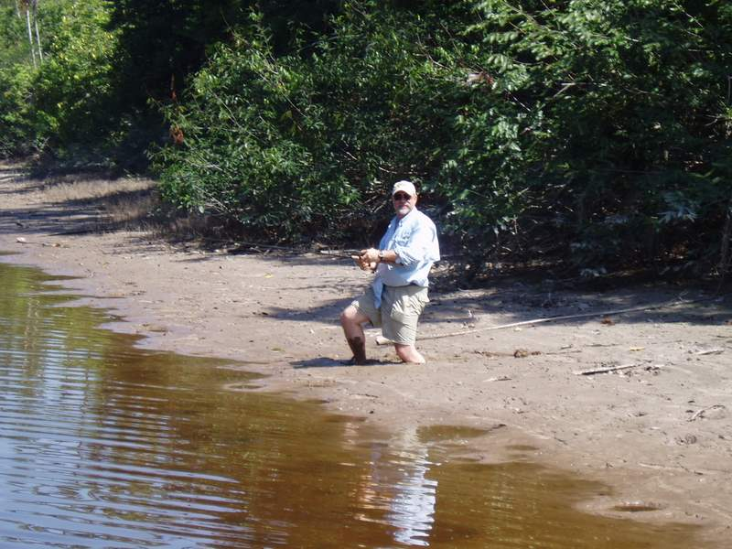Bruce – In the Mud
On the other side of the mudflat the bare ground along the shoreline was very narrow. It varied intermittently between 15 feet wide to points where it disappeared altogether and the jungle came right up to the water’s edge. At such points we were forced to enter the water and wade through until the bare shore opened up again. In some ways it was okay, since, even though I was still sinking in the mud, the water washed most of the excess mud off of my shoes as I came back ashore. We traversed the shoreline in this fashion for a short distance when Enrico came to a halt at a spot where there was about 10 feet of solid, bare ground with overhanging trees between the water and the Jungle’s edge. He said, “We fish here”.
I looked around. The lake was about 150 feet wide at this point with the water running right up to and into the jungle on the opposite side. The immediate problem was that there was not enough room behind/above me to make a back cast without entangling the line in the overhanging tree branches. There was no other solution but to wade out into the water another 15 feet, or so, which I did. Enrico pointed in a direction of about 45 degrees to my right and indicated by hand motions that I should first cast in that direction and, then, on successive casts, work a pattern around towards the left.
I proceeded to do this, casting out the lure towards the opposite shore and working it back in with strong, intermittent retrievals. With each cast I rotated about five degrees to the left. It didn’t take long! On the third cast there was a strong tugging on the line. It felt different than the tug of a bass that I had experienced the day before. It’s hard to describe but, while it was as unrelenting as the tug of the bass, it was, at the same time, more vibrant. It seemed to be “moving” more, with more back and forth sideways motions as opposed to the continuous run of the bass. Suddenly the fish jumped clear of the water and “stood” on its tail, trying to shake off the lure. It was a very different looking fish than a bass!
The tail of the fish was strange. Instead of flaring out into two separate, finned points as all common fishtails do, this fish’s tail tapered to a rounded, single finned point, reminiscent of a spade! It was my first encounter with an Aruana, a fish that is native to these Amazon waters. As I found out later, its biggest claim to fame is its ability to feed directly from the limbs of overhanging trees, which it does by vertically leaving the water and “standing” upright on its tail as it feeds from the overhanging branch. It fought valiantly and hard for a short time and, then, it quit. It was completely spent as I reeled it in.
We didn’t weigh it but it looked to be about two to three pounds. It was as strange a fish as you will ever see! As a species it has an almost prehistoric look about it. With its single “spade” tail and its entire rear body rimmed with a continuous fin, its general shape resembles a cross between a fish and a large, foreshortened eel. This first catch proved to be the beginning of a great day of fishing, one in which I caught not only a good string of respectfully sized Peacocks but, also, several other varieties of different looking species of native fish.
About two casts after catching the Aruana there was another hit! This time, while it was a strong hit, it definitely was a smaller fish than my previous Peacock catches. It put up a good fight but, finally, it gave in earlier and easier. It turned out to be a different, but similar, species of bass than the Peacock. Enrico called it a “Butterfly” Bass and he looked at it with happy eyes. It weighed in at just short of three pounds; perfect eating size! This one we did not throw back. Enrico set it up on a short trotline for later retrieval. It was destined to become a welcome treat for dinner for him and his family.
I resumed fishing and proceeded to have a most amazing morning. In addition to the two previous fish, my catch for the morning included two 9 lb. Peacocks, two 5lb. Peacocks, two 3 lb Peacocks, the 3 lb. Butterfly, two smaller (approx. 1 lb.), menacing looking fish with very large, sharp teeth that we nicknamed “barracuda”, and some small piranha.
There was one downer! We took the first 9 lb. Peacock off the hook and, after a short, joint appreciative look at it Enrico proceeded to throw it back in without weighing it. I yelled for him to stop, but not soon enough. I was pretty sure of the weight, though, because, later, I caught one of the same sizes, and it weighed in at 9 lb. Enrico looked at me, somewhat perplexed, since the fish was definitely not of trophy size. With our limited Pidgin English I just couldn’t seem to get through to him the requirements of our group’s daily pool which would only recognize correctly weighed fish. This was in spite of the fact that I had already shared with him 10% of my winnings for the previous day. He was very appreciative but, apparently, he didn’t recognize the significance of it. However, I made sure that we weighed every Peacock from that point on whether he understood why, or not.
One good thing about fishing is that it serves as a great leveler within the intimate group of fishing companions. Once into the daily rhythm of pursuing the fish, such concepts as “class pecking order” blur. It really becomes unimportant who you are and what you do in your normal daily life, how much money you’ve made, how big a house you live in, etc. Instead, the biggest determinant of importance becomes the mastery of the fishing art and, ultimately, who is catching the most and largest fish. Under these guidelines Enrico became the maestro by virtue of his direction of the daily activities. He became, in every sense an equal, if not, more than an equal, in all of the days’ events and inter-relationships. There was no question about it. He was highly successful in an area that I, and my companions, wishfully wanted to excel in and he gained our mutual respect because of it.
Sometimes, however, an event will happen that brings home the realities of life in a dramatic way. Such an event occurred that was very thought provoking to me and showed just how fortunate my lifestyle was compared to Enrico’s, despite all of his great skill in, and mastery of, what he does.
In a way it was a simple event. Because of the fishing success that I was having I asked Enrico to go back to get Bruce, which he did. Bruce began fishing about 50 yards from me, in a spot where the lake narrowed down. He had changed to a bait-casting rod and reel and was fishing with Enrico’s other lure, the golden spoon. As it happened, being fresh off of a fly casting rod, he wasn’t quite used to casting the heavier spoon lure and the greater distance a cast with it would travel. On one of his first casts the lure traveled all the way to the opposite shore and became entangled in some downed tree limbs that protruded above the surface of the water. Try as he might, no amount of tugging and working of the line could free it from the tree limb. Finally, in desperation, he gave a mighty pull, designed to either free it, or break the line. The line broke and the lure disappeared under the water.
Enrico had seen none of this. As I came to recognize, his style was to get us fishing in a spot and, once we started to catch fish, he would move ahead to find the next promising spot. He had been on such a scouting expedition during the entanglement episode. Bruce called him and started to trudge toward him with the rod and its broken line, asking him for another lure. When he saw the broken line, Enrico became visibly perturbed.
He asked Bruce to take him to exactly where the incident had occurred. When he got there Bruce pointed to the protruding tree limbs near the opposite bank. Without hesitation, Enrico immediately dove into the water and swam to the other side, a distance of some 100 odd feet. This was the same water that I had just caught the menacing “barracudas” and piranhas in! When he got to the tree limbs he commenced diving, looking for the lure. On each successive dive Bruce would direct him forward or back trying to recollect the exact spot. Finally, on the 6th or 7th dive, Enrico emerged triumphantly holding up the lure over his head with the loose line trailing it. He swam back, stripped and threw away about 20 feet from the line on Bruce’s rod, and retied the lure. The incident was over and we resumed fishing.
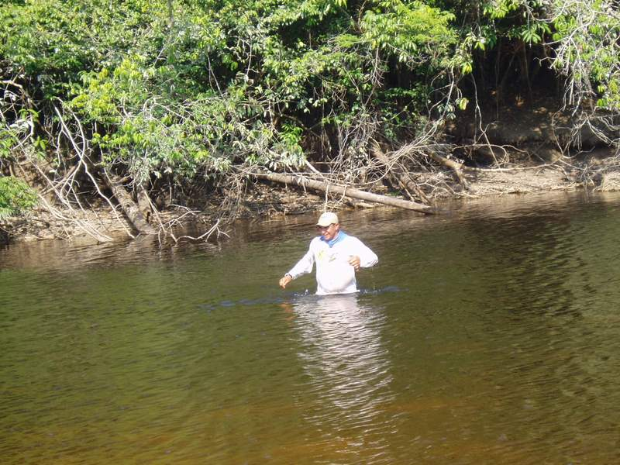Enrico – Rescuing his Lure
Later, over some Jack Daniels “on the rocks”, Bruce and I reflected on the incident. Neither of us liked losing a lure, especially, a larger, more expensive one. It is not quite as bad to lose one as a result of a battle with a fish but it is especially frustrating to lose such a lure in a fruitless battle with a tree limb. However, such things do happen and, when all is said and done, it is just another, inevitable price to be paid in the sport of fishing. Philosophically, one has to accept such incidents and move on, or else, the joy of fishing becomes diminished.
Not so for Enrico, however. With him, this lure is part of the tools of his trade – a very important and hard to come by part in his world. It would be hard to imagine a circumstance wherein either Bruce or I would dive fully clothed into any waters, not to mention piranha infested waters, just to retrieve a fishing lure. For Enrico, however, the loss of such a lure constituted a major threat to succeeding in his vocation and his ability to put food on the table of his family. In such a situation, the danger was secondary and probably did not even enter into his thought processes. What we consider to be sport and engage in solely for pure enjoyment is, in reality, much more of a life and death struggle for Enrico.
Overall, it was a good lesson in comparative values and the things that are really important in life! If I did not have it already, the incident gave me a lot more respect for Enrico and his people and their personal struggles to provide for and keep their families alive and well.
The Amazon Queen: Bruce and I had agreed, before leaving in the morning, that we would return to the lodge at noontime because he had to make a business phone call. (Especially during the first few days of the trip, both Bruce and my son, Bob, had a lot of trouble separating themselves from their business lives. Neither one seemed to be able to get away from their dependence on the telephone.)
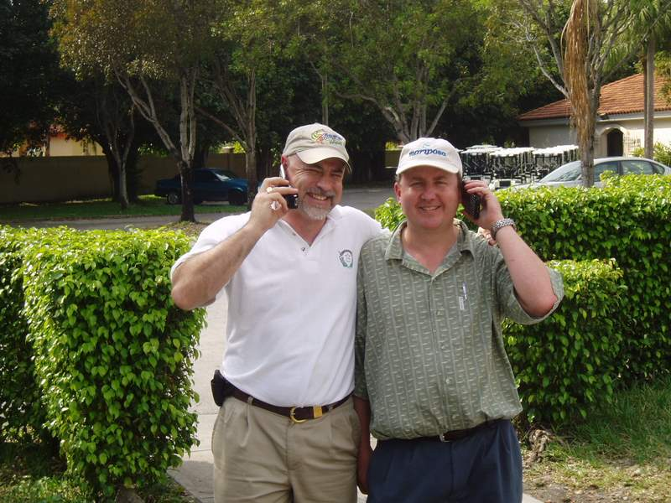Bruce and Bob – Telephone Buddies
Bruce and I had had a superb morning of fishing on this first morning of the trip and our appetites for the Peacocks had definitely been whetted. We were both anxious to get the business part over with so that we could get back on the river for an afternoon’s fishing. However, it was not to be. While we did not get to fish, the afternoon did produce an unexpected, surprise adventure of another type. It turned out to be a different, unexpected event that resulted in a most interesting and memorable afternoon.
Upon arriving at the dock of the lodge we ran into Phil, the owner of the lodge. He was immediately friendly; asking about our morning’s fishing, and such. He asked if we wanted to take a plane ride with him down the river where his boat, the Amazon Queen, was grounded on a sandbar.
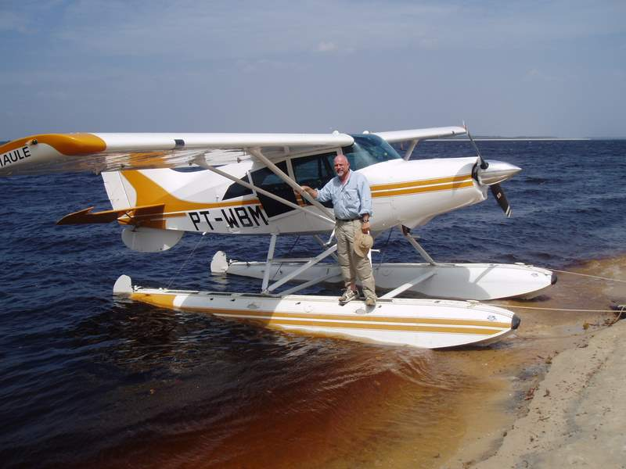 Phil’s Plane
Both Bruce and I jumped at the chance. It would be an opportunity to fly over many miles of river and uninhabited jungle at low altitudes with our own, personal pilot – an unexpected bonus that was not part of the advertised itinerary. Phil said he would be ready to go in about an hour. He first had to attend to a matter in the lodge village’s medical commissary. One of the fishing guides was in there with a woodchopper lure firmly implanted in the top of his head. Phil wears many hats and one of them is as resident medical technician. The task fell on him to remove the lure.
We had time enough for Bruce to make his telephone call and, for a good lunch at the lodge, consisting of sandwiches and a welcome cold beer. Afterwards, we met Phil at the dock and boarded his four seated, single engine floatplane. Bruce and I were the only passengers, with Phil piloting the plane. He was a good pilot. Flying over the jungle was superb. We were many miles from any civilization. Looking down at the tops of the jungle all one could see was an unending savannah of green that was made up of the tops of the rain forest trees. It went, basically unbroken, for as far as the eye could see, in every direction. The only break in the greenery was the wide gash made by the Rio Negro. Except for an occasional riverboat, the Rio Negro, too, was undisturbed as we followed it downriver. In a lifetime that has included many treks to remote areas of the world I don’t think that I ever felt so far, and so pleasantly, removed from meaningful civilization.
From our flight altitude (probably no more than 1,000 to 1,500 feet) the Rio Negro lived up to its name. At water level it is actually a dark brown in color but from our altitude the basic color of the river appeared to be black (i.e., Negro). At this time of year, with its low water levels, there were many long areas of pure white that were interspersed along its edges with the green jungle. These were the sand beaches and the sandbars exposed by the low level of the river in this dry season. Along the edges of the sand the water takes on a reddish color that, as the water progressively deepens into the main riverbed, morphs into the black color of the main river.
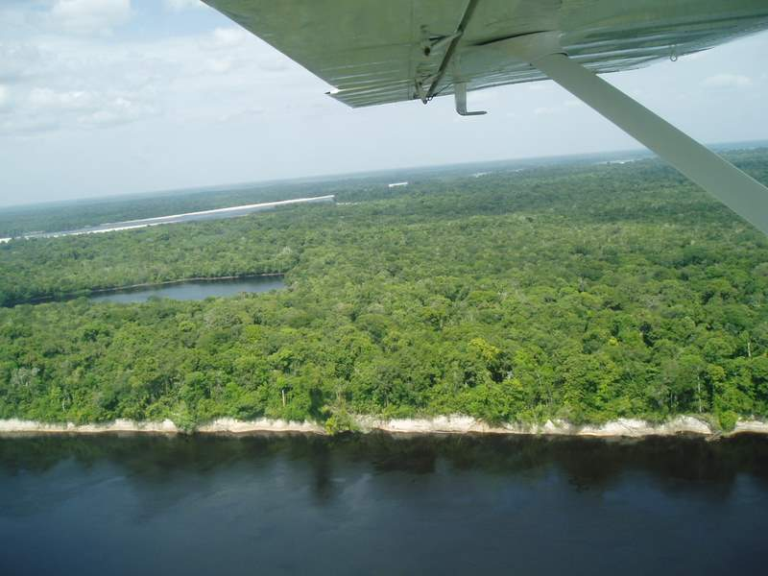Black Water, White Sand and Green Jungle
After a flight of about 30 minutes, we came into sight of two miniature appearing boats, each parked and spaced along the edge of a wide sandbar in the middle of the river. One was the Amazon Queen and the other one turned out to be the boat of, what Phil called a “Johnny come lately” competitor. Phil explained that it was an unusually dry year, that the river was still receding, and that it would continue receding for several more weeks. If he didn’t get the Queen upriver right away, past this low spot in the river, it would be too late and the Queen would miss a whole season of fishing. The good news was that, even while we were flying to meet her, the crew of the Queen had freed her from the submerged bar she had been trapped on and she was now floating free, moored to the side of this larger, exposed, mid-channel sand bar.
We landed and grounded the plane on the sand bank in back of the Queen and proceeded to walk along the sandbar to her. The captain met us halfway and informed us that directly ahead of us, upriver, there was a maze of submerged sandbars that were too high for the minimum draft of the Queen. He had gotten the boat hung up on one before, eventually, freeing it. He and Phil quickly got into a confab about strategies of what to do. They decided that it was in order to take a flyover of the area to see if they could determine the best directions for a channel through the maze. In the meantime the Captain had radioed in one of the Nitro’s that had been out fishing to come in and help with the piloting.
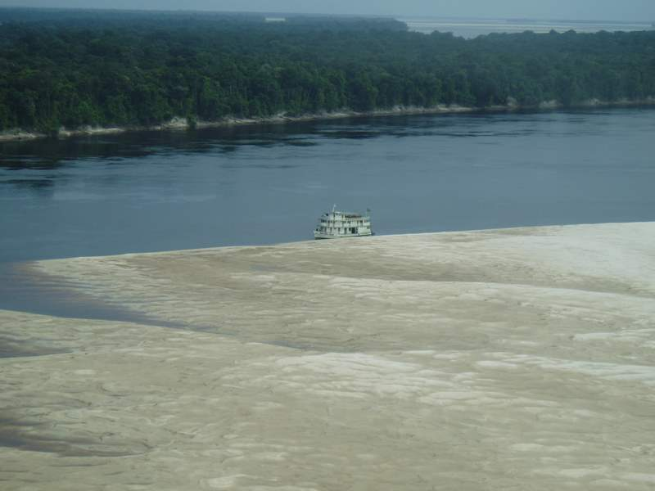Amazon Queen – At the Sand Bar
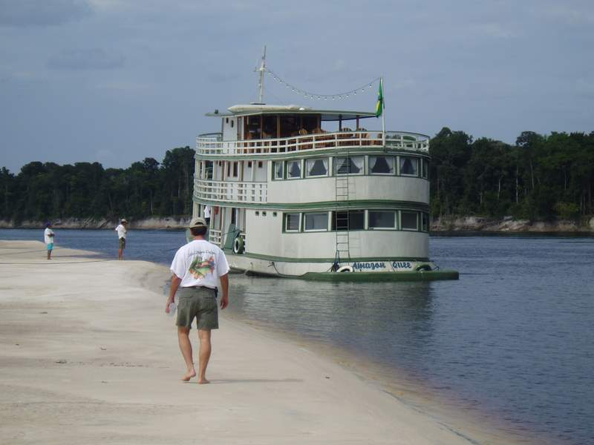 Phil – Heading for the Amazon Queen
Phil told Bruce and I to go aboard the Queen while he and the Captain were making the reconnaissance flight. He informed us that there was a well stocked bar on the sundeck and a fully stocked kitchen below. There was also a steward to help us if we needed it. We were to make ourselves at home. “How good does it get?”
The Amazon Queen is an 85 foot, three level boat that Phil advertises as a “floating resort” with air conditioned cabins, private baths, a full kitchen, and all the amenities necessary for good comfort after a hard day’s fishing. It is built in the classic jungle riverboat style and Phil has had it completely refurbished and strengthened for hard use on the river. It takes a total of 15 client fishermen plus the guides and the crew for weeklong, self-contained fishing trips on the river. It tows a total of eight Nitro’s behind it during the nights when it travels from one spot to the next. During the day the clients fish the river on the Nitro’s and return each evening. All of the boats, except for the one recalled Nitro, were out fishing when Bruce and I boarded.
We went directly to the open top deck so that we could observe all of the goings-on. Fortunately, as it turned out, this is also where the outdoor lounge and bar are located. One item of information that I should add is that the price of the week’s fishing included a continuously open, fully stocked bar, provided gratis by the house. This welcome feature applied on the Queen, as well as, at the lodge. As if by magic, a youngish looking native person in a white serving jacket appeared and asked us for our drink preferences. I looked at Bruce and, after some discussion, we both chose tall Marguerites with lots of ice. The steward made them and they were perfect! With drinks in hand, we sat in the lounge chairs and proceeded with our job of observing the boat piloting actions. The plane took off and proceeded upriver, circling back and forth in its efforts to locate a clear channel.
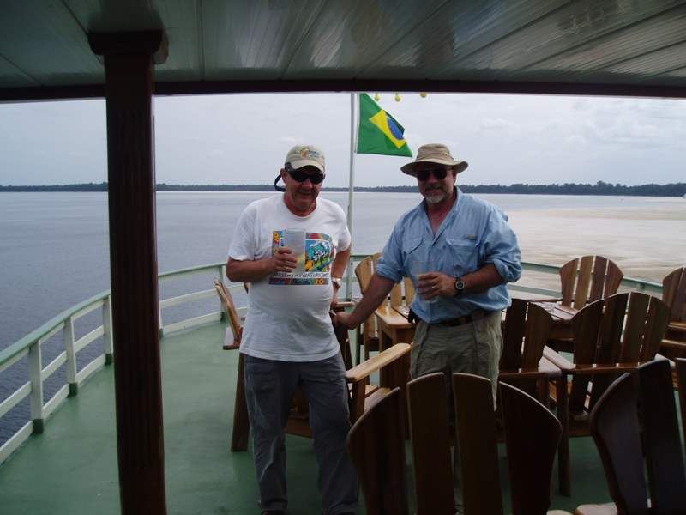 Tough Life – but someone has to do it!
While this was going on, some native riverboat traffic began to appear at widely spaced intervals. The riverboats were interesting. Most were of a long, broad canoe type, powered by a small outboard motor that had a greatly extended, trailing drive shaft to power the propeller. Some had whole families aboard – from little ones to older grandparents. All were dressed in the native clothing distinctive to the area. Most of the boats also had flimsy types of enclosures (i.e., cabins) mounted on their decks for shelter and/or storage. All of the people were friendly with much waving and talking back and forth with the Queen’s crew as they went past.
Upon learning of our plight, some of the boat captains offered to, and did, show us where the clear channels were on their way upriver through the sandbar maze. This well intended advice was of negligible assistance, though, since the Queen needs a minimum of 5 feet of clearance for her draft and the typical riverboats’ needs were, typically, only in the order of 2 to 3 feet. Places where the native boats could pass with ease could become traps where the Queen would become hung up in the bottom sand. With all of these goings-on, Bruce and I, with drinks in hand, moved down to the bridge on the second level in order to better take in the action.
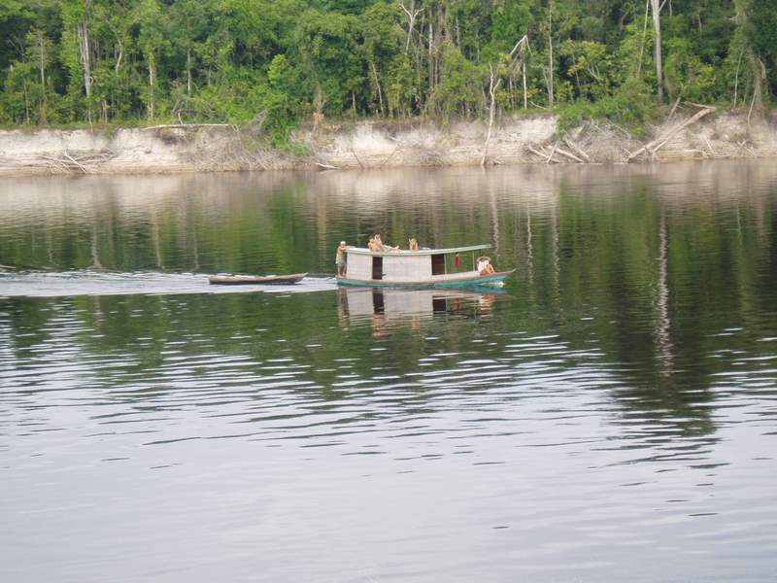A Local Family
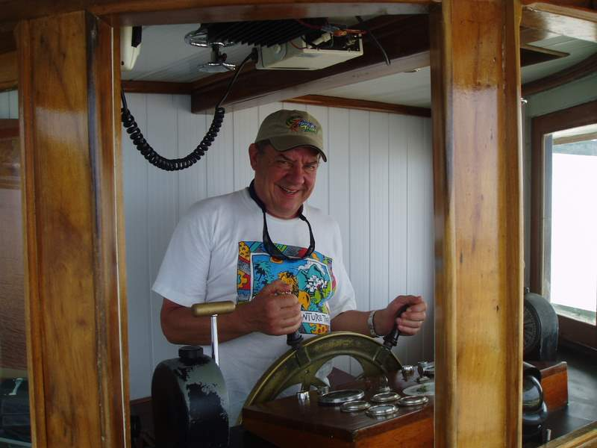Bob - Helping Out
The plane returned and the consensus was not overly encouraging. It appeared that a way might be possible but the clearance would be marginal, at best. The Captain then enlisted the aid of the Nitro. Its job was that of a scout. It scoured the region in front of the boat in the direction that had been indicated from the plane’s reconnaissance. As the Nitro progressed at idle speed, a man perched on the front bow taking continual soundings by dipping a 5 feet long stick straight down into the water. When the water entirely covered the stick the Queen attempted to follow in that direction. By this time, Phil personally had taken over the steering of the boat and the command of its gears and speeds.
Using this system, we moved forward unimpeded for a while but the submerged bars were quick changing in their shape and depths. It didn’t take too long before we were completely hung up on a narrow sandbar. I didn’t find out until later that Phil had steered purposely for this point; since, it was the only possible way through the sand, even though it did not quite meet the 5 feet criterion. He intended to bulldoze his way through the sand using the boat’s propeller for traction. I also found out later that when he had the Queen refurbished he had installed a larger diameter drive shaft with a heavier duty, welded propeller and oversized bearings. She was set up for just such a contingency as we were experiencing. With all of that, it still wasn’t an easy procedure.
When we, inevitably, hit a bar it would be at a good speed. The boat would continue moving forward, slowly losing momentum, for 5 or 6 feet, all the while throwing great clouds of murky sand in the water behind the stern, until all forward motion stalled. Then, the gears would be thrown in reverse and the boat would move backwards for an equal distance, again producing much murky turbulence in the water. Thus a small channel would be dug under the keel allowing the boat to gain speed and momentum for her next forward charge into the bar and to, thus, gain another 5 or 6 feet before again stalling. In this “rocking” fashion we proceeded upriver in a winding course, busting through the bars at their narrowest points as the way required us to.
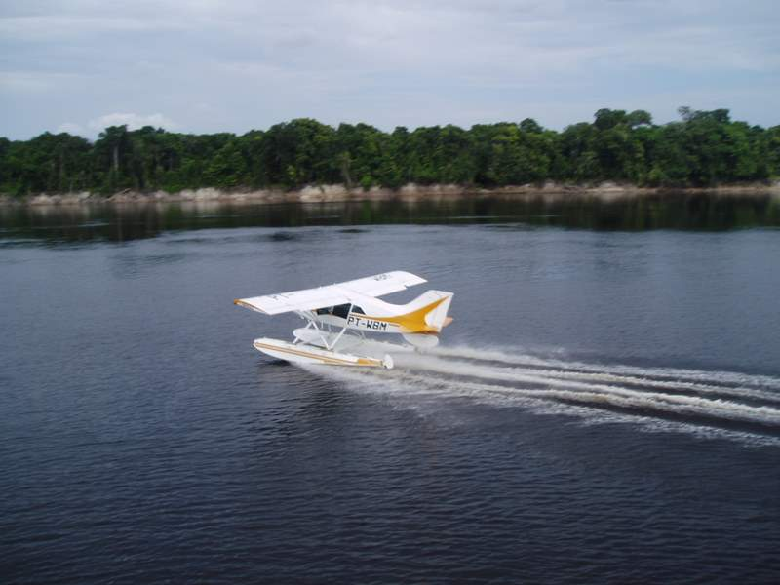 Taking off to Scout the Sand Bars
We were probably at it for about 1½ to 2 hours before the Queen finally broke through the maze for the final time. Phil returned control of the boat back over to the Captain and, when the Captain moored the boat to a nearby riverbank, Phil came up to the lounge where Bruce and I had returned, after the action ceased. By this time some of the other Nitro’s had returned and there were half a dozen, or so, fishermen in the lounge, mostly drinking beer. We offered Phil a drink, and he looked longingly at the cold beers, but he chose a Coke instead. He still had to fly the plane back to the lodge.
It was fun swapping fishing stories with the guys on the boat. They had already, on this first full day, had some good fishing. None that we talked to had, as yet, caught anything over 10 lbs. But all that we talked to had caught something, mostly in the three to eight lb. range - all good fighting fish! Everybody was enthusiastic, happy, and looking forward to the next days’ of fishing. You could tell that each one was sure that he was the one who was going to catch the prize fish. If you aren’t optimistic you will never be a fisherman! When I told them of our experiences fishing the inland lakes and the good luck we had experienced, some looked interested but none had tried, or even been aware of its possibilities, yet.
Phil Marsteller: We left the Amazon Queen, riding back to the plane in one of the Nitro’s, and were soon back in the air. As we gained altitude, the competitor’s boat came into view, still moored to the sandbar. I said to Phil that it didn’t look like they would be able to make their way up the river judging by all that we had been through. He looked at me with a smug look on his face but didn’t say anything.
Phil Marsteller was proving to be a truly impressive person – a many talented, “jungle renaissance man”. The entire Rio Negro experience was there because he had, personally envisioned and implemented it. He knows every inch of his domain and he had amply demonstrated that he is able to perform competently in any area that a job needs to be done.
In just the last few hours he had personally taken care of the medical needs of the injured guide, he then piloted the plane to find the stranded Amazon Queen (which he had personally redesigned and refurbished), he took over the rescue operation, personally directing the operations and piloting the boat through the tricky submerged maze of sand bars, and he was now flying us back to the lodge to host some 40 odd guest fishermen. He accomplished all of these things in a nice way, treating all of the people with whom he interacted with a compelling, respectful attitude.
In particular, I thought that he had handled the situation with the Captain of the Amazon Queen extremely well. Phil treated him with respect and deference to his ideas, never criticizing him for getting the Queen stuck in the first place and, consequently, the Captain reacted with a grateful air. He gave Phil his full co-operation, even when Phil took over the piloting of the boat. If it hadn’t been handled with tact, the way that Phil did, the captain’s attitude could have just as easily been one of resentment and tacit non-co-operation.
On our flight back Phil began to talk about his life and to point out some features of his domain. He was born and raised in the Brazilian jungle to American missionary parents. He was educated in the U.S. and stayed there to make his fortune as a successful businessman. He came back to the Rio Negro area, acquired thousands of acres along the river, and proceeded to create and build his lifelong dream. It all culminated in the Rio Negro Lodge, its environs, and the unparalleled Peacock Bass fishing experiences that it provides for its quests.
As we neared the lodge he pointed out the fields he owns that his people farm to provide the food that we were eating. Closer in we could see the village, surrounding the lodge, which he created to house the large and diverse staff that is required to keep everything in operation and good repair. This is where the native population lives who do the cooking, the farming, the maintenance, where the fishing guides live, etc. They live and raise their families here.
The village is completely self contained, with interconnecting, paved pathways and roads, its own, electric power, medical commissary, maintenance buildings, church, school, etc. All of the wetlands and swamps, local to the lodge and village have been drained and dried out to the extent that one can walk around unprotected at night and not experience a mosquito bite. The people are healthy, clean and well dressed, and exhibit an obvious sense of well-being.
Another program that Phil carries out to help provide medical care for his flock involves an open invitation to any qualified physician or dentist. Any professional of these persuasions can come to the lodge and enjoy the full, weeklong, standard fishing/lodging package, absolutely free, if he is willing to donate just 4 to 5 hours of his time during the week to tending to the needs for his profession among the village residents. Overall, the place and the venture, itself, are testaments to what one dedicated, talented man with a dream can accomplish.
Larry had a Bad Day: When we got back to the Lodge it was just before dinnertime. Many of our party were already in the pool, most with a drink in one hand. The big attraction was an otter that Phil keeps as a pet and for the entertainment of his guests. The otter was living up to its billing, swimming and frolicking with the men, to the obvious enjoyment of all. One of the men in the middle of all the play with the animal was my son, Larry. In the excitement the otter lashed out and accidentally nipped him. It wasn’t the animal’s fault but Phil decided that it was enough for one day and had the otter put away for the night.
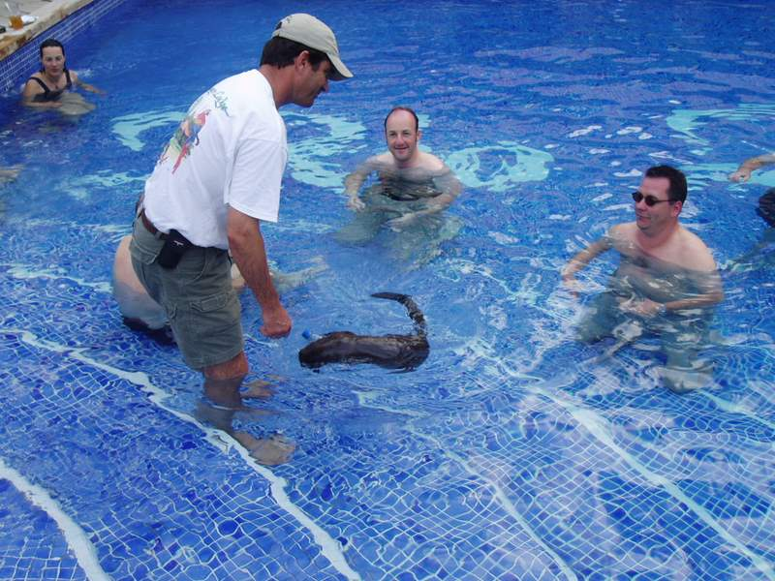Phil, Larry, and the Otter
Larry had had a bad day! I didn’t know it at the time when I came in that noon but it was Larry’s lure that had become embedded in the guide’s head that morning. It was an unfortunate accident wherein no one was really at fault. The boat had lurched from a passing wave, making the guide stumble into the lure’s path, just as Larry was back casting. It was a freak occurrence but it did end up with the lure tightly locked, by a double barbed hook into the man’s head. It was too difficult to extract on the spot; hence, they had to come in for more experienced help. Except for the immediate pain of the occurrence, the guide was all right after Phil removed the lure, and he returned to fishing that afternoon.
Larry, however, felt guilty and was quite distraught. He’s good hearted and he decided to give the guide a sizeable tip for his troubles. For that purpose he took $100.00 and put it in his pocket, intending to give it to the guide at the end of the afternoon’s fishing. However, when he went to retrieve the money from his pocket when leaving the boat, it wasn’t there! Apparently, he had lost it, somehow, during the afternoon. To top it all off, the fishing had not been too good. All he had caught that day had been some smaller Peacocks. The slight nip by the otter was the last straw! It was, literally, tantamount to adding “injury to insult”. It had not been a good day! What Larry, or any of us, did not know at the time was that his luck was about to change, significantly for the better, within the next two days!
It had been a full and exciting day but it wasn’t over, yet. After dinner, the score sheet was totaled up and two in our group were tied with the biggest total weight of fish. My reported total weight was third but, if I had been able to include the 9 lb. Peacock that Enrico had mistakenly thrown back before weighing, my total would have easily beaten both of them and I would have won the $250.00 daily first prize. As it was I didn’t win anything.
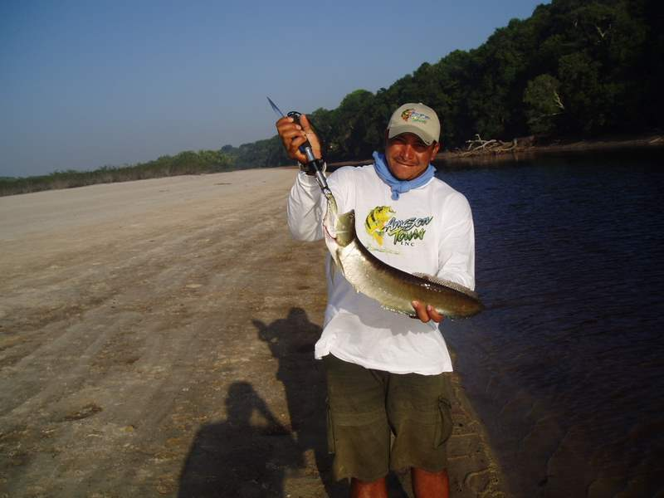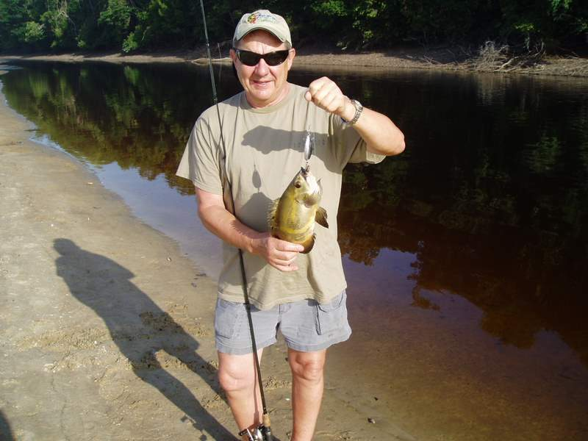
Enrico with an Aruana Enrico’s Dinner – Butterfly Bass

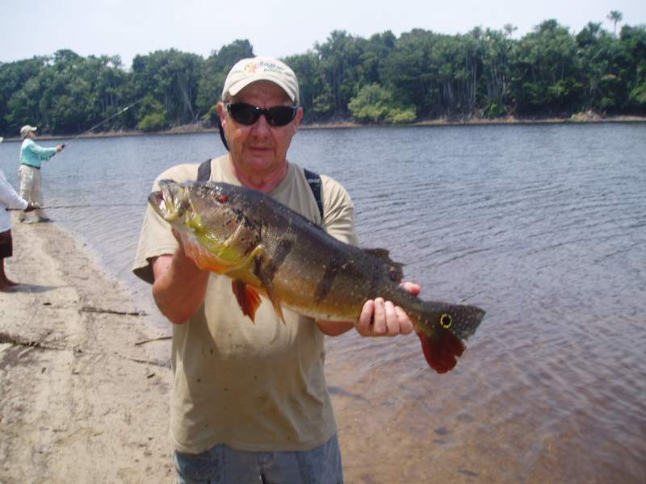 Bob – A12 lb Peacock

With all of that, except for Larry’s bad luck, it had been a great day! I had tracked into the jungle and caught a total of over 45lbs. of fish; mostly fighting Peacocks, and it only had taken about 3 hours to do it! I had caught some strange looking, new (to me) species of fish, flown over and experienced the immensity of the trackless jungle, and vicariously participated in the unique event of freeing up the Amazon Queen from the sandbar maze. I went to sleep that night a happy guy!
Day 3, The Fishing gets Better: The client fishermen/women stay in cottages that string out from the lodge, through the woods, along both sides of a concrete path that meanders through the jungle along a bluff overlooking and parallel to the river. Each cottage comfortably accommodates four people. A wooded area in between separates each cottage and each one is quite private from its neighbors. There is a good-sized, common use “living room” in the center of each cottage with a double bedroom flanking each side. The living room contains a couch, a generously sized table and chairs, a refrigerator that we could stock with “free” beer and soft drinks, and 120-volt electrical outlets along the walls. Each bedroom has two, separate, double beds and is shared by two people. Each bedroom also has its own bathroom with a shower. There is electricity (supplied from the lodge’s central generator), running hot and cold water, and each room is air-conditioned. There is also an attached, outdoor screened-in porch on the backside facing the river. In our cottage, Larry and I shared one bedroom and Bob and Bruce shared the other.
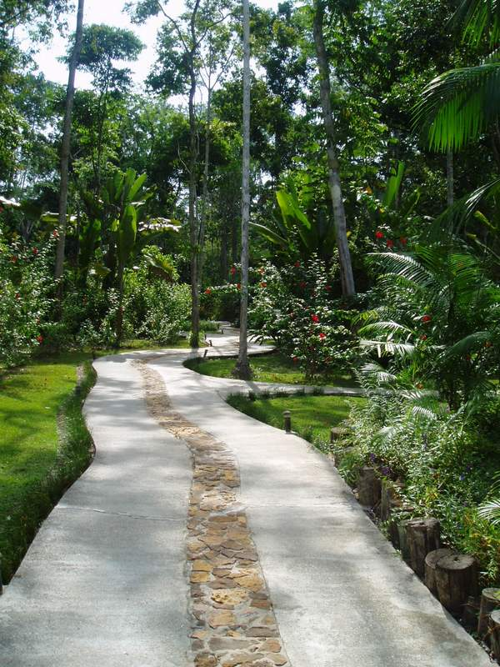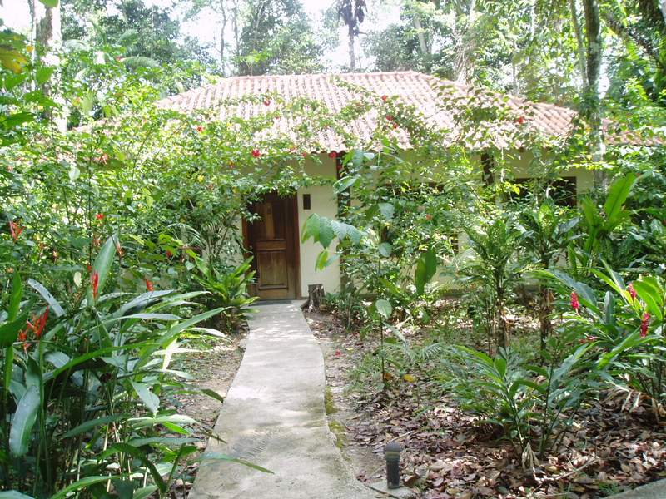
Path to Cottages Our Cottage
The normal day begins while it is still dark. A member of the staff comes to each cottage door and rings a bell at 5:00 AM. The object is to get out on the river by 6:00 AM. Breakfast is served in the lodge and it is a good one! Eggs, pancakes, cereals, fruit juices, and lots of fresh fruit - all offered, in as much quantity as desired. There is a table laid out with lunch meat, cheese, bread, fruit, packaged drinks, and condiments and each person is expected to make up and wrap his/her own lunch to be eaten mid-day on the river. There is a cold box on each Nitro that is stocked with water, cold drinks and beer. Everyone meets at the dock just as the sun is rising above the horizon, about 6:00 AM, to pick up his or her boat and get out on the river for the day’s fishing.
I had risen, breakfasted, and prepared my lunch as proscribed and arrived at the dock just as the top rim of the sun was appearing over the horizon. It came up in the east (the downriver direction) and produced pleasing pink, orange, and gold color patterned reflections on the water surfaces as it did. As the sun rose further, at one point it was directly behind, and silhouetted, the moored floatplane. It made a strikingly beautiful picture. It was my second good omen for the day. I already had my first when I went to put on my New Balance’s. They had been soaked when I took them off the previous afternoon and I had put them in the sun on our back porch to dry. They had dried completely and were, now, quite comfortable.
There was a crowd of fishermen on the dock when I got there and Phil was in front of it, waiting for all to assemble. Apparently, the previous day’s occurrence of a person being hooked by an errant back cast was not an isolated incident. It had happened before, with other fishermen, and Phil, with his river guides, had come up with a method of casting when in the boat that would prevent its reoccurrence. He was waiting for all to assemble in order that he could demonstrate the technique.
The technique is really quite simple. Its basic requirement is that the lure should be hanging freely, but quite tight against the tip of the rod, with no slack line between it and the tip during the back-cast. The line should not begin to play out until the forward motion of the cast begins. It was obvious that the use of this technique would have prevented the previous day’s accident and, judging by the lack of comment or grumbling from the group (many of them very experienced anglers), it was readily accepted.
While I was standing there, Mark, one of the young men in our group approached me and invited me to join him as the day’s fishing companion. I had just met him the night before during the cocktail hour and we had gotten along most agreeably. We shared common interests in wanting to experience the jungle features of the area, in addition to the fishing, and our conversation revolved about that subject. He was really interested in my experiences fishing the land-locked lakes and, additionally, he was just as anxious to go ashore because of the possible opportunities it would provide to see the flora and animal life of the region. He wanted to meet some native Indian people if he could. We were both on the same track and, despite the great difference in our ages, we got along famously.
I had already arranged with Bruce and Enrico to hook with up them for the day, as Enrico had promised some really good lake fishing in spots that he knew about. Reluctantly, I had to turn down Mark’s kind invitation but I did direct him to the dock-master and told him to tell him his wishes for a jungle based fishing/exploring trip. He did this and, when I last saw him he was taking off in a Nitro with a guide and just himself, no other companion.
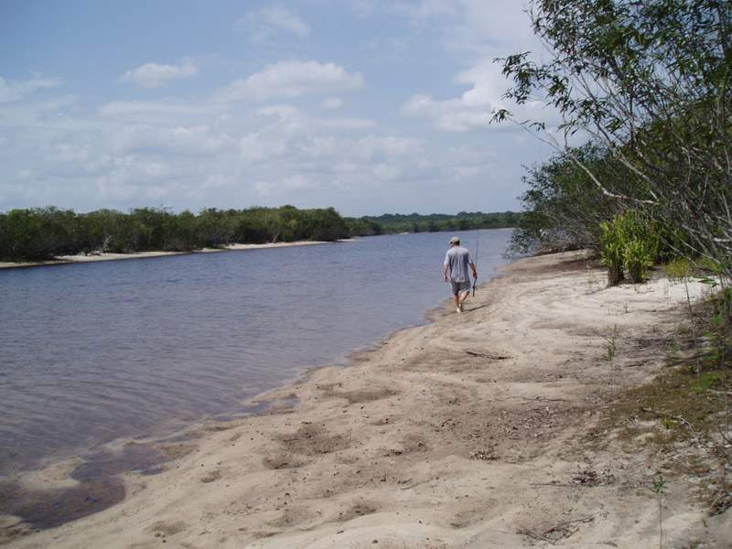Bruce – Heading Inland
My boat, with Enrico driving, was one of the last to leave the dock that morning. I purposely delayed until I could get the dock-master to explain to Enrico how our daily fishing pool worked and the importance of weighing every Peacock. I made sure that he told Enrico how his failure to weigh the fish the previous day had caused me to lose the $250.00 daily prize and, consequently, how it had caused him, Enrico, 10% of that. Enrico gave me an embarrassed, crestfallen look. I just looked back at him and said that it was OK but that we shouldn’t let it happen again. The incident was over and, happily, we managed to weigh all of the bass I caught after that.
Bruce and I took off in the Nitro with Enrico at the wheel and, after about 45 minutes of, first, a rush straight upriver, and then a wild, winding path through what seemed like an endless array of small islands and channels, we landed the boat on the sand at the edge of a dense jungle. Surprisingly, it was not too difficult to make our way through the jungle despite its density. We followed a discernible, if not well-worn, path for about 10 minutes and came upon a fair sized lake. We followed the shoreline of the lake and it became really muddy in spots. Because of the density of the jungle edge, there was no choice but to just keep on trucking through the mud, which we did. It got to be really funny at times and, at one point, Bruce sank in almost to his buttocks. We were all in, at least up to our knees, at times, but we persevered and finally came to a stable but narrow shoreline.
After about 5 minutes along the shoreline, Enrico stopped and indicated that we should fish. Bruce and I separated a good distance, about 40 to50 yards. We had to fish while standing ankle deep in the water since the jungle came almost to the shoreline and did not provide enough room to back cast from the shore. I used the same silver spoon lure as the day before and Bruce went back to his fly rod. The action was immediate and urgent! On my second cast I got a tremendous hit that took off immediately in a strong run. However, when I attempted to set the hook, the line went slack, and I lost the fish.
Enrico was watching and he came over to me. He pointed out my mistake. I had tried to set the hook with an upward motion of the rod, which only succeeded in ripping the hook from the fish’s mouth. He recommended that I use almost horizontal, slightly angled downward and sustained, strong sweeping motions instead. He was right, as usual. I used the technique from then on, throughout the trip, and I never lost another fish that took my bait.
He pointed to the same spot where I had lost the fish and indicated that I should cast there, again. I did as I was told and, on the first cast, I got another strong hit and ensuing run. I didn’t lose this one when I set the hook! That fish and I had a really good battle. He was big enough that I had to “pump and reel” to make any progress in the beginning stages of the battle. When I finally got him in he looked like a monster and he weighed in at a full 12 pounds! I’ll never know for certain but I‘m pretty sure that he was the same fish as the first one that I lost, giving me a second chance. Peacocks have the reputation of being tenacious, not liking to lose a prey once they are onto it. They are known to strike repeatedly at the same lure, sometimes, even when that lure is in another fish’s mouth.
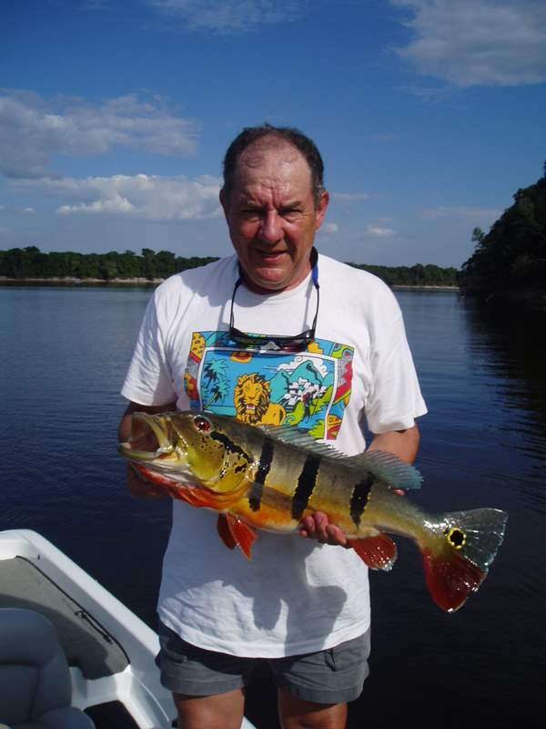 The Fishing’s still Good!
I went on to catch a 7 and a 5 pound Peacock in that lake in addition to another new (to me) species that Enrico called a Cara (Darling?). This fish was a lot bigger and fatter but it had the same general shape as a large Crappie from northern Minnesota waters. He did not throw that one back and he thanked me for again catching him his dinner. I also caught a small, maybe 2 lb., Butterfly bass that he also added to his larder. His family would eat well that night! Bruce had also caught some good fish but, I must confess, I was so intent on what I was doing that I didn’t pay too much attention. I was having too much fun on my own!
By this time we had to get back to the lodge, since, Bruce was expecting another telephone call. We left the lake with Enrico carrying his dinner fish, had some more fun tracking through the mud, and preceded back, downriver, to the lodge in another rapid and exciting Nitro ride. Enrico really enjoyed riding that boat at high speeds, making tremendous, “rooster tail” wakes as we knifed through the water.
After lunch, we were out on the river again to a different, but similar lake about half of a mile’s hiking into the jungle. This time however we did not have to track through any mud and the shoreline was wide enough so that we could stand on dry land to fish. We spread out as we had in the morning and proceeded to fish in the spots that Enrico indicated.
This time; however, we would only fish a spot for a short time after the immediate action stopped before Enrico indicated that we should move to a new spot. If I cast 10 to 12 times without a hit Enrico would signal a move. If I caught a fish and, then, nothing happened for another dozen casts, or so, we would move along the shoreline, again. Bruce did not like this way of fishing and he tended to hang back before moving, so we got separated after a while.
The fishing wasn’t quite as good as the morning, but it was still good! That afternoon I caught one 6 lb., another 5 lb., and three two lb. Peacocks. In addition, I caught an Aruana, two Barracudas, and a medium sized Piranha. Combined with the morning’s results, it was a good day’s catch. As it turned out, the weight of my day’s catch was good enough to earn me a second prize in the daily pool; my third consecutive day of prize worthy fishing!
The best story for that day’s fishing, however, was Mark’s. When we got back in he was already there and he was brimming over, waiting to tell the story of his day’s experiences. His day started off similar to ours. His guide had led him to a secluded jungle lake where he proceeded to have a very satisfactory morning of fishing. He caught a good number of Peacocks, in addition to some of the same, other, native species that I had been catching (Aruana, Piranha, etc.). However, the highpoint of the morning was the 18 lb. Peacock that he caught! To that point in time, it was the largest Peacock that had been caught by anyone in our group and, along with the weight of the other Peacocks that he had caught that day, the total weight of his catch beat mine and he won first prize for the day.
That wasn’t the end of his day, however. After spending the morning fishing, they moved the boat to another jungle location where his guide led him on a trek through the jungle. He related seeing many of the local fauna of the area, monkeys, flying macaws, and a caiman (the local specie of small river crocodile) among them. Also, he had come upon a group of feral pigs where, apparently, it was a toss-up as to who was the most startled, he or the pigs.
This type of pig has been known to be dangerous and, for a moment, it proved to be a somewhat scary situation. There was much snorting and milling around him before the group finally decided to take off into the surrounding woods leaving Mark unharmed but, as he said, ”rather shaky”!
They finished the day by again moving the boat to a new location where there was a native village alongside the river. In the village he was able to trade for hand made Indian artifacts. He was wearing a necklace around his neck that was composed of colorful feathers, polished wood beads, and shells that he had bartered for. It looked good on him. All in all, he expressed a lot of satisfaction for his day’s activities and he looked the part.
We all went into dinner. Our group of 17 had its own designated table and we all spread ourselves around at it. The food was served family style and the typical menu can best be described as “meat and potatoes” or, many times, “fish and potatoes”. There were ample complementary vegetables and fruits to round out a healthy diet but, overall, the fare was definitely tailored to the active masculine outdoorsman. The meals were well cooked and ample. The kitchen was always open in between meals for snacks. Coupled with the fully stocked, never closed, open bar, the gastronomy situation was quite perfect!
I did have one complaint, however. It had to do with the stocking of the open bar. On the first evening, during cocktail hour, Phil categorically inquired if everything was OK. I informed him that things were in pretty good shape except that there was one glaring error. There was no bourbon or sour mash whiskey anywhere in his stock, especially, no Jack Daniels! If I had not brought my own, private stock I would have been more concerned but, taking into account sharing with others because of the bar’s lack, my stock was quickly disappearing. In the next few days the situation could quickly deteriorate.
Phil said not too worry. New supplies were due to be flown in in the next few days and that he would personally see that the proper supplies would be on the flight. True to his word, two nights later a large bottle of Jack Daniels appeared on the bar shelf and the crisis was averted. I never had another complaint.
Day four: Barney’s Ladder: The more that I saw of our native guides in action, the more apparent it became just how multi-talented these gentlemen really are and the more respect I gained for them.
Although each guide has his own individualized, recognizable physical features and each one, certainly, has his own, individual personality, all are easily identifiable as belonging to the same Indian derived race and they all seem to possess the same admirable traits when it comes to their job performance. They all are shorter in stature than the average USA American, have dark, suntanned complexions, straight black hair, dark eyes, and each is uniformly dressed in shorts, tee or sweat shirt, and bare feet.
Each one that I inter-acted with was uniformly intelligent and exhibited a high degree of self-initiative. Invariably they make a real effort, indeed, go to great lengths, to please their assigned clients, sometimes, in creative ways. They uniformly go about their guide duties, uncomplainingly, with great enthusiasm. Without exception, they appear to be well trained for their jobs and they execute them well. This day’s activities were destined to bring out all of these fine traits in a most demonstrative and positive way.
Larry and I had decided to fish together on the same boat for the day. When we arrived at the dock in the early morning Enrico informed me that, today, we were going to fish differently than I had become accustomed to during the previous days. He was busy tying a trailing rope to our boat, the other end of which was attached to the bow of an open aluminum skiff, approximately 16 feet long with a small outboard motor on its stern. Alongside our Nitro, the guide on the next Nitro was doing the same thing with a duplicate aluminum skiff. Today, we were going to fish as a team of two boats.
We met our companions to be for the day. They were two fishermen who were staying at the lodge but were not from our group of seventeen. They were friends, both from the southwest, USA. The older of the two was named Barney. He appeared to be in his late 30’s or early 40’s. As it turned out, Barney had been crippled from birth and had all he could do to sustain a hobbling walk, which he did, whenever necessary throughout the day, with no complaint and unfailing good humor. His friend was younger, appearing to be in his early 20’s and in fine physical shape. Both were enthusiastic, experienced bass fishermen. They each had natural, “regular guy” personalities and we all hit it off good, right from the start.
The two Nitro’s sped side by side up the river, at speeds in the order of 40 mph, each pulling its aluminum skiff behind. Barney’s Nitro had two native guides in it instead of the normal, single guide. After about a 40 minutes long run, sometimes weaving our way through small, scattered islands, we beached the Nitro’s onto the shore.
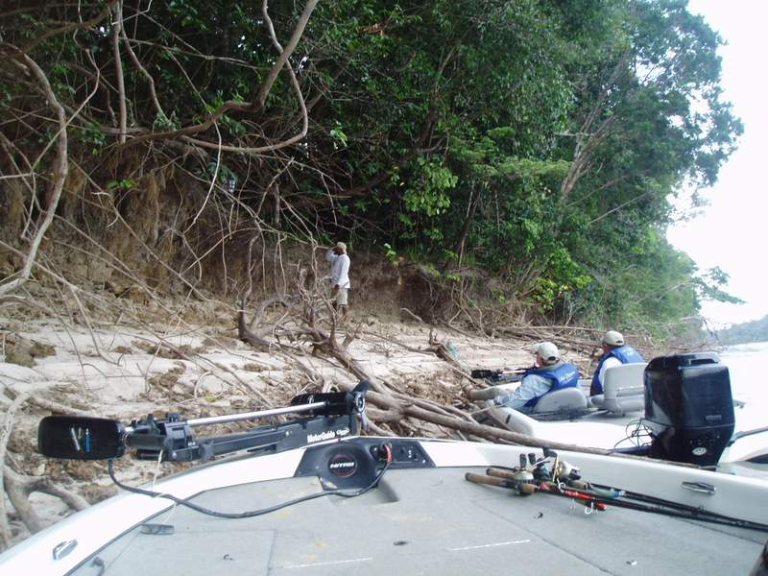 Landing at the Sand Cliff Beach
The point that the guides had chosen looked extremely unpromising. There was only a narrow, approximately 15 feet wide, beach that butted up against a vertical sand cliff about six to seven feet high. At the top of the cliff, very thick jungle undergrowth came right to its edge. As it turned out the beach area was cluttered with debris and it was severely infested with mosquitoes.
We helped the guides pull in the aluminum skiffs and beach them alongside the Nitro’s. Then, all three of the guides picked up their machetes and scampered up the sand cliff, telling us to wait there until they returned, and, then, disappeared into the jungle.
We waited, having a brisk time battling the mosquitoes. In a short while we could hear hacking sounds from inside the jungle. In another short while the three guides reappeared, laden down with loose bundles of trimmed, straight tree limbs, each about 8 feet in length, and several coiled lengths of vines. They, then, immediately set to work to fabricate an 8 ft. long ladder. One hacking evenly spaced notches into two of the 8 ft. poles, another to cut shorter lengths for the ladder cross-steps, and the third guide started stripping down and trimming the vines. They quickly assembled the cross-steps to the notches in the poles using the trimmed vines for lashings.
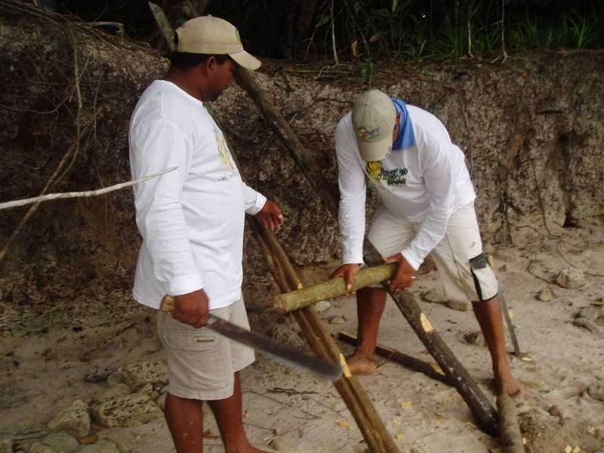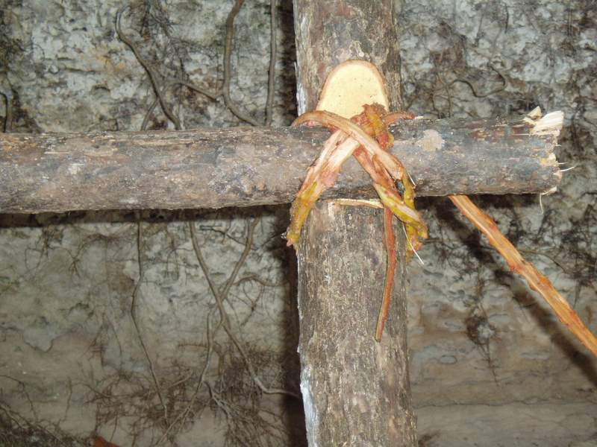
Building the Ladder Vine Lashing
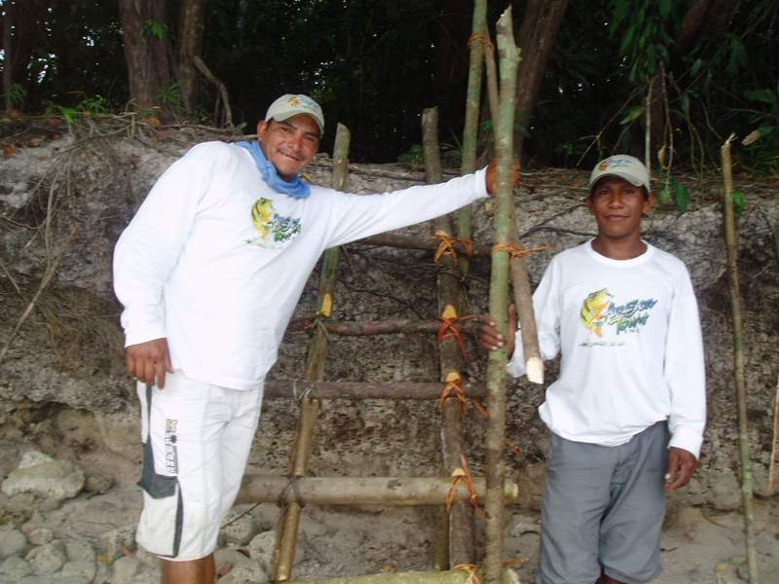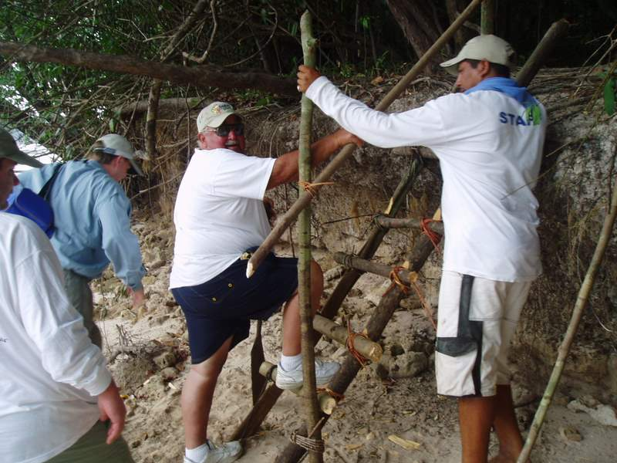
The Ladder – with Railing Barney Climbs the Ladder
In no time, it seemed, they had constructed a strong ladder that they leaned against the cliff and it reached past the top. Larry, teasing Enrico, said, “It looks great, but there’s no handrail.” The guides glanced at each other and, not to be outdone, they grabbed their machetes and, again, disappeared into the jungle. They returned in a short time with additional tree limbs. Using the same notching and lashing techniques, they quickly fashioned a creditable handrail and attached it to the ladder. They then disappeared into the jungle with their machetes and we could again hear the hacking, this time with the sounds slowly progressing away from us. They were clearing a pathway through the jungle.
When they returned, we all got together and pushed/lifted the skiffs up over the cliff, onto the path. The next job was for Barney to climb the ladder, which he did, slowly, but completely on his own. Everybody in our party, including Barney, had a great smile of triumph on their faces when he finally made it to the top of the ladder and stepped onto the jungle floor. We then proceeded in a linear progression through the jungle pathway.
Enrico, Larry and I pulled the first boat, laden with the fishing gear, lunches, the outboard motors, gasoline, life preservers, etc. along the cleared jungle floor. Behind us, the two other guides and Barney’s young friend pulled the other boat. Barney gamely tried to walk but, for a good part of the trip, he rode inside the pulled boat. After about a half of a mile’s distance we came upon the shore of a large, inland lake. This was our objective, where we were going to fish for the day.
The guides continued to surprise us. They pulled a revolving bass chair from under the boat seat and set it on a chair-high pole in the back of Barney’s boat. When we launched the boat and were all set in the water, Barney was ensconced on that seat with a big smile on his face, looking, for the entire world to see, like the “cat that ate the canary”.
The whole episode spoke volumes about the abilities of our guides and the real care that they have for their clients.
Larry’s Luck gets Better: When we finally got onto the lake, the two boats split up. Steve, Barney’s young friend, had told me his intentions on how to fish the lake. They were going to slowly paddle parallel to the shore, about 40 to 60 ft. out, casting in toward, and almost reaching, the shoreline. Their lines would be rigged with painted lead, feathered jigs. The technique would be to allow the jig to hit the bottom before starting the retrieve, then, on the retrieve, allow the jig to slowly “bump” across the bottom. I had fished this way the previous summer in the “boundary waters” of Minnesota and had had good luck fishing for Great Northern Pike. Steve and Barney both said that this was a common way of fishing for bass in the Arkansas/Louisiana/Texas area that they usually fished and they had a lot of faith that this technique would also work well in these waters.
I told Enrico about their plan and he said that it might work but, that the bigger fish were in the center of the lake, and that we should try there, first. If nothing else, I had learned to trust Enrico’s judgment, implicitly, in all matters relating to fishing these waters. He moved our skiff to the center of the lake. Larry and I rigged up our lines, Larry with a woodchopper and me with my normal silver spoon lure. Enrico moved the skiff forward very slowly, under minimal power, with Larry and I standing and casting/retrieving to opposite sides of the boat. In this manner we began to traverse the center length of the lake. It was a bigger lake than I had been used to fishing; a couple of miles long, at least.
It wasn’t long before I got the first hit: a nice sized Cara. Enrico’s family had another meal! In rather quick succession, I pulled in two more fish: a nice, 4 lb. Peacock and a 3 lb. Butterfly Bass. It wasn’t long, however, before Larry topped me, in grand style!
He hit something really big that bent his rod almost double, forcing him to use a “pump and reel” motion for the retrieve. There was a big fish on his line, just sitting in the water tugging on the line. After a good tugging battle between Larry and the fish, the fish took several good runs, before Larry finally landed him. The whole battle had been rather expertly done on Larry’s part. The fish turned out to be a big, beautiful, 15 lb. Peacock! Larry had become the “high hook” in our family and, although we didn’t know it at the time, he wasn’t through, yet.
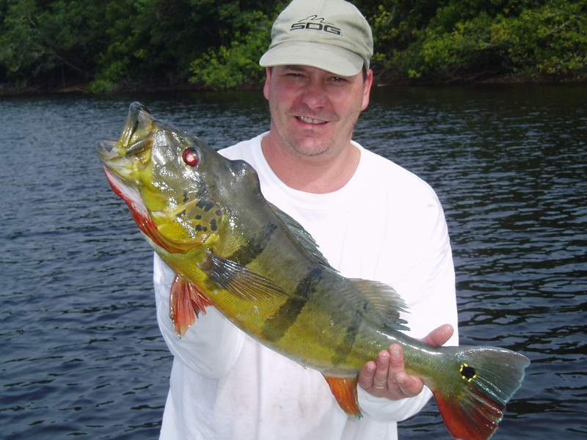Larry’s 15 lb’r
Soon, thereafter, it was getting close to lunchtime and Enrico asked us to reel in. We headed back to the small beach where we had put in, picking up the other skiff on the way. Both Barney and Steve were happy. They had been catching bass in the range of three to eight lbs. and had had a good morning’s fishing. Larry’s catch, however, was still the king.
After lunch on the beach, Enrico came over and said there was another, smaller lake nearby that he wanted us to try. It was connected to the lake we were on by a small creek through the jungle. We brought the boats around the point that bordered our beach and entered the creek. We were immediately forced to shut off the motors and tilt them up, out of the water, as the creek was quite shallow. We started to paddle using Indian carved paddles supplied by the guides and, in many spots, it was necessary to use the paddles as poles to push the skiffs through particularly shallow parts. Every so often the skiffs would bottom out and there was nothing to do but for everyone (except Barney) to get out and wade in the water, pulling the boats along. We proceeded in this fashion for about one half of a mile before the creek opened up into the next lake.
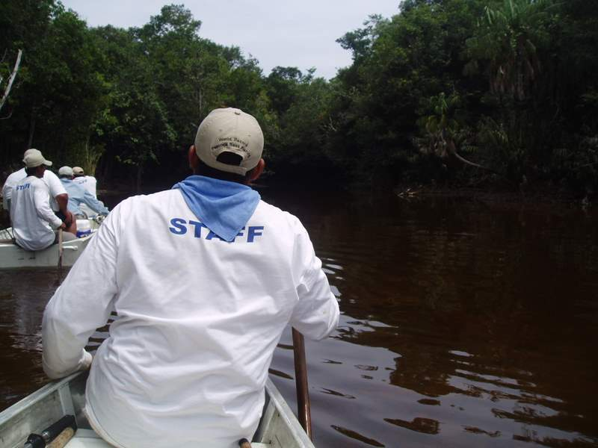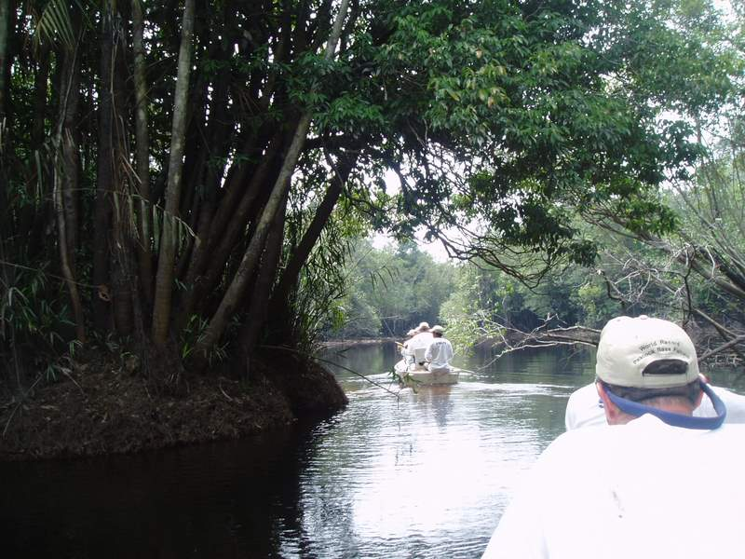
Into the Creek Entering the Inner Lake
The creek had been an interesting place. It was almost like being in a Tarzan movie. It was completely surrounded by thick jungle, on both sides, as well as, above. Although it was a sunny day, it was dark and gloomy at the surface of the water because no sunlight was able to filter through the top cover of tree leaves. Although we saw no wildlife, there were many sounds of jungle life: lots of bird and insect noises. There were many large spider webs with large, colorful spiders in residence, at many places along the way. Overall, the boat passage was spooky, and fun!
When we got into the lake proper, we began to fish as we had done in the previous lake. In no time, I got the first hit and it proved to be bad news! The fish I caught was a native specie that we had been calling a “dog fish”. In short order we caught several more of this same specie. The dogfish we caught were in the range of 2 to 5 lbs. They give an immediate good fight but give up easily, surrendering themselves to be pulled docilely in on the final retrieve. In other words, they are not a fun fish to catch. They resemble in shape the common carp that we have in the USA but, unlike the colorful carp, they are uniformly dull gray in color. However, the most distinguishing feature has no resemblance to a carp, whatsoever. The mouth is large and, when it is wide open, it exhibits the meanest set of large teeth that can be imagined. By any measure, it is one scary looking fish!
Enrico appeared surprised and, with a disgusted look on his face, said that we should reel in and return to whence we had come. The problem was that the dogfish are known to be fierce predators. So fierce, in fact, that when their numbers become large they are capable of taking over and completely dominating their immediate habitat. This includes eliminating any Peacock Bass in the area, even though the bass are a larger species. The lake we were in had been taken over by the dogfish and we were very unlikely to catch any bass in it. It was a shame; too, because Enrico told us that the last time he had been there (months before) the bass fishing had been good. Apparently, it had been one of his better, “secret” spots.
We returned to the first lake via the same creek passage that we had arrived by. In short order, we were back fishing the same way we had been in the morning, with Larry and I in the middle of the lake and Steve and Barney fishing its edges. After a bit of a lull, I caught a nice 5½ lb. Peacock and shortly after that Larry and I both, simultaneously, hooked and reeled in “barracudas”, each about 12 inches long. This is another native specie that looks rather docile until its mouth opens and displays its dangerous looking teeth. This fish is just another, stark reminder that we were in the jungle and that the jungle can be a really mean place.
Enrico continued to surprise. He took one of the barracudas and stitched its body with fishing line, for its entire length, in such a manner that the fish remained alive. To the trailing end of the fishing line he attached a triple hook creating, for all intents and purposes, a living fishing lure. He, then, rigged this living lure to the line on our spare rod and played the line out into the water, allowing it to troll after the boat as we slowly traveled along. We could see by the movement of the line in the water that the fish swam erratically as it followed the slowly moving skiff.
I didn’t realize the full significance of these actions at the time but I later figured it out. Enrico wasn’t trying to catch a fish on the ”barracuda lure”, so much as, he was using it to create a disturbance in the water that sent the signal out to other, larger fish in the area that there was a wounded fish nearby (hence, easy prey) to be had for the taking. In other words, it was meant as an attraction to bring fish to our vicinity in the hope that they might, then, see and take the lure on the end of either Larry’s or my line.
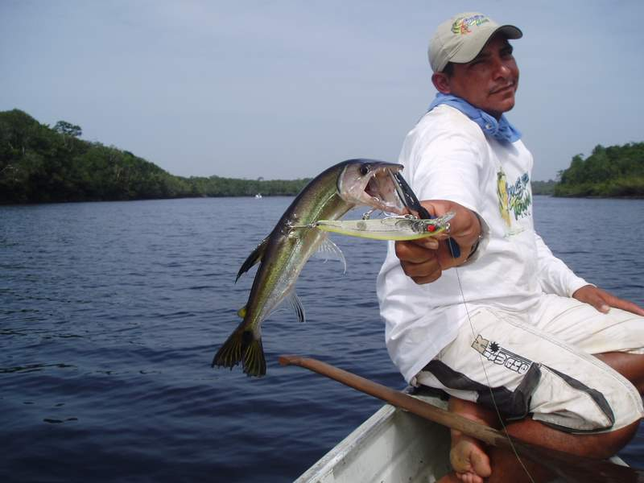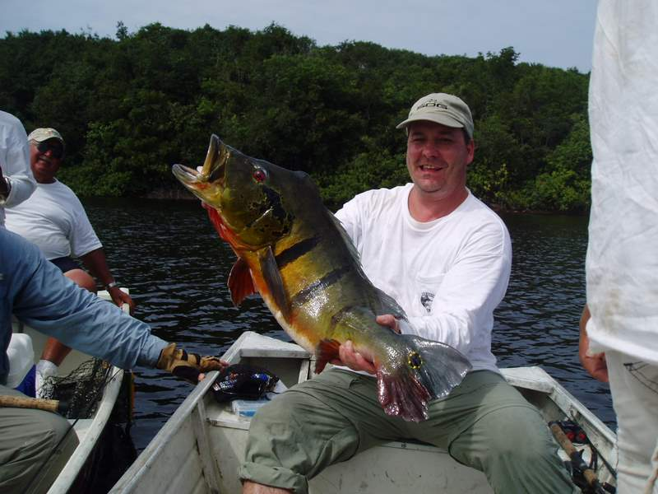
A Barracuda Fish Larry’s 24 lb Prize Winner!
We fished this way for a while (possibly, 10 minutes). All of a sudden, Larry got a tremendous hit! A fish really took the lure with an immediate and furious run. Larry set the hook but there was no way that he was going to turn that fish! Enrico reversed the motor and we began to follow in the fish’s wake, allowing Larry to make some progress, reeling in line. When he finally got the fish closer to the boat, maybe 35 to 40 feet, the fish surfaced and, with one large red eye showing, he looked at us. He was huge and, I swear, he looked right at us, right in the eye! Apparently, he did not like what he saw because he immediately took off on another furious run and Larry lost all of the line that he previously had worked so hard to reel in, plus more. If Enrico had not turned the boat to follow, the fish might well have reached the end of the line, snapped it, and kept on going. However, between the team action of Enrico and Larry, we managed to follow that fish for a good portion of the lake. Eventually, the fish appeared to tire somewhat and Larry was able to, again, get him near the boat. That fish was still not finished, however, and he took off again on another good run. Then there was a lot of back and forth pumping and reeling action before Larry managed to finally bring it to the boat, completely spent, for the final time.
According to Enrico’s scale, the fish weighed in at just over 24 lbs! The world record is just shy of 27 lb. We wanted to make sure that there were no mistakes in the weight so we decided to call the other skiff over to verify it with the other guide’s scale. They were a good half of a mile away from us and it took a lot of shouting to just get their attention. It then took more time for them to realize that we wanted them to come to where we were. We learned later that they were on a fish. Finally, they headed our way. For all of this time Larry had not unhooked the fish and had been holding it in the water to keep it alive, since, we were releasing all Peacocks.
In a short time the other boat reached us and, using the other scale, we verified the fish’s weight at 24 lb. Larry had really done the job! He not only had caught enough to win the daily, $250.00 prize, but that fish was destined to be the largest fish of the group for the entire week and it, eventually, would win Larry the grand prize of $2,000.00!
We fished for a while longer and I managed to catch another 5½ lb. Peacock but, after Larry’s catch, it was all anti-climatic. We left in the early afternoon because we still had to drag the skiffs through the jungle and we were a long way from the lodge.
Possibly, the best ending that the day’s trip could have had, occurred when Barney made his final descent down the ladder. He had experienced a great day of fishing and had caught a lot of Peacocks. It had been quite a feat on his part just to be able to access the deep part of the jungle that we had been in, no less, to successfully fish it. You, also, had to admire the guides for the manner in which they had enabled him to do it. I have a photo of Barney looking straight at the camera just as his foot touched the beach after descending the ladder. The happy, triumphant, and grateful look on his face says it all! After that, we were all a happy crew as we debarked from that site.
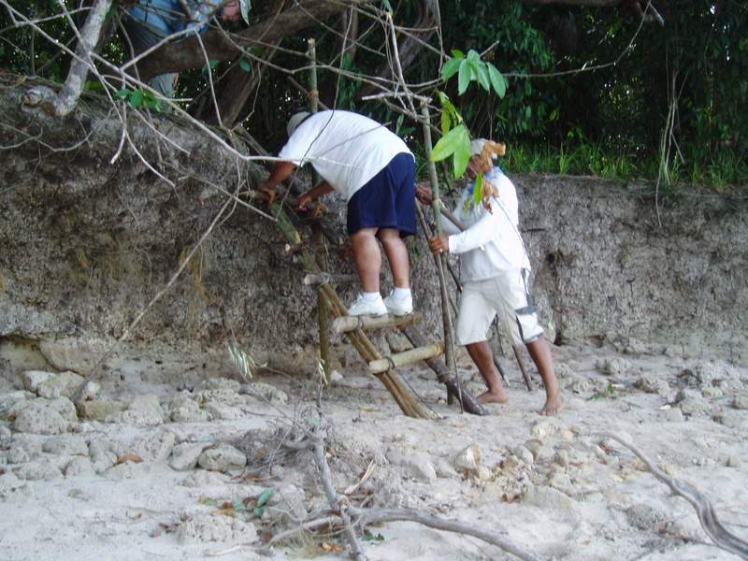
Larry’s Prize! Barney – After a Successful Day
Day 5: Carmen and Don: At cocktail hour that night at the lodge, the story of Larry’s big fish caused quite a stir, since, it turned out to be the largest that week of any of the 40 total fishermen currently staying at the lodge. There were two dentist guests of Phil’s, not in our group, who also had had good luck that day. They were drift fishing from a Nitro at the mouth of one of the many channels that feed the Rio Negro when they hit it big. One had caught a 20 lb. and the other, a 22 lb., Peacock! Both were using woodchopper lures. As the week progressed the catches were beginning to get better.
During that same cocktail hour I met an interesting couple that had just arrived that day. They were also guests of Phil’s. In addition to the medical and dental guests that Phil brings in and provides with gratis lodging and fishing, he, also, provides similar services to a sprinkling of other people. I would classify such people as “fishing celebrities”. His motives in bringing them in have to do with the maintenance of good public relations.
For instance, during the first part of the week he brought in a world famous “fly casting expert” and an accompanying film crew and they were busy for several days making a film centered on the lodge. In addition to working on the film, this expert had, also, given us demonstrations and, for those interested, lessons, on fly-casting techniques.
The new couple that I met fell into this latter category of “fishing celebrities”. His name was Don and hers, Carmen. He was a well-known writer of fishing lore, frequently published in various sporting literature. He, also, wrote a syndicated column on the subject. It was hard for me to tell but both he and his wife appeared to be in their early to mid 40’s. They were an attractive couple; he, prematurely gray, bearded, with a pronounced “outdoorsy” look and, she, very feminine and quite beautiful with a dark, definitely South American, complexion. They were both very friendly and gregarious.
We hit it off well, right from the start and Don seemed to be particularly interested when I started to describe the details of fishing the inland lakes and the good catches of fish that I had been experiencing. The upshot of it was that he asked if he could accompany us the next day. I sure had no objections and neither did Larry, who had, also, already agreed to partner with me, again, the next day.
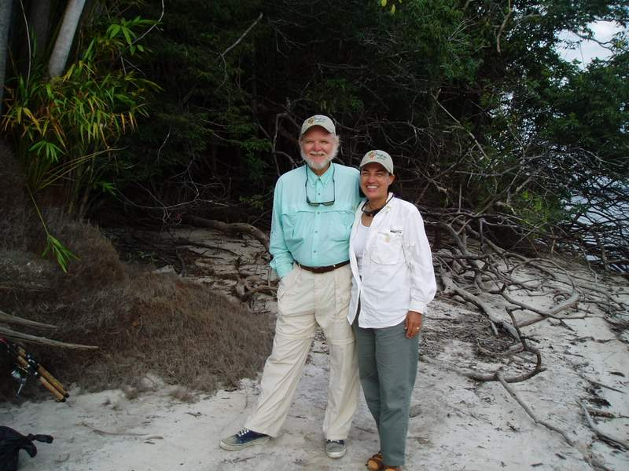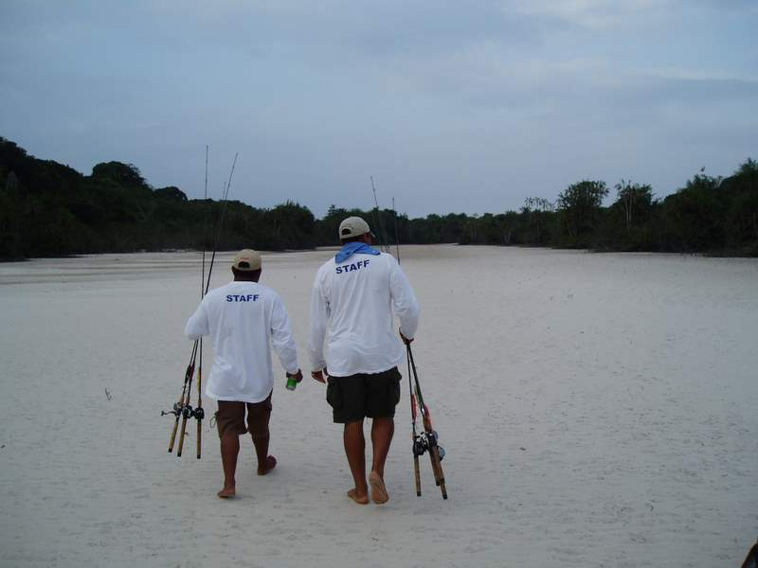
Don and Carmen Good Service from the Guides
We all met on the dock the next morning and I was a little surprised, but pleased, to see that Carmen was accompanying him, correctly outfitted for fishing. Although, I don’t think he asked for, or even realized, it, I got my first inkling that Don was being provided special treatment that day. In addition to his guide/driver for the day, the senior guide of the lodge also accompanied us in Don’s boat. He was Enrico’s unofficial leader and this was the first time I had seen him accompany a client into the field.
We left the dock side by side in two Nitro’s. Enrico was driving Larry and me in one, and Don and Carmen with the two other guides were in the other. We drove for a long time that morning, maybe an hour, at high speed and we were in a part of the river that I had not seen before when we finally reached our landing spot.
The beach was wide and sandy and we walked at least 100 yards before we reached the jungle. We found a trail that was somewhat overgrown and the three guides went ahead, periodically using their machetes. All in all, the way wasn’t too rough and we reached our destination after about ten minutes. Throughout this time we had been carrying on a pleasant conversation with Don and Carmen. Mostly, it amounted to swapping fishing stories between Don, Larry, and me but Carmen, also, held up her end of the conversation with some good stories of her own. She was proving to be a good fishing companion.
During the walk, Enrico stepped on a large splinter and it became deeply embedded in the sole of his bare foot. He couldn’t get it out by himself so he called the other guide over to help. After some preliminary and fruitless trying, the guide picked up his machete and calmly proceeded to cut a deep notch into Enrico’s foot. The notch turned out to be at least ¼ of an inch deep and, about, ¾ of an inch long. It got the splinter out and, surprisingly, there was no blood. The calluses on Enrico’s foot were that thick! The whole incident only lasted a few minutes and Enrico resumed walking, with no sign of a limp, as if nothing happened.
When we got there the lake was a good size, about 100 yards wide and it extended, out of sight, around a curve into the jungle. The good news was that there was a pretty wide beach along the near shoreline, plenty adequate for back casting. We would not have to stand in the water while fishing from that side of the lake.
I had been talking with Don about lures and I, of course, recommended the silver spoon that I had been using. However, he glanced over at Larry who had a woodchopper rigged to his line and, probably taking into account Larry’s recent 24 lb. catch, he decided that he and Carmen would try woodchoppers. Who could blame him?
At that point the chief guide kind of took over. He beckoned Don and Carmen to follow him and they strung out, single file, behind him with the other guide trailing behind. Enrico came next with me, then Larry, following. We, the four fishermen/woman, spaced ourselves about 30 to 40 feet apart and began to fish. As soon as Don, the lead fisherman, had fished a spot for a while with no success, the lead guide would signal him and they would move forward to the next likely spot and begin to fish there. If we, the following fishermen, were not having any luck we would also move, roughly taking the place of the person who had just vacated in front of him. We proceeded to fish in this manner for the first part of the morning.
The problem with this method, though, was that Larry and I were in the rear and by the time that we got to a spot, that spot had already been thoroughly fished by two or three other fishermen. It looked like the odds were all wrong for either Larry or me to catch the good fish. This wasn’t of Don’s choosing because, judging by his speech and mannerisms, it was apparent that he was somewhat uncomfortable about it. If it had continued, I felt he would have said something to periodically alter the rotation to give everyone an equal chance. He was too much of a sportsman, and a gentleman, not too.
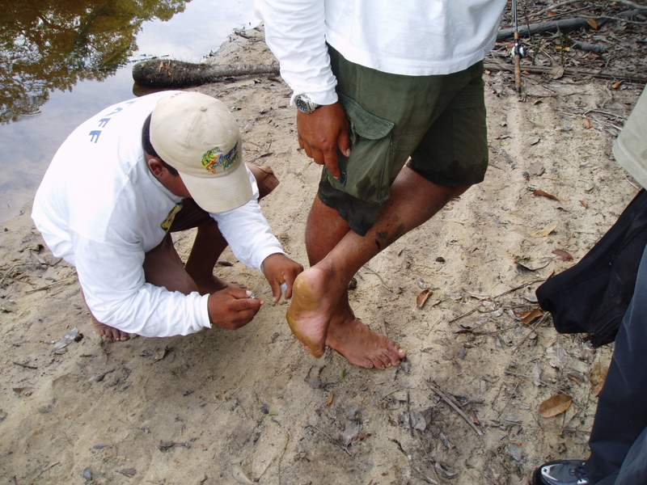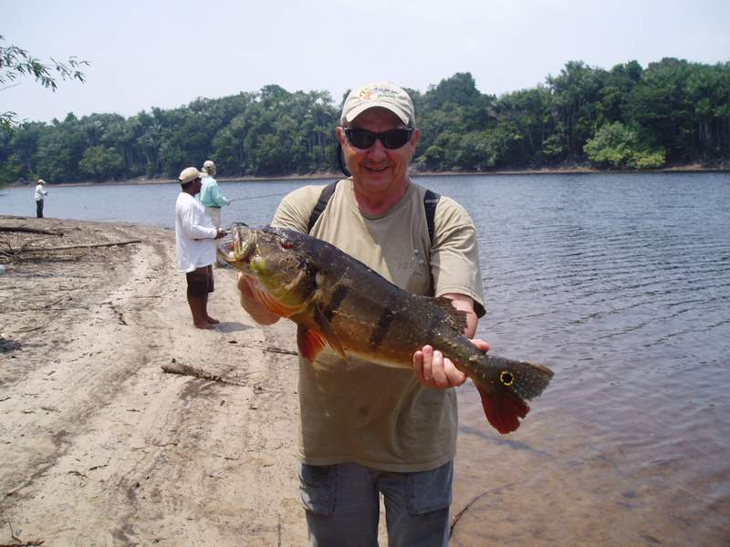
Enrico’s Splinter Removal Good Results - From the Back of the Line!
However, as it turned out it didn’t matter. After we had moved our fishing positions 2 or 3 times in this manner, with no one having so much as a single strike, I started to catch fish and no one else did. Don’t ask me why some fishermen just get hot and are able to pull fish out of the same spots where other fishermen just left without catching any. It certainly wasn’t that I had any greater skill than the others, quite the contrary. To everyone’s great amusement I had managed to create a king sized bird’s-nest on my very first cast in this latest location. The line was so tangled that I needed Enrico’s help to untangle it. Needless to say, it was embarrassing, especially in front of Carmen and her nationally famous fisherman husband, Don.
On the very first cast after being untangled, I got a strike. For sure, it wasn’t a bass because the line was running around in tight circles and, after a short while, the fish quit fighting and I effortlessly pulled it in. It turned out to be the biggest piranha that I had ever seen or, even known existed! It was big and silver, about the size of a good sized serving platter. In a few more casts I had a nice 5½ lb. Peacock, a few more and I tied into a really good one: a magnificent 12 lb. Peacock that I managed to bring in after a very spirited battle. It was my second Peacock of that size of the trip!
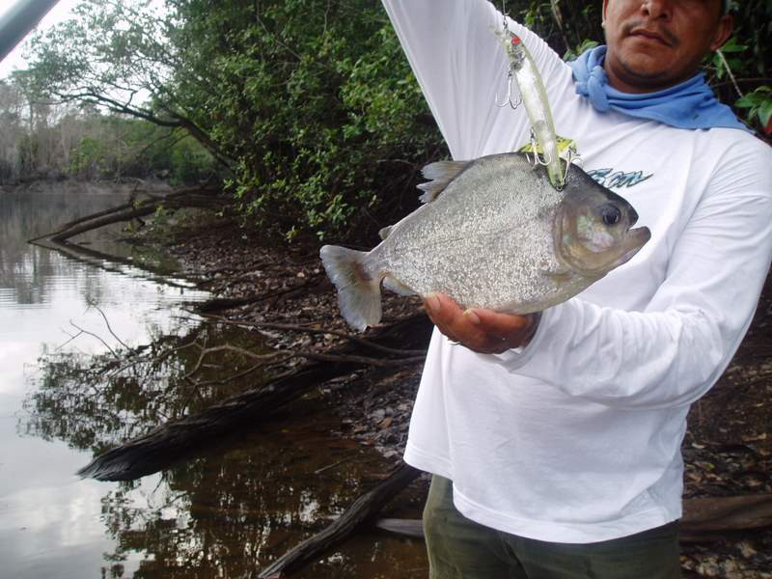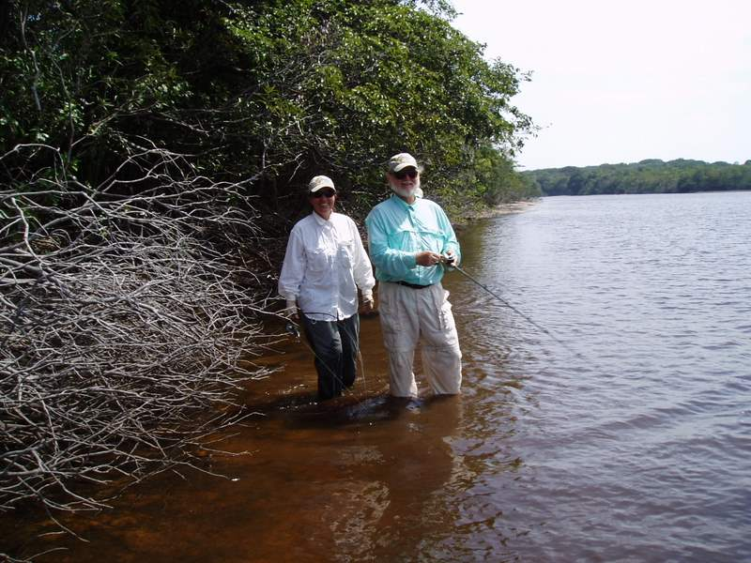
Bob’s Big Piranha Don and Carmine – a Good Day’s Fishing
Not to be outdone, Larry, using the woodchopper, got a tremendous strike! He set the hook and all he could do was to hold the rod up vertical and bending almost double. The line steamed out, while that fish made a tremendous run towards the opposite shore. Then it seemed to stop and just sit there. It became a tugging contest between Larry and the fish. After a lot of “pumping and reeling” Larry got it in close. Once that fish got in close enough to see our feet (by this time we were both standing in the water), it apparently did not like what it saw because it immediately took off on another savage run. It went on this way for several more runs until it looked like that fish was finally spent. Larry reeled it in close and Enrico started over to assist in the landing. Just about when it got to Larry’s feet, the fish surfaced and, for an instant, I could see its full length. It was a monster Peacock! Just then, the fish found some new energy and with a violent jump, it leaped from the water and spit out the hook. In an instant, the fish was gone and the fight was over. This time, the fish had won.
I had seen Larry’s 24 lb. monster the day before and I had, also, seen this fish for its full length. This fish was definitely bigger! We will never know if it would have been a world record, or not, but it sure would have been close. After the first rush of disappointment over his loss, Larry looked at me kind of ruefully.
Then we both grinned. After all, this was sport fishing and it had been a great battle. It’s what you come for and you can’t expect to win them all. However, it’s definitely the kind of thing that keeps you coming back.
Very shortly after Larry’s big fish got away, I received another good strike and succeeded in bringing in another 5½ lb. Peacock. Almost immediately after that, Larry pulled in a battling 7 lb. Peacock. We were in a good fishing hole! After that, except for a couple of barracudas (we each caught one), the action petered out, at least, for a while. During this whole time there had been no action from Don and Carmen’s end.
After about 10 minutes of no activity, Enrico approached me. He looked somewhat uncomfortable when he told me it was time to move. He had been conferencing with the other guides and the consensus of it was that they thought that it was too crowded fishing together like we were. Enrico said we were going to fish on the other side of the lake while Carmen and Don continued to fish this side. He turned and started off along the shoreline in the direction we had come in from. I looked at Larry, we both reeled in, and, without comment, we both started after him.
As we got to the end of the lake nearest the river, the lake became shallower and, as we followed its rounding contour on the other side of the lake, back away from the river thick undergrowth of jungle began to impinge closely to the shoreline. This forced us to either walk very closely to the water’s edge or, in some spots, to wade directly in the water. In either instance we were walking in mud, usually, up to our ankles. By this time we were far away from the others but I did hear some loud yells from Don so, I assumed that he was catching some fish.
We walked a good ways in this fashion until the beach area began to open up. The lake was still shallow but, at least, we were able to get away from the mud. When we got to a point that was approximately even with the others on the opposite shore, Enrico stopped and indicated that we were to fish there.
Even though there was plenty of room for a back cast from the beach, he indicated that we should wade out into the lake a ways so that we would be able to cast our lines into the deeper water. This was more important for me than for Larry, since, Larry could cast the woodchopper farther than I could the spoon. Enrico offered me the spare rod that was already rigged with a woodchopper but I declined. I had been having too much success with the spoon to quit on it.
We waded out into the water a good 50 or 60 feet, until the water was up to our knees, and began to fish. Carmen and Don were approximately 200 to 250 feet away from us on the opposite shore of the lake in the same area that Larry and I had recently vacated. We fished for a while like this with moderate success. I caught a small Peacock, about 2 lb., and a small Butterfly, again, about 2lb. Every once in a while we could hear Don’s excited yips so we knew when they were getting action. From our distance away, however, their catches seemed to be respectable, but moderate, in the range of 5 to 6 lbs.
At last, Larry hooked into something of size. After a good battle, he brought it in and it appeared to be a Peacock in the 8 to 9 lb. range. However, when he called Enrico to weigh it, Enrico looked very uncomfortable and said that he had left his scale with the other guides. They had forgotten to bring theirs. Apparently it was Enrico’s day to be uncomfortable but there was nothing he could do about it. He was out voted.
After my previous bad experience of not weighing a fish of similar size, with the consequence of having it cost me a first prize in the daily pool, there was nothing to do but to send Enrico back for the scale. We did that and Enrico started back, moving rapidly through the way we had come. Combined with his other catches of the day, Larry might still have a chance at a daily prize.
Larry held his fish in the shallow water, still hooked to the lure, and we stood side by side, talking for a few minutes while we waited for Enrico’s return. While we were standing there, for no reason, I started to watch Carmen while she was fishing on the other bank.
Unlike the rest of us, she was using a spinning reel. The reel was rigged with a woodchopper lure. She was working it efficiently and had good technique with the woodchopper. She was laying down a radial pattern of continual, long and accurate casts. On the retrievals the lure was correctly producing intermittent, violent rooster-tails that we could easily see and hear from our vantage point on the other side of the lake. She knew how to use a fishing rod!
As we watched, she got a tremendous strike! She set the hook and a furious battle ensued. All the while, Don was whooping with loud exclamations of delight and encouragement. She played that fish expertly and, in good order, brought it to net. It weighed in at a trophy sized, 16 lb! She had become, and would remain, our “high hook” for the day.
Enrico returned with the scale and Larry’s fish weighed out at 8½ lb. We continued to fish for about another hour but there was little, further action from either side of the lake. I caught another barracuda and so did Larry, but that was about it. We had all, previously, agreed to quit early, and it was now approaching 2:00 PM. In addition to the trudge back through the jungle, it would be a long ride home. We decided to quit for the day.
It had been a good day all around. Everyone had experienced good fishing action and the catches were sufficient. The camaraderie and conversations at lunch and while walking along the trails had all been especially good. We swapped stories about a good many things relating to both fishing and our life experiences. In particular, Don had a large repertoire of good fishing stories. He told them well and he was very expansive with them on the way home. Carmen, also, was very chatty and witty. She was one happy lady; as well she deserved to be after her big catch. Carmen and Don made a really interesting couple and I thoroughly enjoyed the time I spent with them.
That night, over cocktails, there was another pleasant surprise waiting. My other son, Bob, had finally got on the board. His catch that day was good enough for second prize in the daily pool and it won him $125.00. First prize went to one in the group who had landed a 22 lb. Peacock. That was as close as anyone would get to Larry’s big fish of the day before. The Luciano family was doing OK!
Day 6: Ken’s Trophy Fish: One of the older men in our group was named Ken. He appeared to be in his mid to late 50’s and, though that made him at least a dozen years younger than me, it still made us the oldest pair in the group. We had made friends early in the week and each evening, over Jack Daniels “on the rocks”; we had gotten in the habit of getting together for a while to swap stories about that day’s fishing.
His experiences were totally different than mine. The small group of friends with whom he had been fishing with was among the most serious and devoted fishermen in our group. They were, to a man, really nice guys and fun to be with but they were, also, very serious and competitive when it came to fishing. In particular, they put big emphases on who would catch the biggest fish and on winning the daily pool competition. There was a lot of side betting going on. They were not too interested in the combination jungle trekking and lake fishing that I had been doing all week.
As Rich, Ken’s brother and our group’s unofficial leader succinctly put it, “I came here to catch prize fish, and anything that takes time away from my fishing for them, takes away from my chances for catching them. Walking in the jungle would take away from my fishing time and it just doesn’t appeal to me.” Consequently, they spent all of their fishing time in the boats, putting in as many total hours fishing as they possibly could. And, I might add, they were successful in their quest. They consistently brought in some of the largest catches of our group.
Ken was not of the same inclination, however. He was not as experienced in the sport as his friends and, though he really enjoyed fishing, it was not the only driving passion of his life. He didn’t feature being cramped up in a boat all day. In other words, Ken and I had a lot in common. That night he was concerned that most of the week had gone by and he still had not had too much luck. He had caught some fish but not in the same size or quantity as his companions. He desperately wanted to catch a more meaningful fish. He expressed interest in my stories about the landlocked lake fishing that I had been doing and the good fishing luck that I had been experiencing. He asked if we could possibly team up before the trip was over.
So it was, the next morning, Ken and I became a team for the day. I had already pre-arranged with my two sons, Larry and Bob, to also fish with them that day. Our two Nitro’s left the dock together that morning and sped up the river side by side - Ken and I in one boat and Bob and Larry in the other. That morning we traveled a tortuous path through many channels and around many islands. I did not recognize any of them. We were on the river for at least an hour, traveling, as usual, at top speed.
When we reached our landing for the morning it was at a spot where the jungle came almost to the water’s edge. There was very little beach. The jungle was thick and the guides had to go ahead of us, hacking a trail through the thick underbrush with their machetes. Enrico told me that it was the first time in over a year that they were going back to this spot and part of the reason that we were going there was to open it up for possible future groups if the fishing proved to be good. In a strange way that made me feel good. Probably because it was as close I was likely to get to become a true explorer in this jungle area.
The way was tortuous, becoming low and swampy in spots. There were mosquitoes. We had a couple of bouts of trekking through some serious mud, up to our ankles and higher. At one point Ken sank in up to his buttocks. He didn’t let it bother him, though, and it seemed that if he was not truly enjoying the overall experience, he at least had no trouble putting up with it. As for my sons and me, we had been tramping through woods together since the days when they were boy scouts and I was their troop leader. In a strange sort of way, this all came under the heading of having fun.
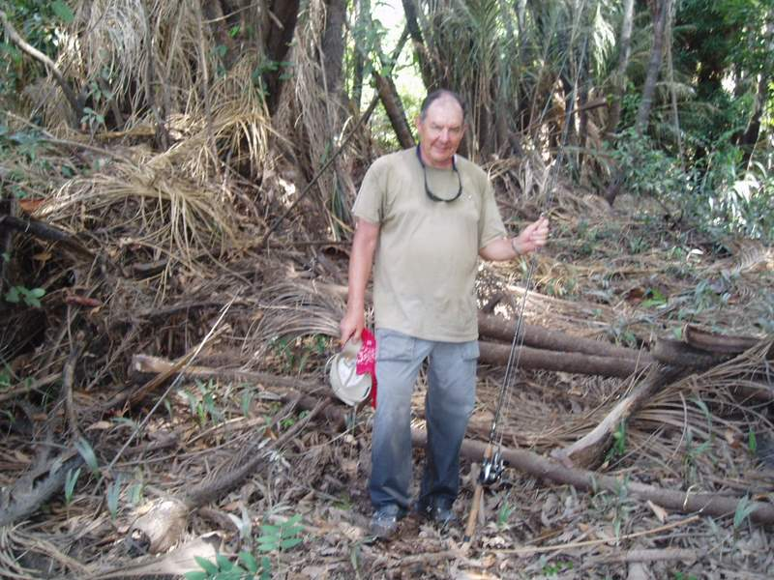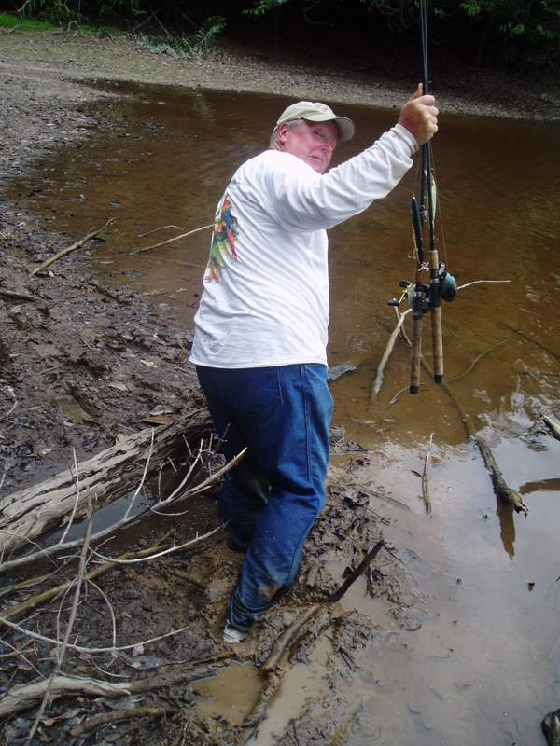
Getting There - Hot and Muggy Ken – Paying the Price
In about 30 to 40 minutes, and at least a half of a mile in distance, we came to our objective. It was a good-sized lake, surrounded by thick jungle. There was very little beach around the shoreline. We would have to wade out into the water to find room to cast. We separated into two teams, with Larry and Bob moving to the right and Ken and I moving to the left. This time I had made sure that each guide was carrying his own scale before we left the boats.
After about 150 feet Enrico told us to stop. This would be our first fishing spot. I could see Bob and Larry across the water, about 100 yards away around the curve of the shoreline. I rigged up my usual spoon lure and Ken put on a woodchopper. He told me that he wanted to master it. To cast correctly we had to stand about 20 feet out into the water. The bottom was muddy, but not overly deep. The mud did not reach over the top of my “New Balances”. Ken and I separated about 50 feet and we began to fish.
I watched him out of the side of my eye. He was working the woodchopper pretty good. Not as expertly as I had seen others do it, by any means, but his casts were long and the radial pattern he worked was accurate and evenly spaced. The lure generated an acceptably furious and noisy rooster tail on most of the retrieves. If the fish were there I felt certain that Ken would catch his share.
I got the first strike and it was OK, but not great. The fish fought well enough but I had no trouble pulling it in. It was a 3½ lb. Peacock. At home I would have been thrilled with a large mouthed bass (its cousin specie) of that size but here, in the jungle, it wasn’t much to write home about. Still, it was a good sign. The Peacocks were here!
It wasn’t much longer until Ken got his big strike. He got a strong hit and he set the hook. That fish took a strong run with line streaming out from Ken’s vertically held, and seriously bending, rod. Ken managed to partially turn its direction and the fish took off towards my lure, which was still in the water. I reeled in quickly in order that our lines wouldn’t cross and made it OK. That fish was a “back and forth’er”. It would repeatedly run furiously in one sideways direction and, then, double back in the opposite direction in another furious charge. It was a really fun fish to catch and I could see that Ken was smiling all during the battle. When he finally landed it, the fish weighed in at a whopping 17 lbs! Ken had caught his trophy fish. He was ecstatic.
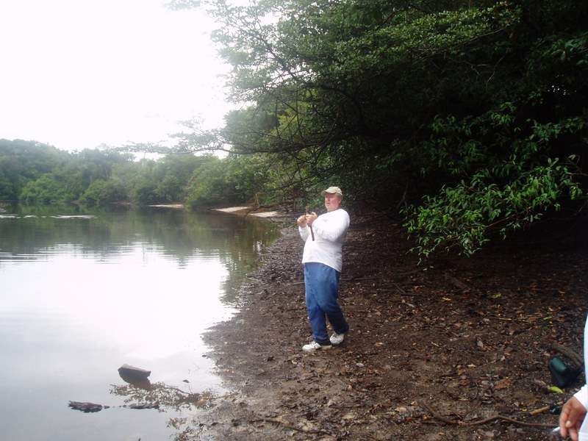 Ken – On the Big One!
There had been some excited noise from the area where my sons were fishing so I knew that they too were getting some action. Later, I found that Bob had caught a 10 lb. Peacock, among others.
Piranha Alley: Later that morning we boarded the Nitro’s to move to a new spot. We went around a lot of islands and through many narrow channels. In most places the riverbanks were short, vertical sandy cliffs, dropping directly into the water and typically running 4 to 8 feet high. Thick jungle came right up to the edge of the top of these cliffs. After another, somewhat wild boat ride, we slowed and Enrico nosed the Nitro into a narrow channel that entered perpendicular to our waterway. After only a couple of hundred feet, the channel narrowed even more, down to about 30 feet. In addition it was almost completely blocked by a high sand bar. There was only a very narrow passage of free water on the left side of the bar. He carefully, and slowly, nosed the Nitro into the passage. The boat bottomed out and ground to a halt halfway through. We were stuck and still had about 10 feet to go to open water.
Enrico asked us to get out, into the water, which we did. The other Nitro had followed into the passage and closely pulled in behind us. They, too, got out of their boat, into the water. The water was about waist high but the sandy bottom gave us good footing. With all six of us tugging and pulling, it didn’t take too much effort to get the front boat to a point where it was free floating. We pushed it to the other side of the bar and went back for the second boat. When both of the Nitro’s were riding freely in the inner channel, everyone re-entered his respective boat and we were underway again.
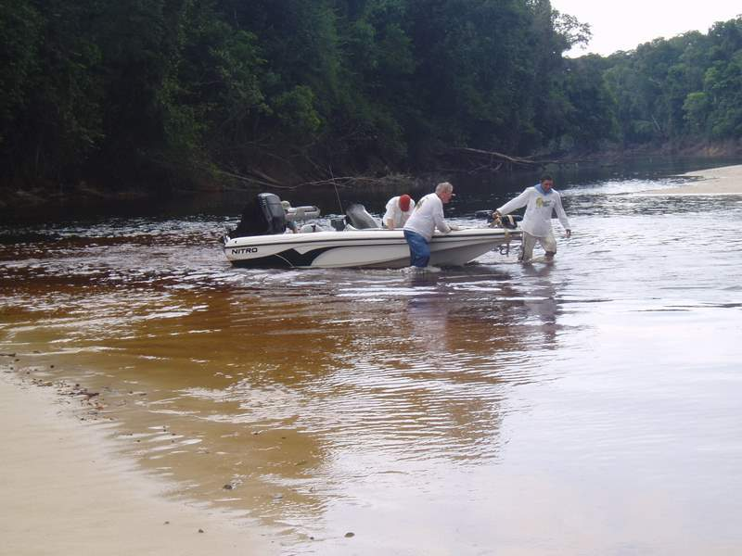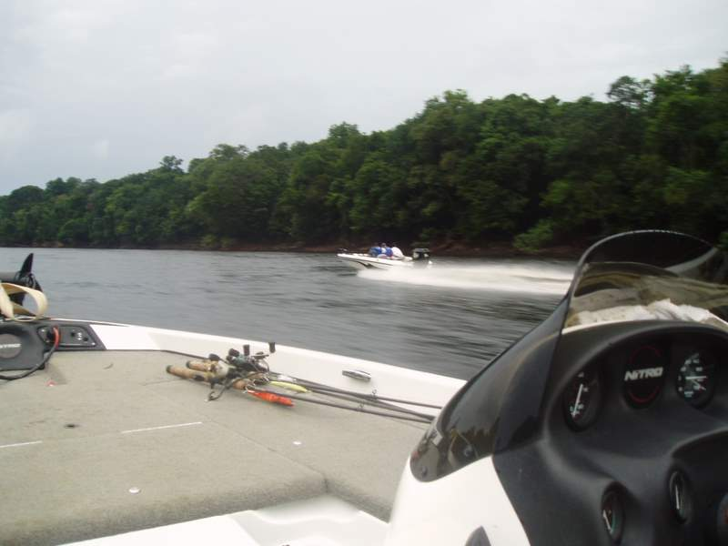
Pushing off from the Sand Bar Racing Down Piranha Alley
The channel rolled out ahead of us for a long way before slowly curving to the right, out of sight in the far distance. It appeared to be between 100 to 200 feet wide and it was miles long. Thick jungle grew right up to the water’s edge on both sides of the channel. Although I knew better, there was no visible evidence that human life had ever been there, anywhere that we could see. Truly, it was a primeval sight - a peaceful and beautiful scene. Little did we know, until later, what dangers lurked beneath these “peaceful” waters?
We rode up the channel, one Nitro following the other. Enrico’s boat was in the lead and the motor throttles were set at medium speeds. We must have gone at least 2 or 3 miles in this manner when Enrico found what he was looking for. There was a small side channel entering our waterway, perpendicularly, from the left. We pulled into the opening of the side channel and were immediately forced to turn our boats onto the side shore because the channel quickly became too shallow for the boats. Directly ahead of us, the new channel was only 5 to 10 inches deep. Apparently, Enrico had been expecting this because all of his motions in slowing and steering the boat were deliberate, not surprised. He knew the place. We grounded the boats and got out, taking our fishing gear.
Then, however, there was a surprise. On the shore, near to where we had grounded our boats, there was a small, motorized, Indian riverboat laying there, camouflaged from the main channel with branches. Enrico went over to it and removed some of the branches. This exposed a dampened canvas cover over the boat. When he lifted the canvas we could see into the floor of the boat. It was covered with large turtles!
Enrico re-covered the canvas and camouflage. He said that it was the work of poachers because it was illegal to take that many turtles. It was plain to see that he had ambivalent feelings about it because, as he told us, the people who were doing the poaching were probably just poor Indians who had little other means of obtaining cash money. He indicated that we should leave everything just as we found it because there might be some danger to us if we didn’t. He said he would report it to Phil, that evening.
We proceeded up the side channel, carrying our fishing gear. We were forced to wade in the water, in the center of the channel, because the jungle closed in on both sides and the underbrush was too thick to walk through. Once we got away from the main channel, it became very dark and gloomy because the thick vegetation overhead did not let any sunlight through. We walked this way for several hundred yards and, finally, our channel dead-ended, perpendicularly feeding into another larger cross channel. This new channel was roughly parallel to the main channel that our boats had just traversed. It was approximately 150 feet wide and it went a long way in each direction. We were going to fish along it.
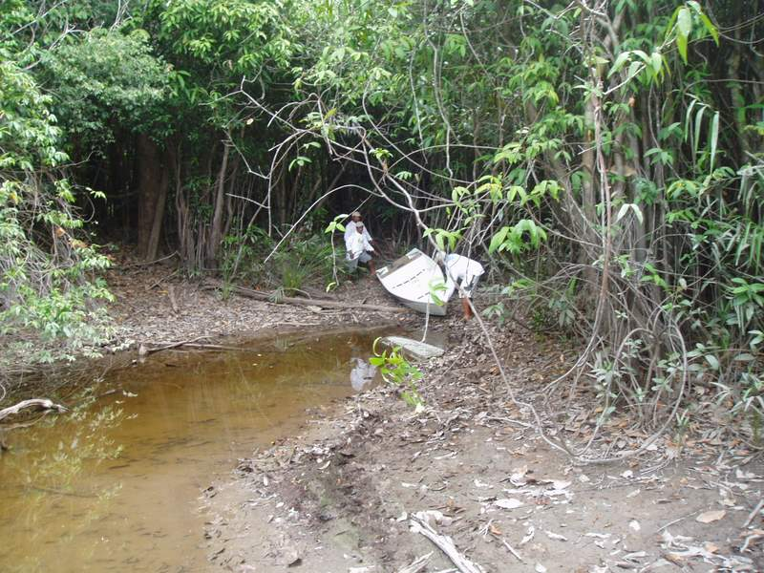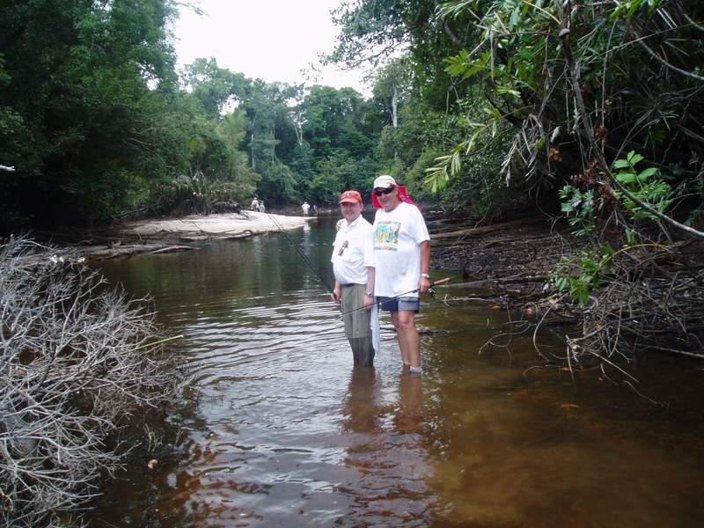
The Poachers’ Boat Bob Sr. & Jr. - in the Jungle Creek
We strung out along the near bank, Ken and I going to the left and Bob and Larry to the right. We caught some Peacocks. The action was good but the fish were on the smaller side, averaging between 2 to 5 lbs. Bob and Larry did a little better but nothing was caught over 6 lb. (Isn’t it funny how quickly we become jaded? On the first day, we would have been delighted with such catches!) After about an hour, Enrico signaled that it was time to leave. We retraced our steps back to the boats.
When we got back into the main channel he stopped and instructed us to rig up with trolling lures. Then Enrico did something that we had not done, yet, this week. He filled the fish-box up with water, indicating that we were going to keep at least some of any fish that we might catch. We proceeded to troll at slow speeds, back towards our point of entry from the river, trailing our lines behind.
There wasn’t any action for while but about halfway back, I got a hit on my line. It wasn’t that strong of a hit and, if it were a bass, it would be a small one. It turned out to be a piranha about 10 inches long. Enrico moved in swiftly to take it off the hook. Surprisingly, instead of throwing it back into the water, he lifted the lid and threw it into the fish-box. While he was doing this, Ken hooked into another one. It was another 10-inch long piranha and, it too, went into the fish-box. As I was getting my line back into the water, I glanced over at the other boat. Both Larry and Bob were also catching Piranha. The place was teeming with them!
The guides kept only those that were about 10 inches, or bigger, returning the smaller ones back into the water. We caught a lot of fish and kept only about 1/3 of them, but it was still a lot. I must say, however, none of the piranhas that we caught that day even approached the dinner platter sized piranha that I had caught the day before, fishing with Carmen and Don.
We were approaching the sand bar at the entrance of the channel and Enrico stopped the boat signaling the other boat to come alongside for a conference. We, the four fishermen, were still intrigued with the fact that the Piranhas were being kept. I, at least, had always thought of them as only a savage carnivore, never as a food fish. Upon questioning, Enrico said that they were very delicious and that it would be a real treat for his and the other guide’s family for dinner that evening. Still intrigued, Larry asked if we could take a half dozen of them, or so, to try that night during dinner. There were plenty of fish and Enrico readily agreed to his request.
During the conference, I made it known that I was not looking forward to going back into the water to push the boats over the sandbar after seeing such a large infestation of savage Piranha in it. The rest of our party indicated that they concurred. We had all read too many books and seen too many movies in which Piranha savagely tore human victims apart for us to think otherwise.
Enrico just grinned and, after he had a short conference with the other guide, the guide also grinned. Mysteriously, they both immediately started to empty the water from their respective fish-boxes. It wasn’t until after that I figured out that it was done to minimize weight.
We approached the sand bar lining up with the narrow passageway, now on the right hand side of the channel. When we got about 150 feet from it, Enrico opened the motor up to full throttle. He told us to hold on and we hit that sand bar going somewhere close to 40 mph. We hardly felt a bump. The Nitro sliced through that bar like a hot knife slicing butter! It caused a real adrenaline rush going through that sand bar the way we did! After we got out into the river, I looked back and the other Nitro followed in our foot steps, roaring through the bar, trailing a great rooster tail that turned light brown as the boat knifed through the sand.
That night, during cocktails, we had a lot to talk about. It had been a full day that had included many mild but, still exhilarating, adventures: Trekking through the mud and jungle, Ken’s trophy fish, dragging the boats over the sandbar, finding the poached turtles, catching so many piranhas, surging through the sandbar, and we still had the fresh Piranhas to look forward to at dinner. You just do not find things like this in Tewksbury, New Jersey!
At dinner we did get a chance to sample the Piranha and it was, indeed, as good as Enrico said it was. The chef prepared them whole, un-skinned, by breading and deep frying them. The most efficient way to eat them is to pick the meat off the bones with your fingers. The cooked meat is succulent, firm and white, with no fishy taste, whatsoever. It proved to be a real delicacy, tasting every bit as good, or better than, Pompano or Yellow Tailed Snapper. The only problem was that there were not enough fishes. Everyone in the group had to try some. Did you ever try to split six 10-inch fishes between 17 hungry fishermen? Only Jesus Christ could succeed at that and he wasn’t at our table, at least not in body.
After dinner, Phil joined our group in the lounge to chat. I brought up the incidence of the poached turtles that we had uncovered. Phil said that, unfortunately, it was all too common. He was not as charitable as Enrico about the perpetrators. He thought of them as nothing but common criminals, typical of the many poachers who were causing irreparable harm to the area. He said that Enrico had been correct in warning us about potential danger from them.
The conversation expanded into a discussion of the general state of jungle wild life that we had seen or, more correctly, had not seen, during the week. Almost to a man, everyone voiced disappointment, my voice included. All had been expecting to see a plethora of different animal species in a place as wild and removed from civilization as the jungle areas we had been fishing in. Large snakes (Anacondas), Jaguars, large anteaters, monkeys, colorful birds and parrots (Macaws), and many more, are all touted by the guidebooks as being endemic to, and plentiful in, the Amazon basin area that we were currently in. To date, even though I had spent most of every day in the jungle fishing the land locked lakes, I had hardly seen any animal wildlife.
Phil readily agreed and commiserated with the disappointment that was generally expressed. He said that all of these creatures had been common to this specific area within his lifetime but, as with the turtles, the close proximity to the river made the area too vulnerable to poachers. It was too easy for them to get in, acquire their prey, and get out again, without detection.
Unfortunately there are many existing markets for these exotic creatures and, where there is money to be made, even though it is illegal, nefarious people will always find a way to make it. The overall consequence of this is that the jungle has been pretty well stripped clean of most wildlife for some depth into the jungle, all along the river. He did say, however, that if one were willing to trek a little further into the jungle than any of us had been to date, there were still some areas, not overly deep in the jungle, and not too far from the lodge, where there was a chance to find some of the wildlife we had been describing.
I was intrigued by this and wanted to try a deeper penetration into the jungle the next day. It appeared that I was the only one so intrigued, because I could find no one with sufficient interest to join a potential venture of this sort. Tomorrow would be the last day to fish for the big Peacocks. For many, it would probably be the last chance of their lives. Although, by now, many of our group had caught at least one trophy fish (nominally, 15 lbs., or over), there were still a good percentage of the group’s members, who had not. I couldn’t say that I blamed them for wanting another crack at the big fish.
So it was that I approached the dock-master that evening and told him of my wishes in regards to making such a trip into the jungle to find some of the elusive wildlife. Almost facetiously, I also told him that it would be a good thing if I could find a lake on the way where a trophy Peacock might be lurking, one of 15 lbs, or more. Finally, I mentioned that I was interested in seeing something of the indigenous people of the area and seeing their lifestyle.
To my great pleasure and, almost astonishment, he hardly blinked an eye and he said that he thought that it could all be arranged. He said that he would instruct Enrico accordingly and that I should be ready to leave at the crack of dawn the next morning. He did admonish me, however, not to be overly optimistic about what I would actually see. He felt certain that I would see more wildlife than I had seen to date but he couldn’t guarantee what, if anything, it would be. A much deeper trip into the jungle, and more time than one day, would be necessary to find the larger variety of creatures that I was hoping for. He also warned me that there would be mosquitoes, thick underbrush, swampy areas, and some very slight danger of unfriendly creatures. I assured him that I wasn’t expecting, or looking for guarantees or a tea party, rather, only for the opportunity. I thanked him, we shook hands, and we parted for the night. He was a good guy!
Day Seven; The Best Day of the Trip: And so, here I am walking on a jungle trail, carrying two fishing rods, following Enrico and ruminating about the experiences of this past week. I’m starting to feel really good about my decision to make this exploration, deeper into the jungle. Already we have seen the jaguar’s footprint, heard its roar, and seen the flying Macaw. The day has started well.
Enrico stops ahead of me, holding up his hand, and I hear and see them for the first time. It’s just a glimpse, as they cross the path ahead of us, of a group of wild, feral pigs. All I really see are some tightly packed, plump and grayish rear ends disappearing into the underbrush alongside the trail ahead. I can hear their snorting and trampling through the brush for a short while and then all signs of them are gone. Things happen fast in the jungle!
Enrico is certainly proven right about the jaguar’s likely prey, though. That cat is bound to be more interested in all that succulent pork on the hoof than in a couple of sweaty humans.
We finally come to the shores of a small lake, possibly 4 to 5 acres in size. For most of its perimeter thick jungle undergrowth comes right to the edge of the water. However, right at the point where the game trail that we are walking on ends, there is a wide clear, somewhat boggy area. I can see the tracks of the pigs in some places in the mud. When I look around I spot a large bird perched on a branch and outlined against the sky on the other side of the lake. It looks like a vulture. I ask Enrico and, after much discussion, mostly made necessary by language differences, he confirms that it is a vulture. I’m still not sure that we have completely communicated on this issue of the bird’s true specie but at least between Enrico and me, this bird is a “vulture” from now on.
He says that we will fish here. We walk to the right for a ways, leaving the clear area at the end of the trail and are forced to start wading in water that is a little over ankle deep. He stops and points to a downed tree at the water’s edge about 75 feet, or so, ahead of us. The top branches of the tree are protruding above the water about 15 feet in, towards the center of the lake. Enrico points to a spot about 10 ft out from the end of the tree indicating that I should cast there. I’m using the rod rigged with the spoon lure and I manage to accurately throw the lure in the right direction, about 10 feet past the tree before beginning the retrieve. It’s a good cast.
The retrieve technique is to, intermittently, and strongly, sweep the rod backwards, thus, producing short bursts of darting motions of the lure. A continuous reeling in of the line immediately follows each sweep as the rod is moved forward again, preparatory to making the next backward sweep. It is a technique that Enrico has taught me over the last week and it takes a bit of practice to get it right. The object is to make the retrieves sharp and lifelike, emulating, as closely as possible, the motions of a real fish with flashing and fish-like movements. If the line is jerked too sharply and repetitively, it doesn’t work too well. Under Enrico’s tutelage I have managed to become, if not expert, at least proficient at it. During the past week I had managed to catch my share of good-sized Peacocks using this fishing technique, combined with the spoon lure; however, a trophy fish (15 lbs., or over) still has not made it onto my catch list.
On the third cast to the same region I get a strong hit! The fish takes off towards the center of the lake and I set the hook as it runs. The line is streaming off the reel at a good pace and all I can do is to hold the rod upright while it is bending sharply, keeping maximum tension on the line, as the fish makes a sustained run. At last I am able to make some progress in pulling the fish in by using a “pumping and reeling” technique. Progress is slow, but sure, until the fish gets in close. It then makes another run but, this time, it is easier to turn it and reeling it in is definitely easier. There is one more, weaker run and, then, the fish has had it. It turns out to be a nice, fat, 9.5 lb. Peacock!
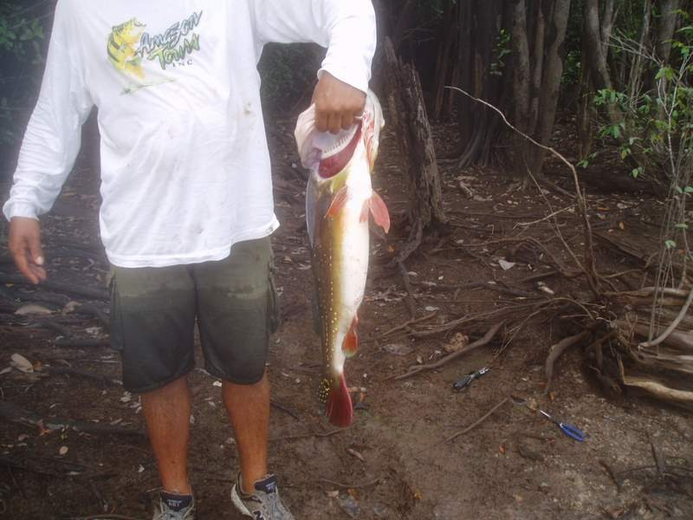
A 9.5 lb Peacock
In rather quick succession I proceed to catch a nice 2½ lb. Butterfly Bass and a small Piranha. We return the fish to the water and I am ready to begin casting again but Enrico says, “No”. He informs that we have to go because there are still many things to do. Reluctantly, I take one more look at the spot where I had just caught the Peacock and, then, turn and follow Enrico.
I follow Enrico back up the trail for a short ways and, at a spot where the adjacent underbrush thins out; we make a sharp right hand turn into the jungle. There is no trail but, also, while there are very many trees, there is very little underbrush. We are able to make our way, basically, unimpeded, with only sporadic need for trail clearing with the machete. Underfoot is a covering of thick, soft and spongy vegetable material. Overhead, far up among the trees, is an impenetrable canopy of green leaves. We cannot see the sun or, even locate from which direction it is shining.
We walk this way for quite a while; maybe 30 minutes, on a line that is, basically, straight through the jungle. Privately, I wonder how Enrico knows in which direction we are going. There is no discernible trail and we cannot see the sun. The only thing I see him do trail-wise is, every once in a while, to blaze a tree with a mark from the machete. I assume that this is to assist us on the return; since, I can see no other, previous blaze marks on any other trees.
Despite my growing negative thoughts about direction finding, we soon come upon a small clearing in the jungle. Enrico says, “Chaga Indians”. It is, by all appearances, a recently abandoned campsite that is centered about a cold, blackened fire ring. There are upright, forked stakes adjacent to the fire that are obviously meant to hold cross spits for roasting. There are, also, near the edges of the clearing, two, long, low horizontal platforms made from cut and notched branches and lashed together with vines. The construction technique is reminiscent of the ladder that our own guides had previously made for Barney. I’m not sure what the platforms are for, possibly, tables or sleeping pads. Other than some charred fragments of unburned wood in the fire ring and an empty, pintsize plastic oil bottle, there is no other debris in the campground. The Indians have left it clean.
I soon find out why the oil bottle is there. Enrico leads me to another, larger clearing nearby. Lying on the ground in the center of the clearing are several lengths of saw cut wooden planks. He says that the Indians come here to obtain “special” kinds of wood that they use either for carving, or for sale. Judging from the radial saw markings on the leftover planks and the sawdust strewn about, it is easy to ascertain that they had used some type of power driven saw; hence, an engine that would need oil.
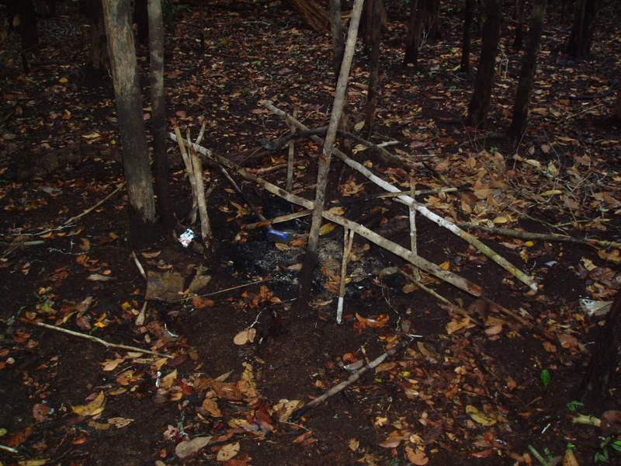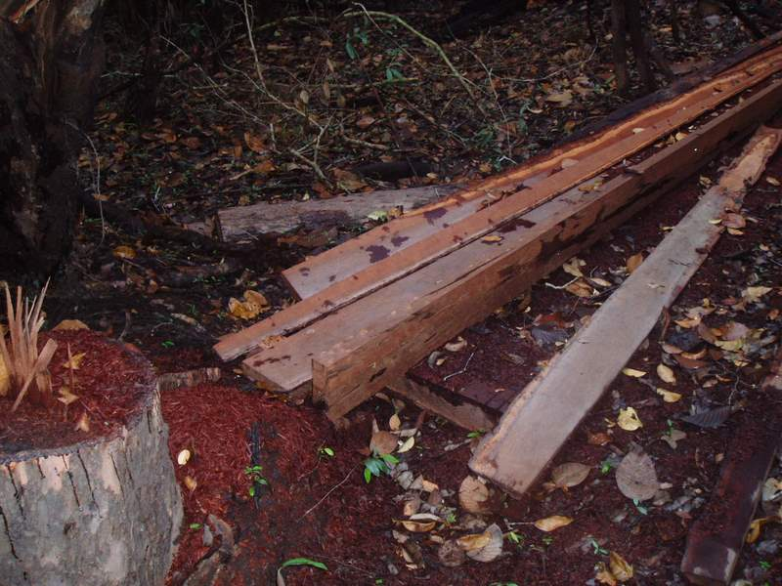
Indian Fire Pit Indian “Saw Mill”
Apparently, they come here periodically, during the year, to harvest the wood. The one thing that is not apparent is how they take the wood from the site. There are no apparent trails or, even worn areas, leading from the site. I ask Enrico how they remove the wood and he grins and says, “On their backs”.
We leave the clearing on a different vector through the jungle than the one on which we had arrived, heading, as nearly as I can tell, still deeper into the jungle. We travel for about another 45 minutes through trackless jungle that is similar to the trek we had just made to the Indian camp except that, this time, it is a little rougher going. There are more incidences of thick underbrush that require machete work and, several times we are forced to travel through boggy, muddy areas. Fortunately, we do not hit any serious mud, though; nothing that reaches to the tops of my shoes.
We reach a convenient fallen log; just the right height to sit on, and Enrico declares a rest stop. All during this latter trek the mosquitoes have been a bother but, once we sit down, they start attacking in droves. I bring out my bottle of “Off” and apply it liberally to the underside of my hat brim, my exposed ankles and to all of the other spots of bare skin showing on my body. It works, almost immediately, and I become comfortable again; if being doused in oily, stinky lotion can be called comfortable. I hand the bottle to Enrico and he takes it, gratefully, coating himself with it in a similar manner to what I had just done. I make a mental note to give him the bottle when I leave. It is a large bottle and it should last him a long time. That thought makes me feel good.
I pull a sandwich out of my pack and start to eat it. I notice that Enrico has no sandwich so I offer him half of mine. He demurs, but I insist, and he does, finally, take and eat it. The same scenario happens again with my water bottle but, after some persuasion on my part, we both end up sharing the water, also. After about a 10-minute long stop we get up and resume our journey. I’m positive that Enrico knows where we are going but I have no idea and he’s not saying much.
It takes another 30 minutes, or so, but we finally arrive at a large lake. I figure that we must have walked, at least, three to four miles since we left the boat this morning. The lake is beautiful. We are standing on one end of it and it widens out in a semi-circular shape ahead of us to a width approaching 150 to 200 yards. The shorelines on each side then go on straight for a ways, with the same approximate width of water, before the entire lake turns to the right, out of sight.
Nowhere, except for the small area that we are standing on, can I make out a beach along the lake’s periphery. Thick jungle vegetation comes right up to the water’s edge along the entire, visible periphery. I spy the outline of another “vulture” perched on a high tree limb that extends over the water about 50 yards from me, along the left shoreline. Its silhouette is vivid and unmoving. The water appears smooth, blackish, and shiny and the surrounding jungle is a darkish green in hue. Overall, the scene is serene and peaceful, possessing a quiet, natural beauty. It is definitely a sight worth walking a long ways to see! I am very glad, at this moment that I decided to make this trek.
Enrico tells me to wait here and, then, he disappears into the jungle, carrying his machete. After a short time I hear hacking sounds from the direction in which he disappeared. Soon he reappears holding two straight sections of tree branches about one inch in diameter. He explains that they are walking “poles”. We are going to have to wade through the water to get to where we are going and, the problem is that the lake bottom on which we will be walking has many holes in it. The poles are to be used to feel the bottom ahead of us as we wade so that we can find and avoid the holes.
He tells me to leave all of my gear here, in this dry spot, so that it will not get wet in case I fall. I am to take only my fishing rod and, of course, the pole. It doesn’t sound too encouraging to me but, if nothing else this past week; I have learned to trust Enrico’s instructions, implicitly.
I do as I’m told, taking off my fanny pack and removing my binoculars from my shirt pocket. I lay them on the ground. Enrico takes his machete and, with a good whack, sticks it into a nearby tree. I keep my digital camera and wristwatch, though, since both have been advertised as being waterproof.
We both pick up a fishing rod in one hand and a pole in the other and he heads into the water, wading to our right. I follow. As he walks he keeps feeling the ground under the water ahead of him with the pole and, so do I, emulating Enrico’s technique as closely as I can. Mostly, though, I follow closely in his footsteps, allowing him to find the correct path. We travel in a twisting path roughly 10 feet from shore, dodging holes that I never feel, for a distance of about 100 feet. We reach a point where the water is up to my knees and Enrico calls a stop. This is our fishing spot.
While we are standing there he points overhead. When I look up there are three large birds flying about in large circles. I see flashes of blue and red. “Macaws”, says Enrico. I reach for my binoculars but they are not there. I left them on the bank. We watch them for a while but, eventually, they fly off into the jungle.
The rod that Enrico is carrying is rigged with a woodchopper lure. He points to a fallen tree that sticks out into the water from the shoreline. It is a good distance away, more than I am used to casting with the spoon. I try my first cast in the direction that he indicates but it hits the water a good 15 to 20 feet short of the target. Enrico takes his rod and, with a sharp, flicking motion of his wrist, he easily sends the woodchopper about 10 feet past the target. After he retrieves it, he hands the rod to me, taking mine. He doesn’t need to say a word. His casting demonstration says it all. If I’m going to reach that tree, I will need the extra weight of the woodchopper to do it.
I take the rod from him and rear back, making a mighty, full arm cast. I stop the rod and release the line between the one o’clock and two o’clock position. There is no way that I can emulate Enrico’s more efficient, flicking motion. However, my cast is successful. The lure flies out at a 45-degree angle with the line describing a high vertical arc as it travels through the air. The lure lands about 10 feet out and 10 feet past the tree. Perfect! I reel in the line with intermittent, sharp retrieves that are satisfactorily turbulent and noisy. Not as good as Enrico’s, but good enough. On the second retrieve of the second cast I get my best hit of the week!

Something big takes the line and charges out to the left, towards the center of the lake. It creates a tremendous tugging action. I set the hook with some strong horizontal sweeps of the rod and then, all I can do is hold the rod vertically upright while the fish peels out line. The rod is bending out, almost 90-degrees, creating a springing action, that, when combined with the drag on the line, will help to tire the fish. Experimentally, I intermittently pump the reel backwards then reel in on the forward motion trying to gain line on the fish. At first, the fish takes as much line back on the “pump” as I retrieve on the “reel” but, gradually, I start to gain on it. I manage to head it off and turn its direction towards me. It is one tough fish!
Then, a disaster almost happens! I try to move a little to get a better purchase for my feet on the mud bottom and, suddenly, I step into a large hole. It catches me by surprise and I end up sitting in the mud, in water up to my neck! I flounder about trying to regain my footing but I’m always conscious to keep the reel upright in order to keep tension on the line. After some struggling, I regain my footing and, fortunately, I am able to keep the tension on all during these gyrations. I am dripping wet but the fish remains securely hooked.
That fish and I have a good, back and forth, tugging match but gradually I am able to reel it in close. It surfaces when it is about 25 feet away from me. For a brief instant, we look at each other. At that, it dives, turns, and begins a run straight out away from me, peeling out line as it goes. It is one, big Peacock! The run is strong but I can feel it tiring. It takes a while longer but after some further, strong back and forth action between us, I succeed in bringing the fish in close enough for Enrico to pick it from the water. It is one tired fish and, it is big!
Enrico weighs the fish in at 16 lbs. At last, on this final day of fishing, I have caught my trophy fish! Enrico hands it to me and I hand him my camera. He takes the picture with me standing there dripping wet from my recent dunking and holding the fish. There is a smug look on my face. I hold the fish for a short while longer, just admiring it and savoring the afterglow of our recent battle. Then, still holding it level with both hands, I very gently place it back into the water. The fish is stunned and doesn’t move for an instant after being released, then, with a flick of its tail, it disappears under the water. That gives me a good feeling. It will live to fight another day.
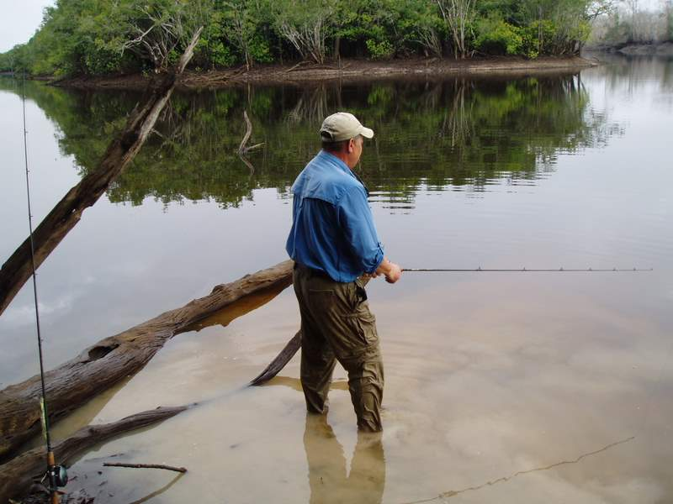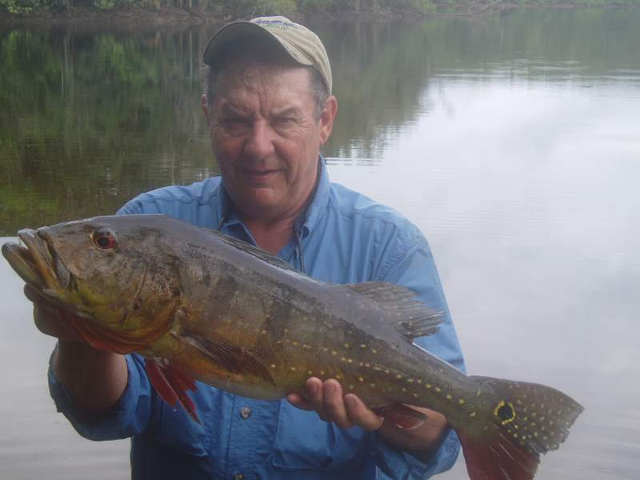
Fishing Deep in the Jungle Soaking Wet with my 16 lb Prize
Enrico advises me that we should start back. I agree. For the time being, at least, I’m satisfied. Catching that large fish has given me a feeling of having accomplished something that I set out to do and I’m now ready to find a new venture.
I pick up my fanny pack and strap it on. Enrico retrieves his machete from the tree and we re-enter the jungle, re-tracing our path back the way we came. I know it’s the same way because I begin to recognize a few landmarks as we go. I’m starting to understand how these Indians can find their way through the jungle so unerringly despite not being able to get any directions from the sun, the stars, or a compass.
Like any of us in the civilized world they memorize landmarks. The difference is that, while we remember street signs, corner stores, gas stations, etc., their landmarks are the natural objects that the forest is composed of; such as, fallen trees, stumps, the roll of the terrain, shapes of streambeds, etc. When they get good at it, I’m sure that they can remember even minute details, right down to remembering each specific tree and bush in a given location; trees and bushes that to us would all look like any others of their species, with no individualized or other distinguishing features. They are born to it and it just becomes part of their natural way of life.
Despite the fact that we follow no discernible trail, our way unerringly takes us back past the fallen log where we shared the sandwich and the insect repellant, to the Indian campsite clearing, and, finally, we emerge on the game trail that we took from the beach where the boat is grounded.
Dogfish Pond: We are back on the water. Enrico says that he wants to try one more small lake on our way before we visit the Indian village that he had promised previously. After some 10 minutes of travel, again, via a twisted path around islands and through narrow channels, we beach the boat on a sandy shoreline. It is a large beach that stretches, possibly, a quarter of a mile before it meets the jungle. Just before it meets the jungle, over a small rise, I can see the glint of water. We reach the edge of the water and it turns out to be a rather large pond, possibly, 3 acres in size.
I’m using the spoon lure and, on my first cast, I get a strike, almost immediately. There is a short, furious fight from the fish and, then, I am able to reel it in without too much effort. It turns out to be a dogfish, weighing probably 2 to 3 lbs. Enrico has a rather surprised look on his face. He holds up the fish with the weighing scale by clamping the scale to the fish’s lower lip. The intention is to de-hook the fish. We discover that the fish has almost completely swallowed the lure. One look at those large, ugly teeth and Enrico decides that he needs a pair of pliers in order to make the extraction. That fish’s mouth is no place for someone’s fingers!
The pliers are in the boat. Enrico turns and starts to walk rapidly towards the riverbank where the boat is beached. While I am waiting for him I hold the fish, still hooked on the line, in the water next to where I am standing. I allow enough slack in the line to allow the fish to swim around a little bit. The water is no more than 6 inches deep.
The fish thrashes around, creating turbulence in the water. All of a sudden another dogfish of the same size appears, apparently attracted by the turbulence, streaking rapidly towards my captive fish. Obviously this new predator is prepared to attack what, at first, appears might be an easy meal. Just as it closes in, it sees the size and, I suppose the identity, of its prey and veers off. As suddenly as it appeared, it is gone. Things happen quickly in the jungle!
Enrico returns with the pliers and we unhook the fish, returning it to the water. I resume fishing. On five successive casts I catch, and release, five more dogfish. It is not much fun. The dogfish may be ferocious predators but they do not put up much of a fight on a fishing line and, besides, they are so darned menacingly ugly! They are not exactly a catch that one can be proud of. I reel in the line and we head back towards the boat. Enrico is disappointed. He informs me that this had been a good spot for Peacocks the last time he had been here.
The Indian Village: The boat ride this time is much longer. We soon find the main channel of the Rio Negro and head down river. We travel with the riverbank close in to the right side of the boat. The river is very wide. It appears to me to be more than a mile to the opposite shore. After many minutes, possibly 30, we approach a small dock adjacent to the riverbank.
At this point, lining the riverbank is an almost vertical, vegetation-coated cliff, possibly 30 feet high. There is a wooden dock protruding into the water at the base of the cliff. Directly in back of the dock is a set of wooden steps that leads to the top of the cliff. We tie the Nitro to the dock and proceed to climb the steps. The top of the steps opens onto a large cleared area contained within a jungle-surrounded plateau. The Indian village resides in this clearing, with the edge of the village close to the edge of the cliff.
The village is composed of a number of wooden frame cottages that are raised above the ground on, approximately, eighteen inches high stilts. The cottages are well constructed, built square and plumb, each with a small front stoop and a set of stairs to the ground. They have thatched roofs. Everything is neat and clean; there is no debris or garbage to be seen. The cottages are spaced closely together in a haphazard pattern. Everywhere is bare ground; some of the areas that are close to the houses have the appearance of being recently swept. There are no discernible streets, no concrete or paving or, for that matter, there is no grass lawn or other cultivated areas, either.
As I walk into the village, the first thing that I focus on is an older man in a white tee shirt just sitting on his front porch steps, doing nothing. He gets a curious look on his face when he sees Enrico and me but he doesn’t say anything. I nod to him and he nods back. The next thing that hits me is a real surprise. Mounted on a pedestal in a small cleared area, right, smack in the middle of that village, is a large TV dish antenna, pointed skyward - so much for my vision of visiting a primitive Indian village!
Enrico leads the way towards the center of the village. After passing a couple of cottages that show no sign of life, he stops at one that has its front door standing wide open. He calls something in his native language and, shortly, a young, dark haired native woman appears.
She is pretty, neat and clean with her long hair combed, wearing a clean, white tee shirt and skirt but bare footed. In one arm she is carrying an infant boy and, closely following, almost hiding behind her is a young Indian boy about 7 or 8 years old. Both she and the older boy are carrying brightly colored objects in their hands. They deposit the objects on a bench at the edge of the stoop next to where Enrico and I are standing. Enrico introduces us and she acknowledges me with a nice smile and a hello, in English. It turns out that she speaks only a smattering of “Pidgin” English and Enrico has to interpret most of the rest of our conversation.
The objects on the stoop are crafts that she and others in the village have made and they are for sale. She introduces me to the older boy and tells me his name. The boy is not her son but her apprentice and he has helped make some of the crafts. I can’t, quite, understand his name but it sounds to me like “Paco”. I smile at him and say, “Hello, Paco”. My translation must be close because he answers me with a big eyed, shy smile. I am quite taken with him. He reminds me of my two youngest grandsons who are slightly older.
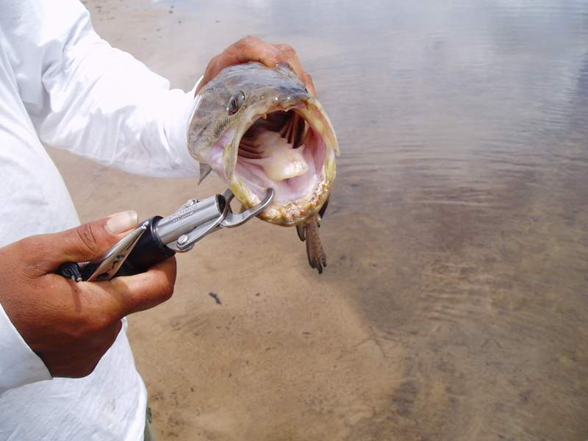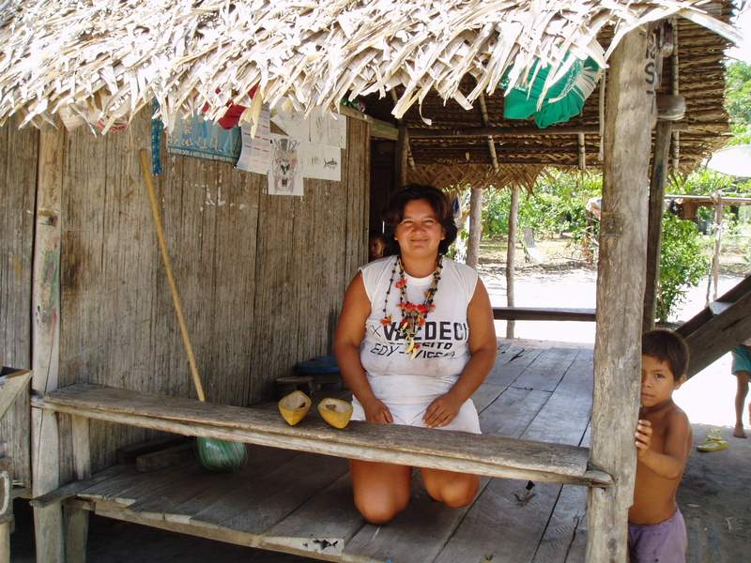
Dogfish – Mouth Open Indian Woman – Paco Hiding
There are three necklaces made of different, brightly colored bird feathers interspersed with beads and hollowed out pieces of light or dark wood. They are quite striking and colorful. They look very similar to the necklace that Mark was wearing on the day he had visited “his” Indian village. I assume that I am in that same village. Also, in the pile of crafts are a woven bowl and two miniature, hand carved “dugout canoes” with matching paddles. She tells me, through Enrico that she, personally, made the necklaces and that Paco had worked on the canoes and paddles with whomever it was that carved them. Paco acknowledges this with another shy smile.
I select one necklace and one canoe and we start to bargain. We have some fun bargaining and it ends up that my final offer, for the whole pile, is $15.00 and she accepts. They will make good presents for five of my grandchildren. I look in my wallet and the nearest I can come to the correct total is two ten dollar bills. She says that she has no change. I take another look at her and the small boys and say to myself, “What the Hell”, and I tell her to keep it all. I know that it’s not the best bargaining technique but I would have paid a lot more in town for them. Those extra five dollars are, surely, much more important to her than they are to me.
I then feel in my pocket and I find a USA fifty-cent piece. I gravely present it to Paco with a handshake and an earnest “Thank You”. He gives me such a grateful, adoring look that I melt and the whole transaction becomes special, and memorable, to me. She finds a much-used plastic bag and puts my booty in it. I put one of the necklaces around my neck, pick up the bag, shake her hand and Enrico and I start to walk away, back to the boat.
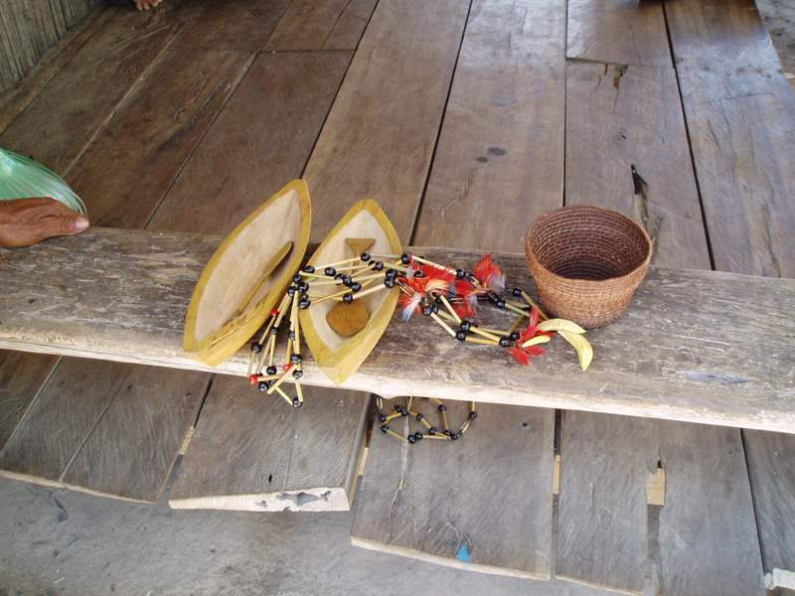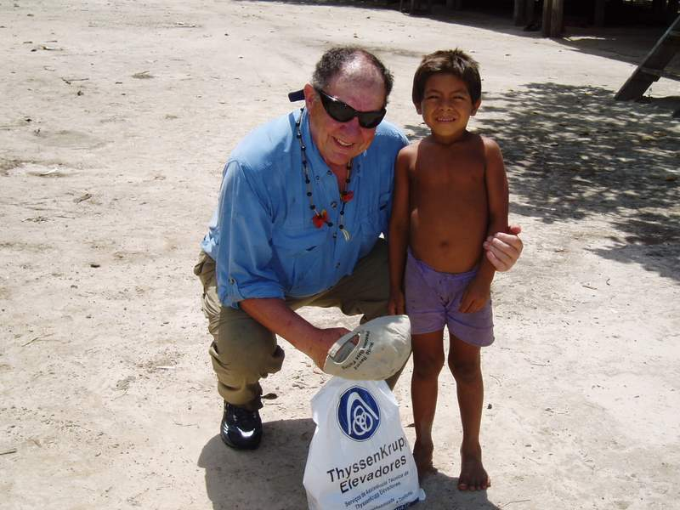
Indian Crafts – For Sale My Friend - Paco
When I look down Paco is following, closely, near my side. I have made a convert. I stop and hand my camera to Enrico. I then kneel down besides Paco and Enrico takes our picture with my arm around him. He has a bright smile on his face. I make a vow to myself that I will get a copy of that picture back to him, somehow. We continue, down the stairs, to the boat and my last memory of that place is Paco, sitting on the bottom step of the stairs, watching us go with a wistful look on his face.
Good-bye: By this time it is mid-afternoon and I decide to go back to the lodge to begin packing for tomorrow’s early departure. I have had a full and satisfying day!
It is a long boat ride back to the lodge. On the way neither Enrico nor I speak but it is a companionable silence. I, for one, have an almost victorious feeling. Today was a day that met all of my expectations.
By any measure, the high point of the day was the catching of the trophy Peacock Bass, but the other events of the day are almost as memorable. Who would have thought that I would be walking in the still fresh tracks of a wild jaguar, or blazing a trail through a wild, trackless jungle to find an abandoned native Indian encampment? Even the “dogfish pond”, as ugly as these fish are, formed an experience that I will long remember. Possibly, the most poignant and memorable way to end the day, though, was watching Paco’s small form recede from my vision as our boat sped away. As I said before, “Things like this just do not happen in Tewksbury, New Jersey!”
Enrico pulls the boat into the dock and then starts straightening up and putting away gear. He removes my reel from the rod it was on and places it on the dock. I dig into my fanny pack and pull out the bottles of sunscreen and insect repellent. Also I reach into my wallet and bring out the tip that I had previously prepared for him. Rich had gotten together with the group and we had agreed on certain guidelines for tipping.
I give Enrico the tip along with the bottles of lotion. He thanks me. I have gotten to know him pretty well over the past week and I can tell that his thank you is very surprised and sincere. Combined with the pool winnings that I had shared with him, previously, I’m sure that this is more money than he usually makes from a client. I, also, know that he would have given me the same good service if I hadn’t tipped him at all. Besides being a crackerjack guide, he is, simply put, one good person. It makes me feel good to think that I am helping him and his family. Besides, he has given me one of the most enjoyable weeks of my almost seventy years of life. I’m the one who is grateful!
We stand on the dock and shake hands, saying good-bye. As we are doing this we look at each other and, spontaneously, we both hug each other in a strong embrace. It has been one helluva week! I pick up my reel, fanny pack, and bag of native souvenirs, turn, and walk up the dock towards the lodge. The trip was over!!

Getting There: The lodge accommodates about 40 fishermen. Every Sunday a new contingent arrives at the Barcelos airport and they are exchanged for the 40 odd fishermen that had been fishing from the lodge the previous week. The leaving group of fishermen is taken downriver on an exciting ride in the lodge’s “Nitro” bass fishing boats. The arriving group takes the same Nitro’s back upriver to the lodge in another speedy, exciting ride. The Nitro ride takes about an hour.

The group assembles at the Miami, FL, airport for a late night flight via Air Bolivia to Manaus, Brazil. Arrival in Brazil is in the very early morning hours and the Lloyd Air flight to Barcelos doesn’t leave until after dawn. In the meantime the group is taken by bus to a buffet breakfast at a local, up-scale hotel.

The Lloyd Air planes are smaller, turbo prop aircraft and it takes two planes to take the whole group. Arrival in Barcelos is in mid-morning. Buses take the group to the waterfront where organized chaos occurs as the two groups and their luggage interchange. The leaving group enters the buses and the arriving group boards the Nitro’s.

Upon arrival at the Rio Negro Lodge, lunch is served. Cottages are assigned, four fishermen to a cottage, and there is an hour provided to settle in. Then, it is back into the Nitro’s, two fishermen per Nitro, for the first afternoon’s fishing on the river.

It sounds exhausting but it really is not. Starting with the Nitro ride, the adrenaline begins to flow. It gets especially exciting when the first Peacock hits the lure and the first Peacock is caught, all before the first day is over!

Everything is pre-arranged and the whole process of getting there is efficient. Contact:

Amazon Tours, Inc.
71 Canyon Drive, Suite 110
Coppell, TX 75019

Tel: (972) 304-1656
Fax: (972) 304-5262

www.peacockbassfishing.com

Note: The Brazilian government requires Yellow Fever shots, only, when obtaining a visa. However, it is strongly recommended to, also, immunize for Malaria, Typhoid, Hepatitis, and Tetanus. There will be no problems with the food, water and sanitation while at the lodge. Their facilities and food practices are first rate; however, there is opportunity to spend time on your own in Manaus and Barcelos. The conditions there, while not terrible, are not guaranteed.

